

**Technology Park Malaysia**

**Web Development**

**AAPP009-4-2-WDT**

**UCDF2208ICT(SE)**

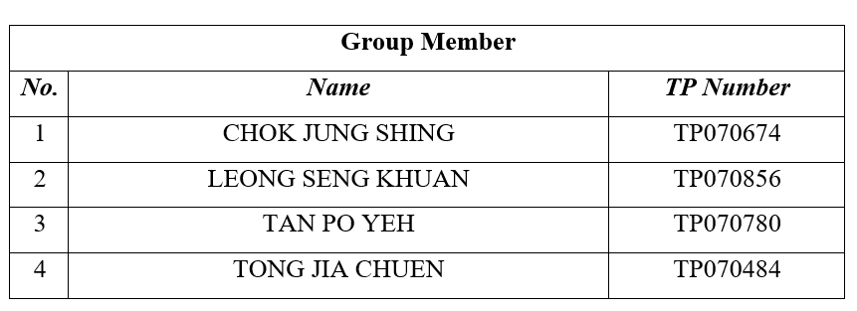

|  |  |
| --- | --- |
| **Module Code** | Web Development (102023) |
| **Intake Code** | UCDF2208ICT(SE) |
| **Project Title** | Society Connect |

Contents

1.0 Introduction 5

1.1 Scope 5

1.2 Objectives 5

1.3 End-user specifications 6

1.4 Major functions 6

2.0 Design 7

2.1. Entity Relationship Diagram 7

2.2 Data dictionary 9

2.2.1 Admin 9

2.2.2 Banner 9

2.2.3 Category 9

2.2.4 Country 10

2.2.5 Course Post 10

2.2.6 Event Post 11

2.2.7 Job Post 11

2.2.8 Profile 12

2.2.9 Saved Course 12

2.2.10 Saved Event 12

2.2.11 Saved Job 13

2.2.12 User 13

2.3 Wireframes for the primary layouts of the web pages 14

2.3.1 Main Page and Job Finder Page 14

2.3.2 Skill Sync Page and Event Page 15

2.3.3 Sign in Page 16

2.3.4 Sign up Page 17

2.3.5 Create Job Webpage 18

2.3.6 Create Lesson Webpage 19

2.3.7 Create Event Webpage 20

2.3.8 Profile Main Page 21

2.3.9 Job Finder Subpage 22

2.3.10 Skill Sync Subpage 23

2.3.11 Event Subpage 24

2.3.12 Post Subpage 25

2.3.13 Setting Page 26

2.3.14 About Us Page 27

2.3.15 FAQ 28

2.3.16 Private Policy 29

3.17 Terms of Use 30

2.3.18 Event Review Page 31

2.3.19 Job Review Page 32

2.3.20 Course Review Page 33

2.3.21 Admin 34

2.3.22 Admin information 35

2.3.23 Admin Update data 36

2.3.24 Admin Approval or Reject User Post 37

2.4 Website Navigational Structure 38

3.0 System Implementation 40

3.0.1 Login Functionality 40

3.0.2 Register Functionality 42

3.0.3 Search Functionality 44

3.0.4 Bookmark functionality 51

3.0.5 Create and Save Post functionality 57

3.0.6 User profile functionality 62

3.0.7 Post Review functionality 74

3.0.8 Admin profile functionality 81

4.0 User Guidance 93

4.1 User Login 93

4.1.2 Users Sign Up 95

4.2 Main page 96

4.3 Job Finder 97

4.3.1 Create a Job 98

4.3.2 Review Post 99

4.4 Skill Sync 100

4.4.1 Create a Lesson 101

4.4.2 Review User Posting Course 102

4.5 Event 103

4.5.1 Create an Event 104

4.5.2 Review Users Posting Event 105

4.6 User Profile 106

5.0 Conclusion 108

6.0 Workflow Matrix 109

7.0 References 110

8.0 Appendix 111

# 1.0 Introduction

Society Connect is our group assignment title for our software application. A web application that is dedicated to community service, providing several interesting features. Our platform provides free e-courses that are from professionals and experts, teaching them vital skills and personal improvements. For those who are seeking for guidance or help, our online consultation service is also provided with other organizations that are willing to help via link & appointments in our web application. Users can seek for career counselling and other related interactions. There will be a friendly-user portal that provides Free Job Finder. This feature supports unemployed individuals. Our website has connection to numerous organizations & even portal links to other webs that are currently hiring individuals. A community forum that will encourage discussions among the society, sharing out ideas and opinions. A resource library feature containing articles, guides, news.. A user feedback system feature that can help our web to do improvements. Making our platform more user-friendly, foster the connections among the community. And of course, all users are required to sign-up and login their credentials to utilize the web application. Other than that, it is easy to navigate and use with ease by the users.

## 1.1 Scope

Our website objective provides free e-courses that are from experts, empower users in skills development and personal improvements. For those who are seeking for guidance, our online consultation service is also provided with other organizations that are willing to help via link & appointments in our web application.

## 1.2 Objectives

Our objective of our website appears to be providing a comprehensive platform to support users in their professional development and career advancement. Firstly, our website creates a networking opportunity by connecting users with similar skills or interests and fostering a sense of community through networking events and volunteering opportunities. Secondly, the website aims to facilitate seamless job discovery by providing users with an easy access to post different employment opportunities across various industries and companies.

## 1.3 End-user specifications

Our website builds in user-friendly interface and intuitive design for an easy navigation through our website features. With a straight-forward layout and some images icons to visually appealing. Furthermore, user can be customized their user unfinished post for the details of job recommendations, skill development, and event suggestions, ensuring that each user’s experience is tailored to their unique needs. With our security measure, it gave the users safer and more trustworthy to our platform.

## 1.4 Major functions

We offer three main features which designed to empower users in their professional journey. Firstly, the Job Finder function is designed to be simplify for the job search process. By simply clicking on a unique designed box, users will direct to the pages of companies offering exciting employment opportunities. Next, Skill Sync features enabling users not only track their skills but also to proactively offer them for improvement suggestions. This dynamic platform serves as a two-way street, allowing users to receive personalized guidance on skill enhancement while also monitoring their progress over time. Finally, event function integrates seamlessly, recommending event jobs aligned with users’ skills and interest. In essence, our website is a user-friendly website with holistic career companion, providing an ecosystem for job discovery, skill development, and meaningful connections through relevant events.

# 2.0 Design

## 2.1. Entity Relationship Diagram

Entity Relationship Diagram

The ERD designed for the society website contains of 12 tables and various relationship that indicate the interaction of the system attributes with each other. The ERD contains of two actors, user and admin and three core tables, Job_Post, Event_Post and Course_Post. The users are able to post or create these three types of posts while admins are able to create and handle (approve or reject) these posts.

For the Country table, it has a one-to-many relationship with User, Job_Post and Event_Post table. This indicating that these three tables have country elements in use in the web. The Job_Post and Event_Post table need the country element to elaborate their content while the Course_Post table don’t have the prior to show the country.

The Banner table are used in the three types of post table (Job_Post, Event_Post and Course_Post) and the User Table. These four tables will display the banner image in the web. For the Profile table, only Job_Post table and User table have relationship with it. Same, the Job_Post and User table will have the need to display profile image in the web.

For the Saved_Job, Saved_Course and Saved_Event table are used for the bookmark functionality. Every time when the user clicks on the bookmark, the data get update in these tables. Then, for the Category table are used for categorizing the Job_Post and Course_Post table in the web.

Overall, the ERD design of the society website efficiently organizes the relationships between various system attributes. It effectively distinguishes between user and admin actors and establishes clear relationships between core tables such as Job_Post, Event_Post, and Course_Post. The inclusion of Country, Banner, and Profile tables ensures the proper display of country elements and images throughout the website. Additionally, the Saved tables facilitate bookmark functionality for users, while the Category table aids in categorizing posts. This comprehensive ERD design lays a solid foundation for the functionality and organization of the society website, ensuring smooth user interactions and efficient management of posts by administrators.

## 2.2 Data dictionary

### 2.2.1 Admin

Below Table 1 shown the data dictionary about Admin table in Admin database

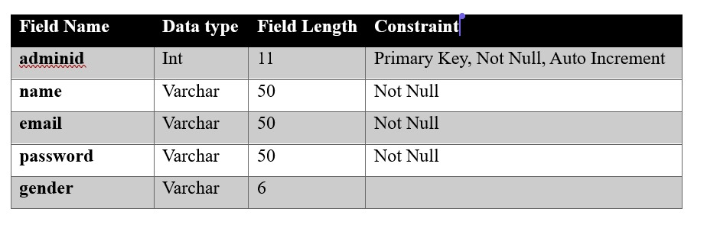

Table - Admin Data Dictionary

### 2.2.2 Banner

The Table 2 show the data dictionary of the banner table in the database.

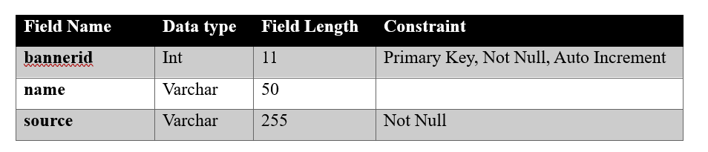

Table - Banner Data Dictionary

### 2.2.3 Category

The Table 3 show the data dictionary of the category table in the database.   
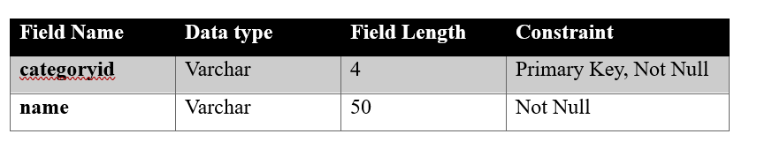

Table - Category Data Dictionary

### 2.2.4 Country

The Table 4 show the data dictionary of the country table in the database.

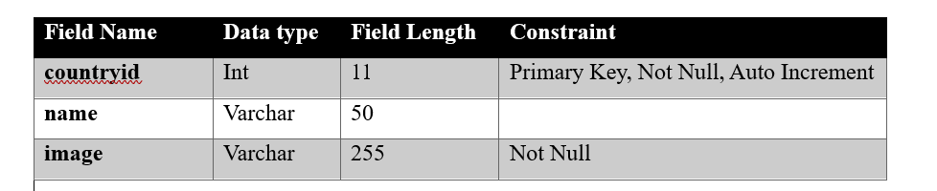

Table - Country Data Dictionary

### 2.2.5 Course Post

The.Table 5 show the data dictionary of the course post table in the database.

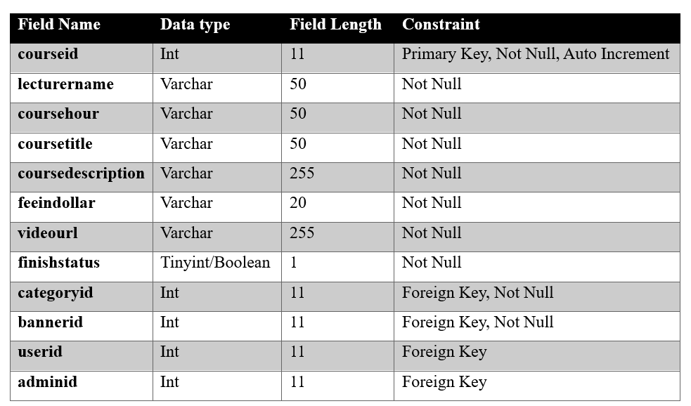

Table - Course Post Data Dictionary

### 2.2.6 Event Post

The Table 6 show the data dictionary of the event post table in the database.

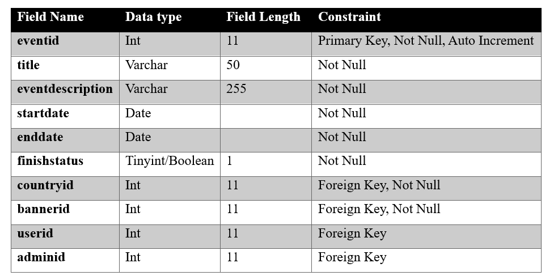

Table - Event Post Data Dictionary

### 2.2.7 Job Post

Below Figure 0.7 shown the data dictionary about Job Post table in Job database.

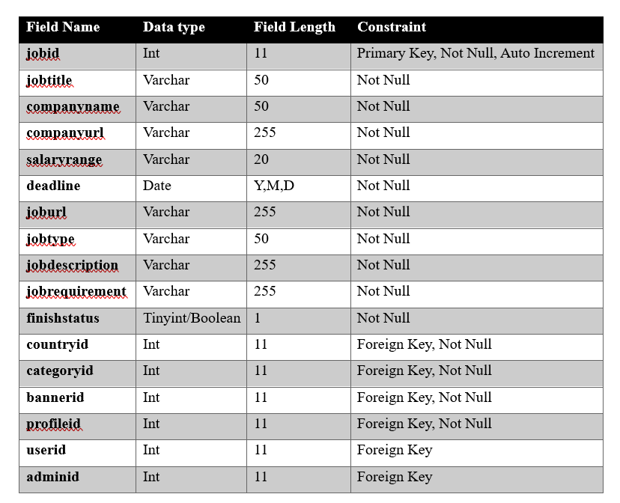

Table - Job Post Data Dictionary

### 2.2.8 Profile

Below Table 8 shown the data dictionary about Profile table in Profile database

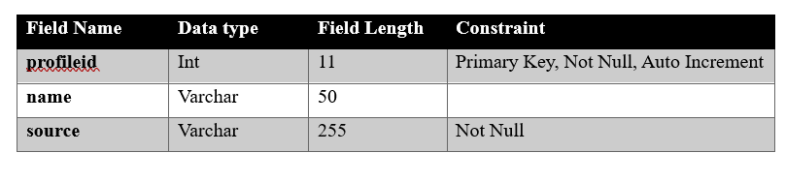

Table - Profile Data Dictionary

### 2.2.9 Saved Course

Below Table 9 shown the data dictionary about Saved Course table in Saved Course database

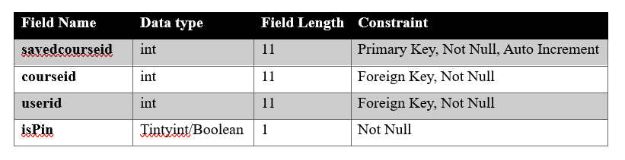

Table - Saved Course Data Dictionary

### 2.2.10 Saved Event

Below Table 10 shown the data dictionary about Saved Event table in Saved Event database

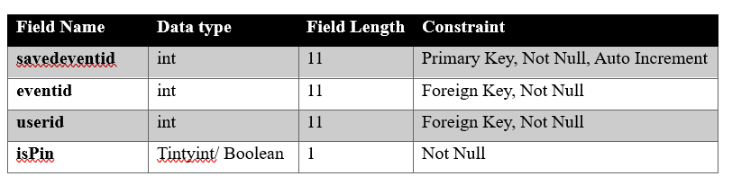

Table - Saved Event Data Dictionary

### 2.2.11 Saved Job

Below Table 11 shown the data dictionary about Saved Job table in Saved Job database

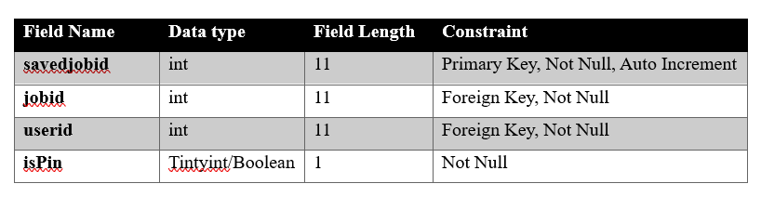

Table - Saved Job Data Dictionary

### 2.2.12 User

Below Table 12 shown the data dictionary about User table in User database

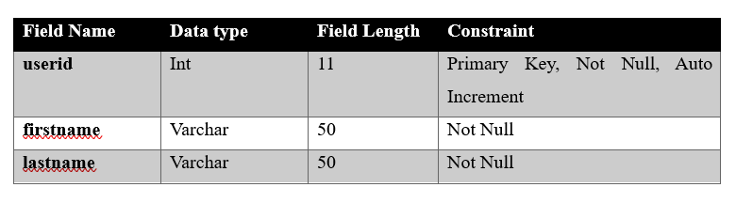

Table -User Data Dictionary

## 2.3 Wireframes for the primary layouts of the web pages

### **2.3.1 Main Page and Job Finder Page**

Figure 2: Job Finder Wireframe

Figure 1: Main Page Wireframe

The picture above serves as a blueprint for Skill Sync Main Page and Job Finder Page before we develop the website. The theme of the page will be more likely in the dark theme.

### 2.**3.2 Skill Sync Page and Event Page**

Figure 4: Event Wireframe

Figure 3: Skill Sync Wireframe

The picture above serves as a blueprint for Skill Sync Page and Event Page before we develop the website. The main idea for the design was to make the page have a space to search for the post by using the search functionality we will be implementing later.

### 2.3.3 Sign in Page

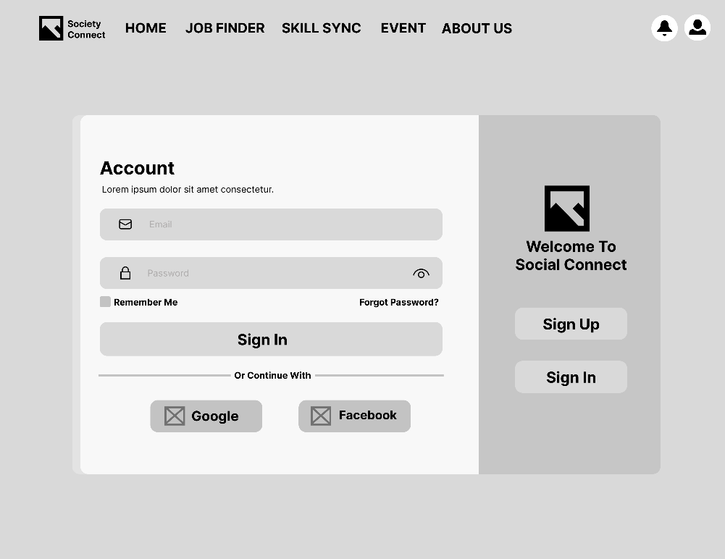

Figure 5: Sign in Page

The page above is the wireframe for the sign in page, which the button besides also allows the user to navigate between the sign in and sign-up page.

### 2.3.4 Sign up Page

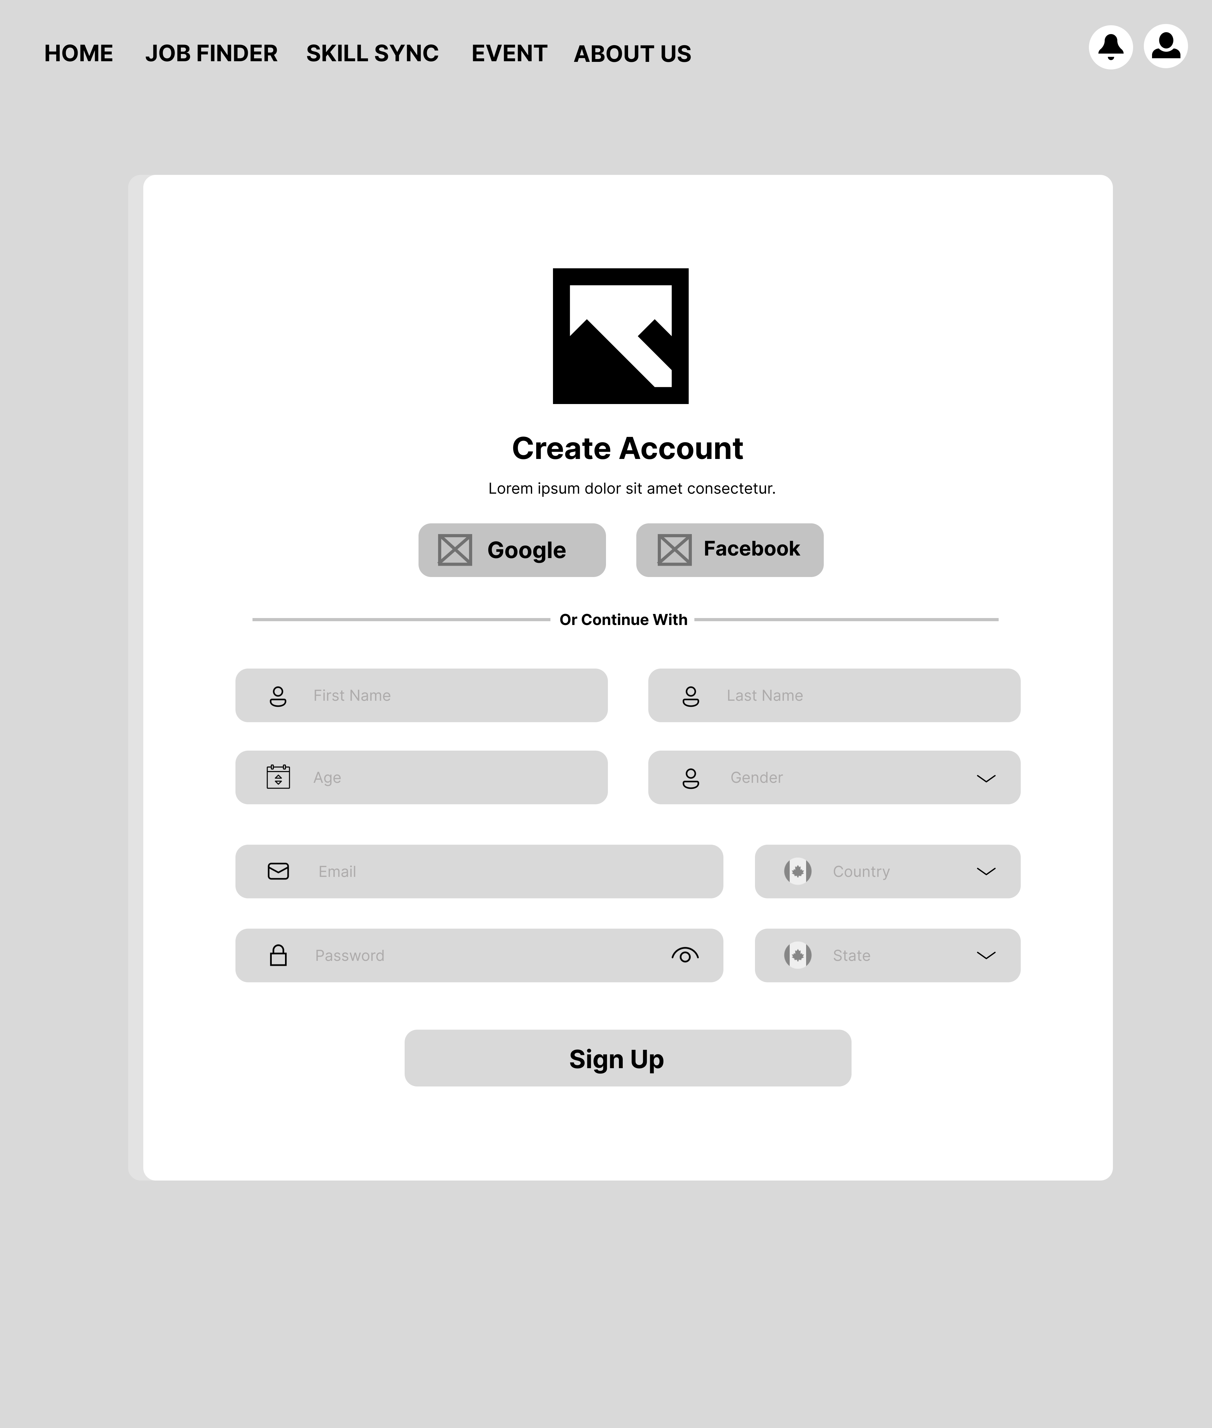

Figure : Sign Up Page

The picture above serves as a blueprint for Sign Up Page before we develop the website. The form is aimed to facilitate the user register process by providing many forms like select drop down and "Google" and "Facebook" for sign up purposes.

### 2.3.5 Create Job Webpage

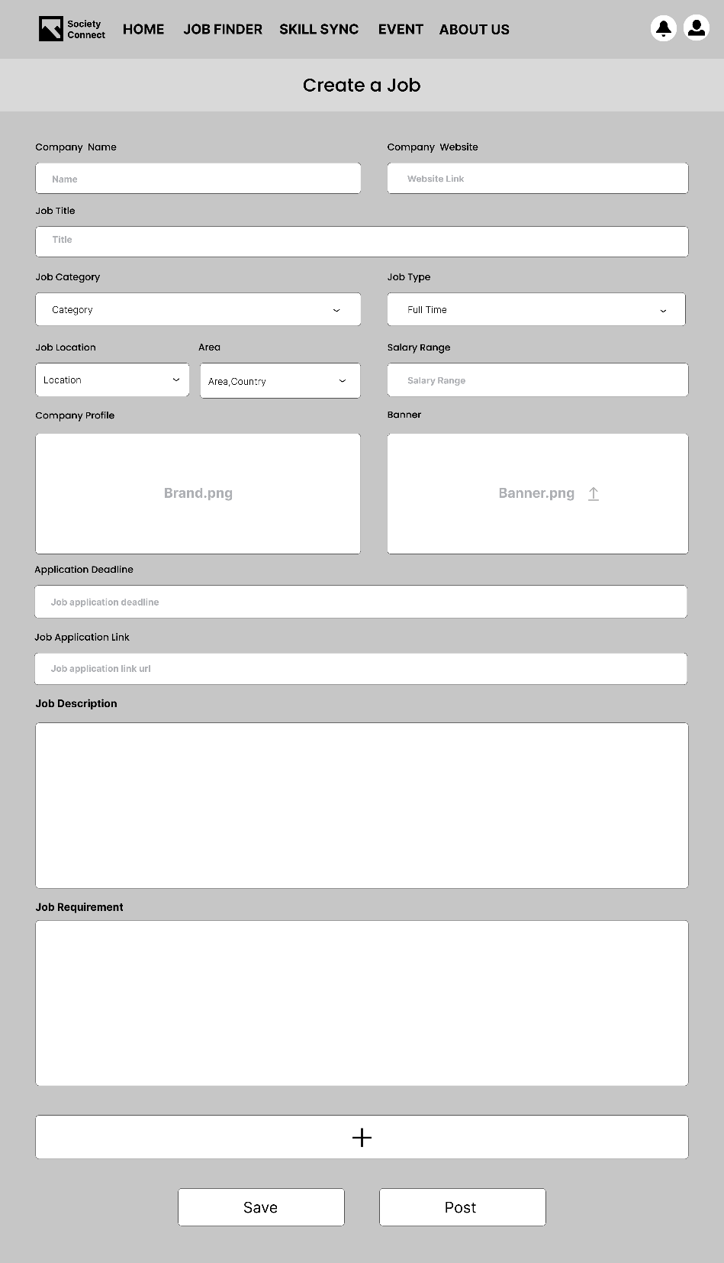

Figure : Create Job Webpage Post Wireframe

The picture above is a blueprint for Create Job Webpage before we develop the website. This page of wireframe is specialized for the posting job finder post.

### 2.3.6 Create Lesson Webpage

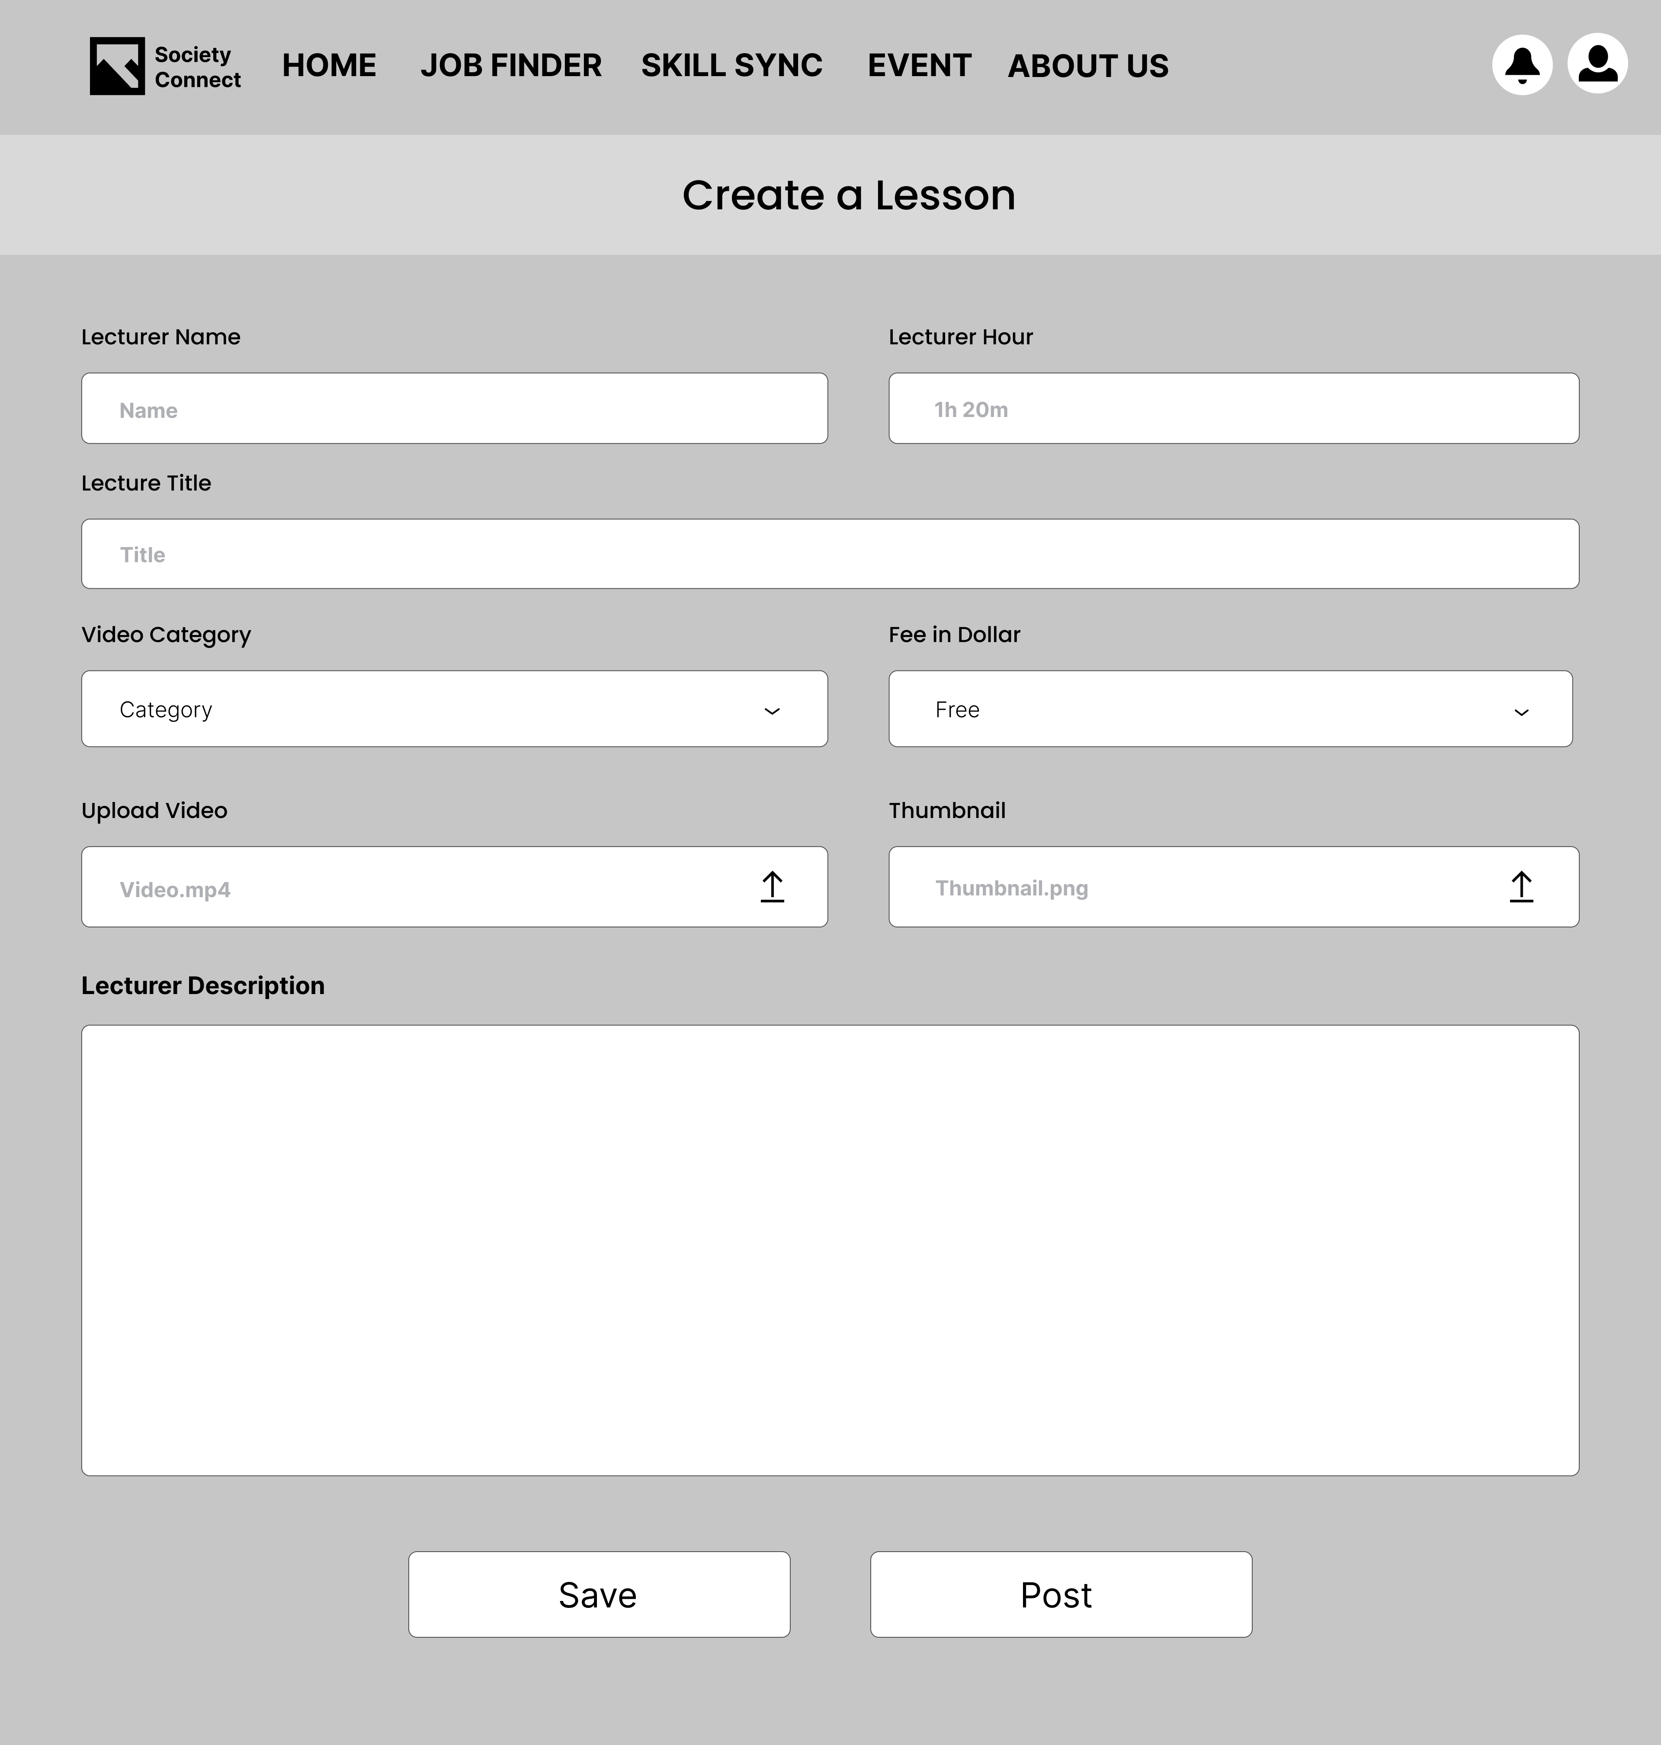

Figure 8: Create Lesson Webpage

The blueprint above is for Create Lesson Page before we develop our website. The wireframe is specialized for the posting skill sync post.

### 2.3.7 Create Event Webpage

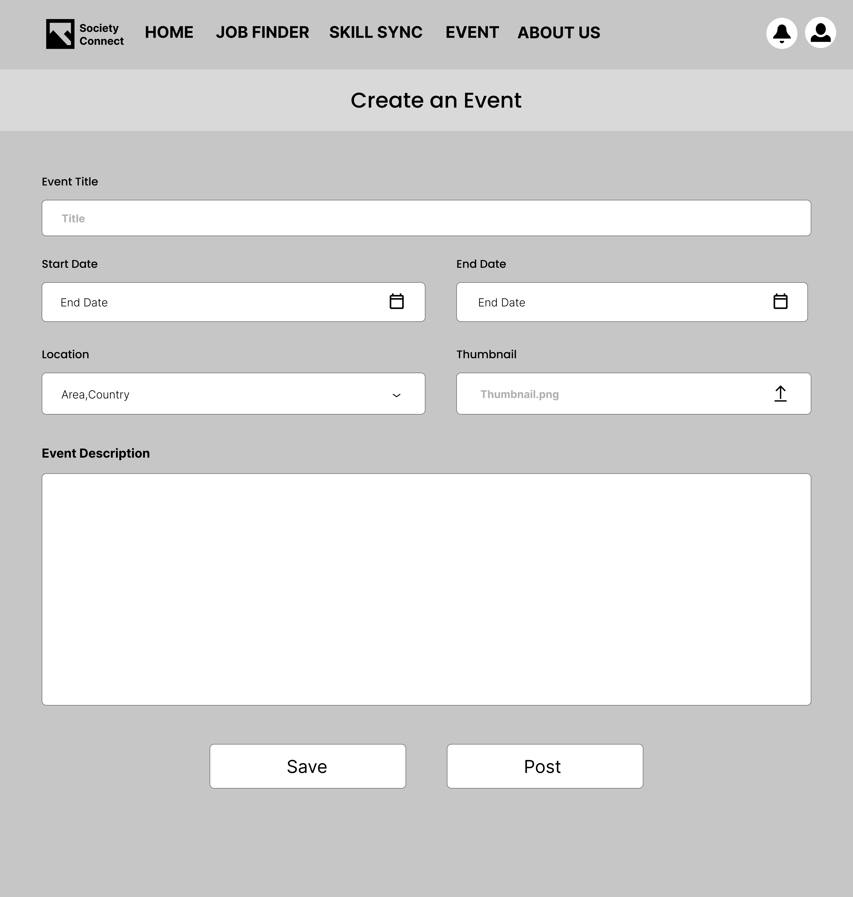

Figure 9: Create Event Webpage

The picture of blueprint above is for Create Event Webpage before we develop the website. The wireframe is specialized for the posting event post.

### 2.3.8 Profile Main Page

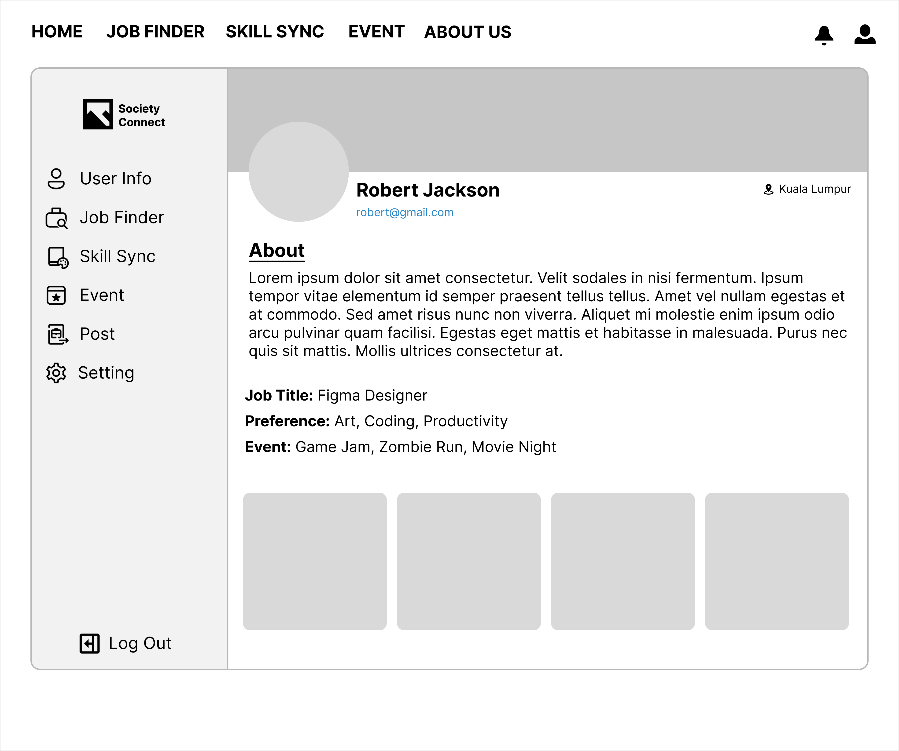

Figure 10: Profile Main Page

The blueprint above is for Profile Main Page before we develop the website. Users will have access to this page if they have their account logged in.

### 2.3.9 Job Finder Subpage

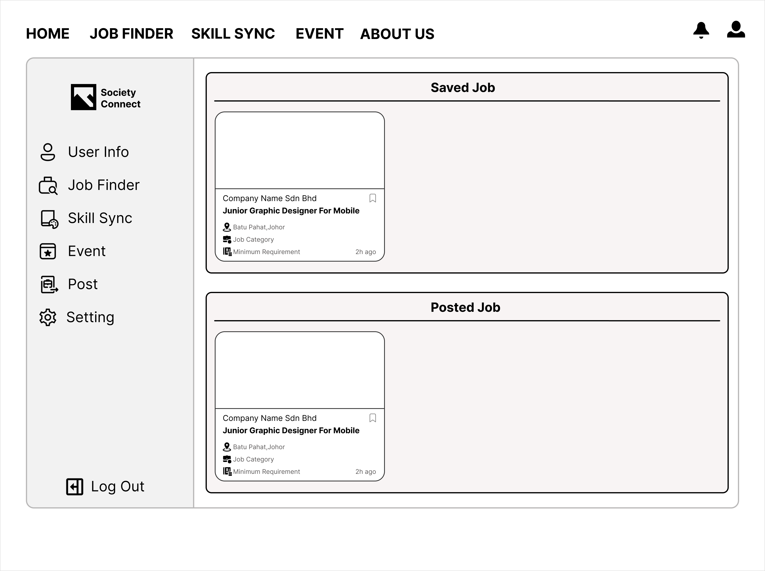

Figure 11: Job Finder Subpage

The picture above is a blueprint for Job Finder Subpage before we develop the website. The subpage will display the job finder post bookmarked by the user and as well as the job finder post that posted by the user.

### 2.3.10 Skill Sync Subpage

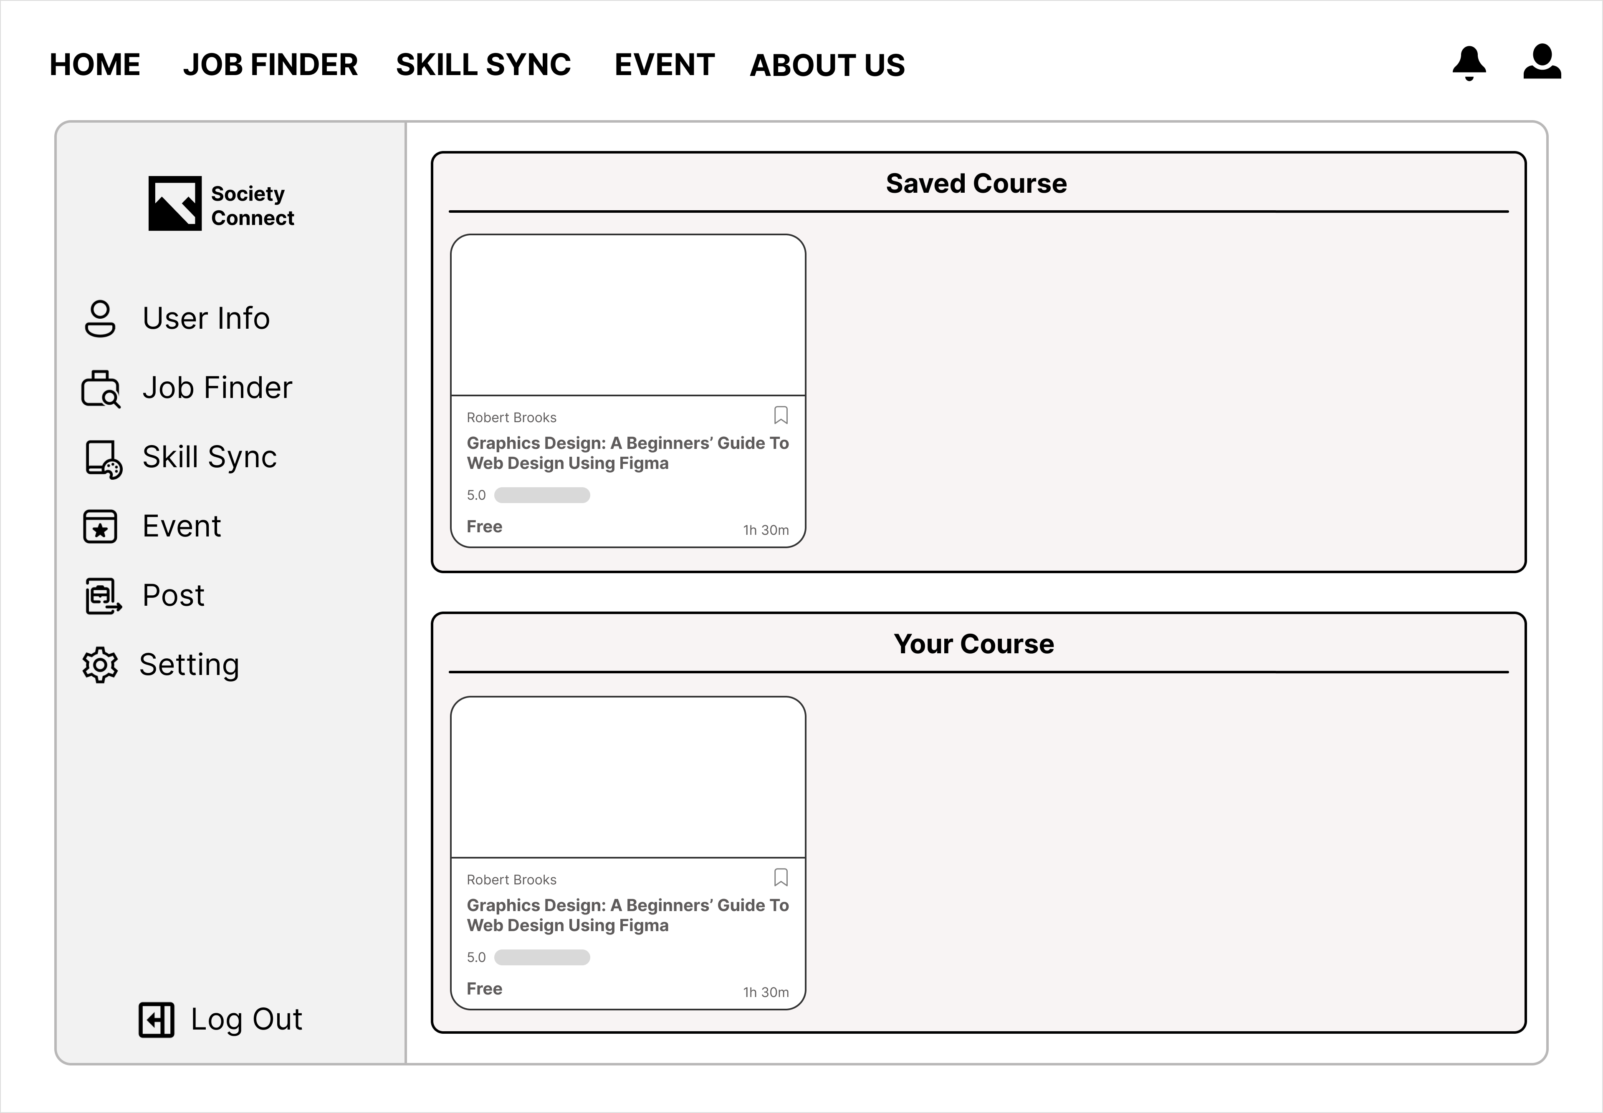

Figure12: Skill Sync Subpage

The provided image functions as a design guide for the Skill Sync Subpage in advance of website development. This subpage will showcase skill synchronization posts bookmarked by the user, along with posts created by the user.

### 2.3.11 Event Subpage

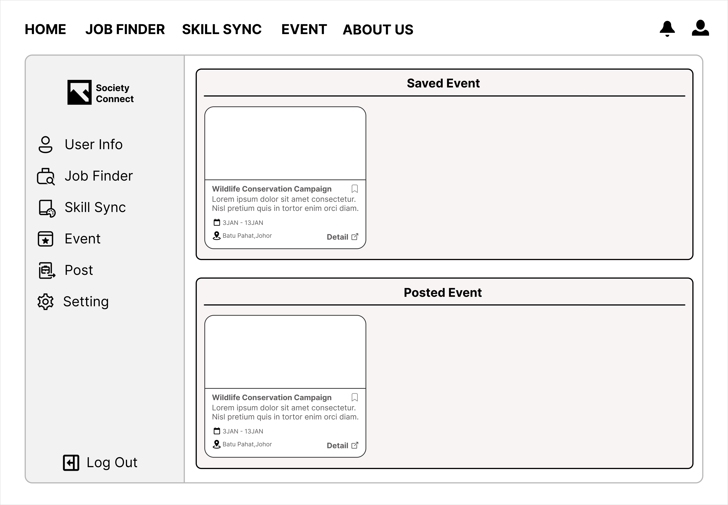

Figure 13: Event Subpage

The picture above serves as a blueprint for Event Subpage before we develop the website. The subpage will display the event post bookmarked by the user and as well as the event post that posted by the user.

### 2.3.12 Post Subpage

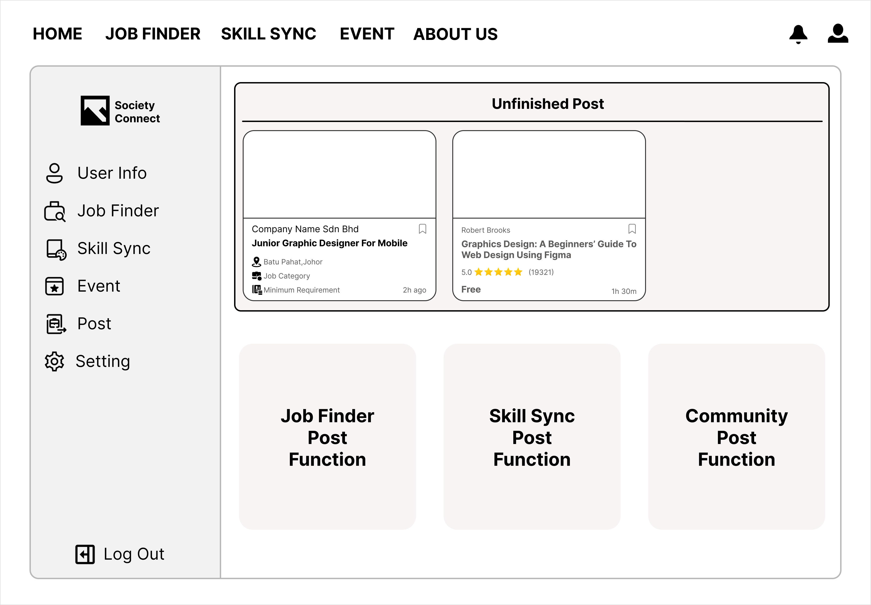

Figure 14: Post Subpage

The depicted image acts as a design blueprint for the Post Subpage in preparation for website development. This subpage will present both incomplete posts and the posting functionality for users.

### 2.3.13 Setting Page

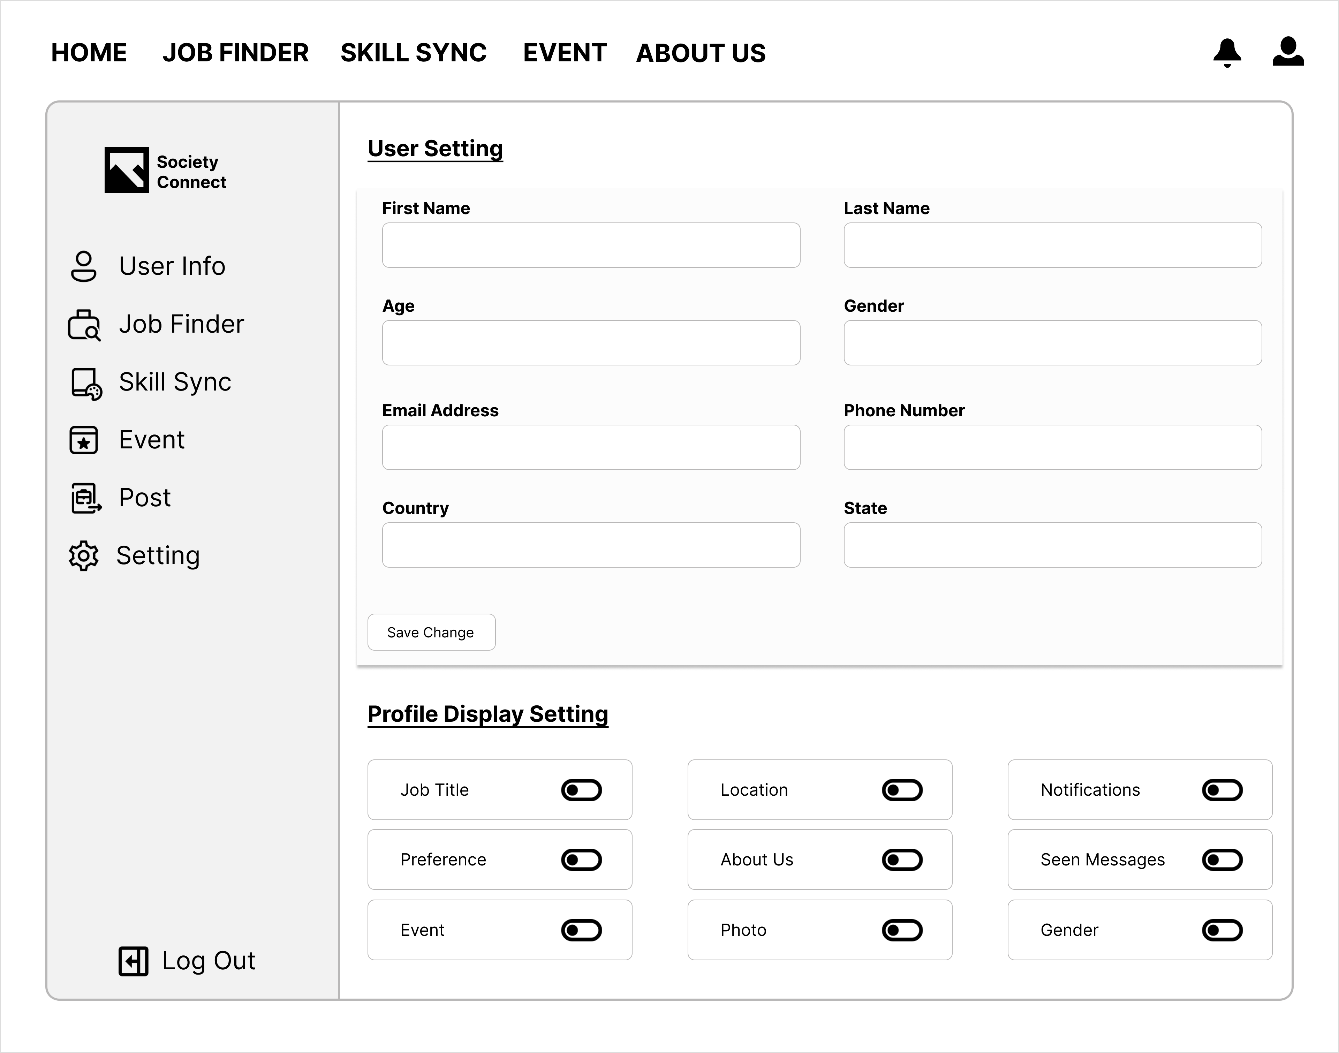

Figure 15: Setting page

The image provided functions as a blueprint for the Setting Subpage ahead of website development. This page is intended for users who wish to modify their user information, providing a platform for updates.

### 2.3.14 About Us Page

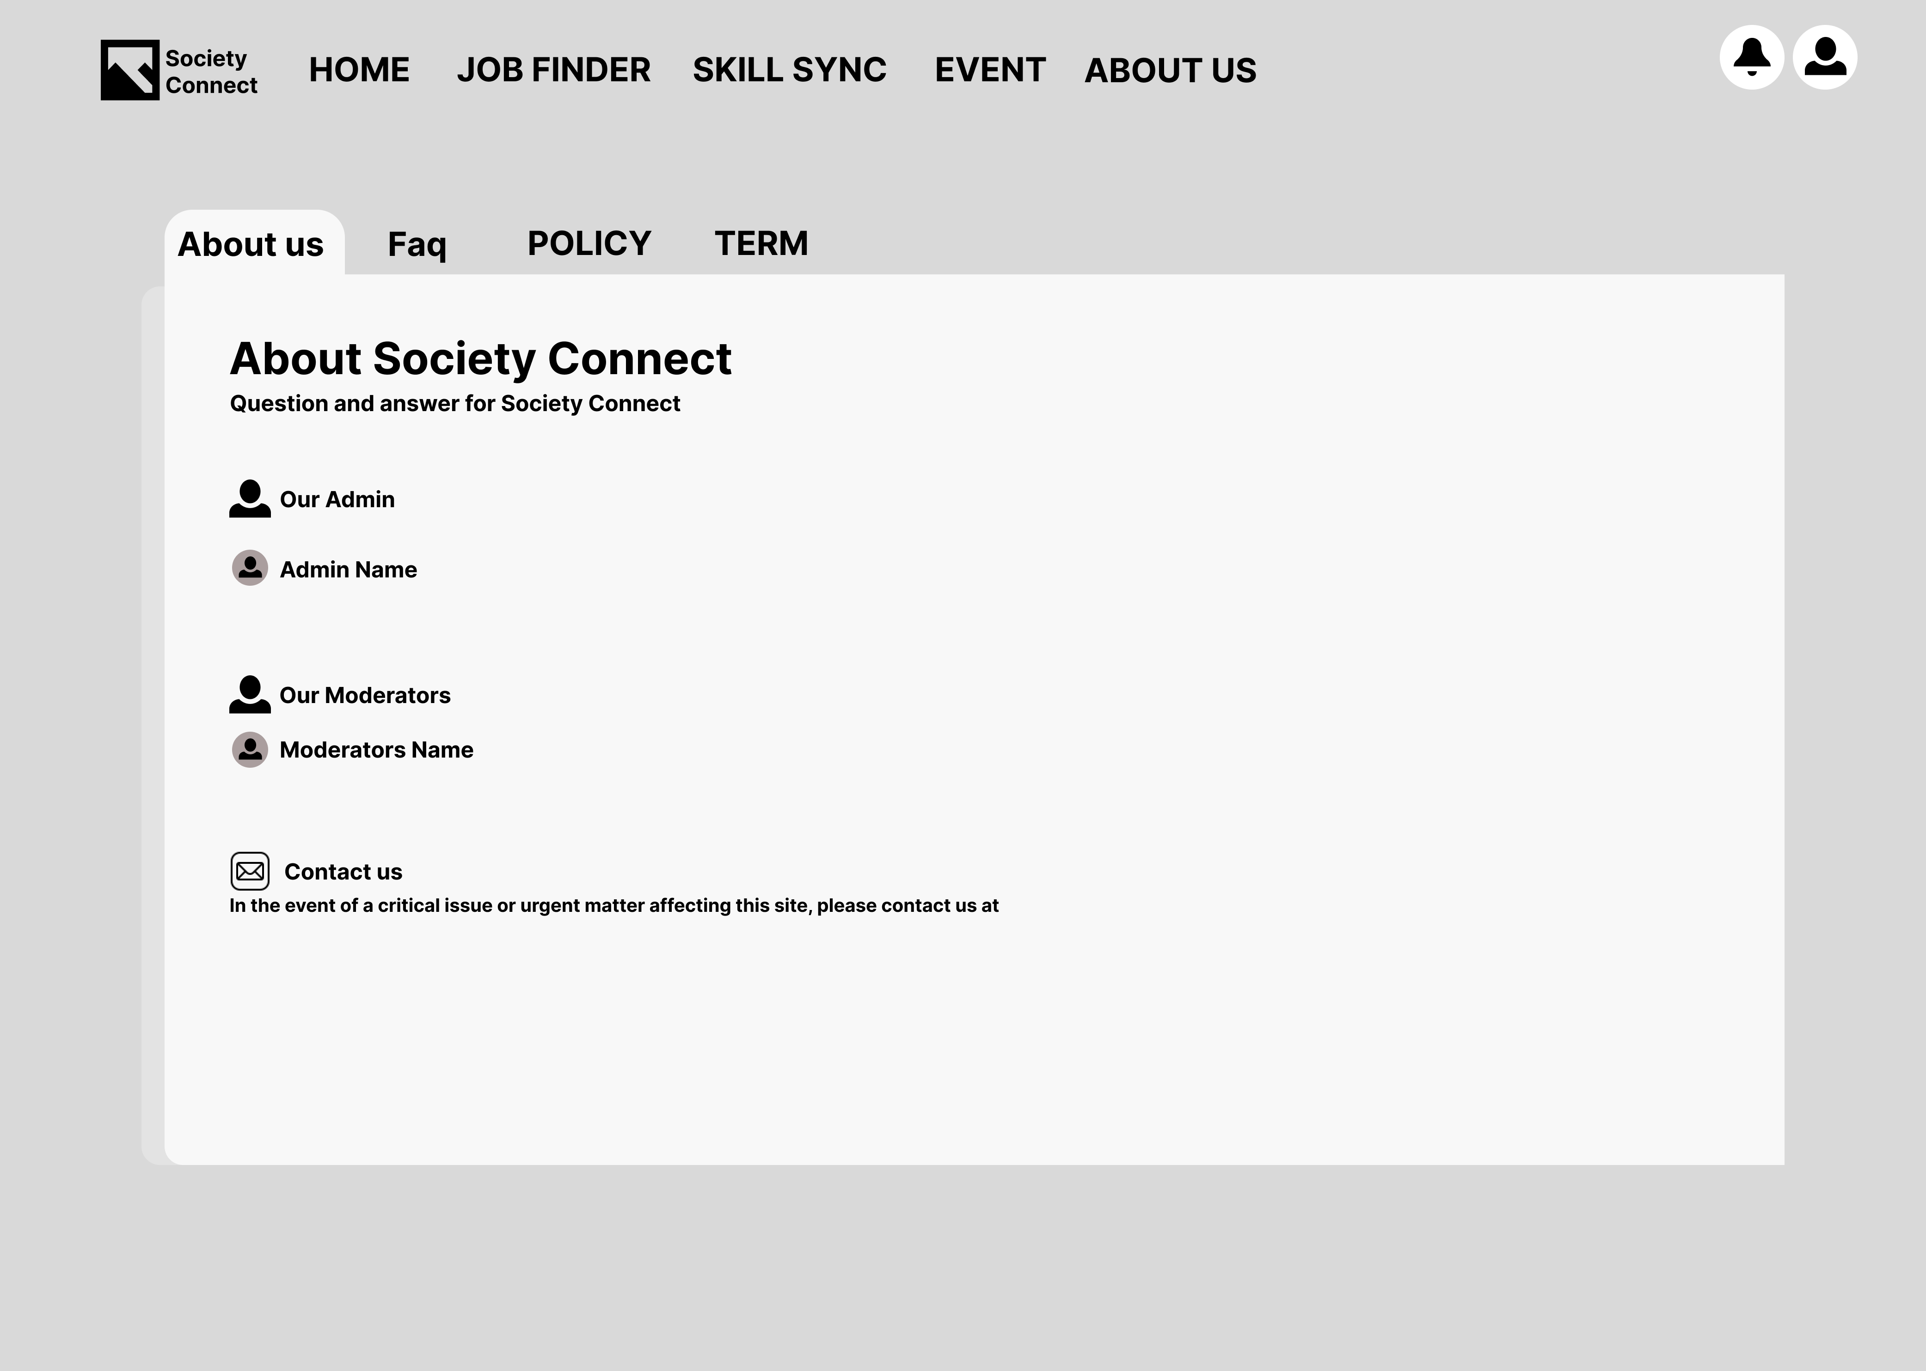

Figure 16: About Us Page

The image above acts as a design framework for the About Us Page in preparation for website development.

### 2.3.15 FAQ

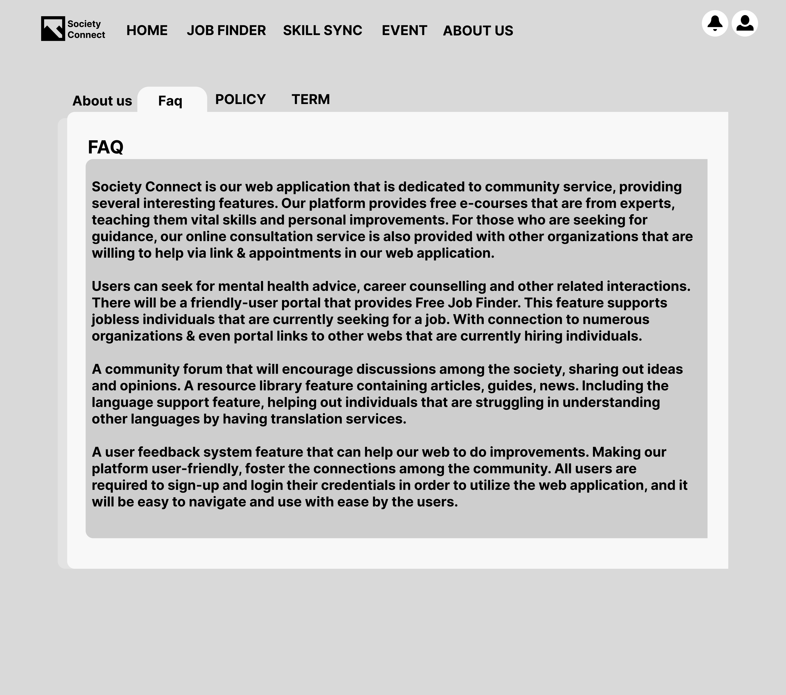

Figure 17: FAQ Page

The depicted image serves as a foundational plan for the FAQ section, outlining its structure and design before website development begins.

### 2.3.16 Private Policy

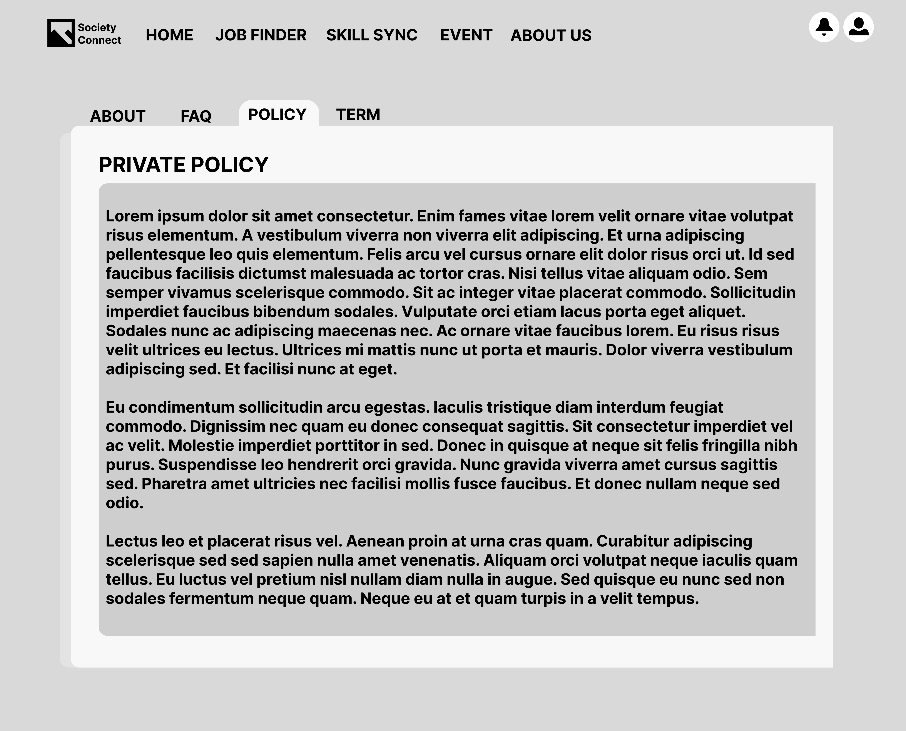

Figure 18: Private Policy Page

The provided image acts as a design guide for crafting the Privacy Policy, outlining its structure prior to website development.

### 3.17 Terms of Use

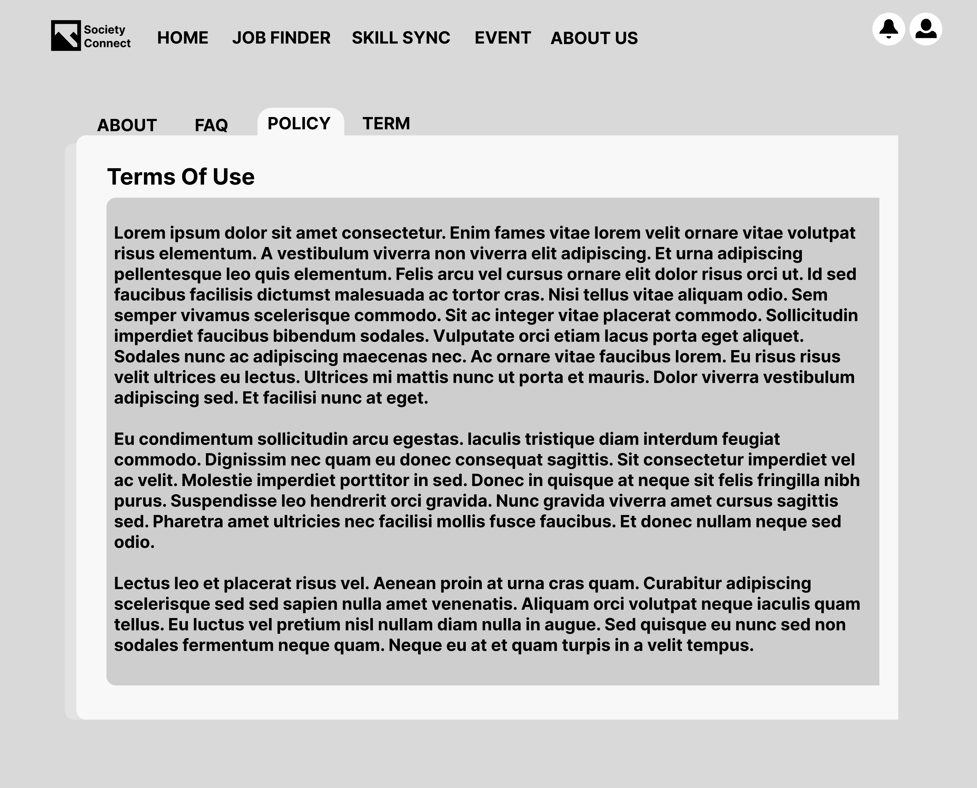

Figure 19: Terms of use page

The presented image functions as a design framework for shaping the Terms of Use section, It's a plan that helps us organize and develop the content that will be user-friendly and clear.

### 2.3.18 Event Review Page

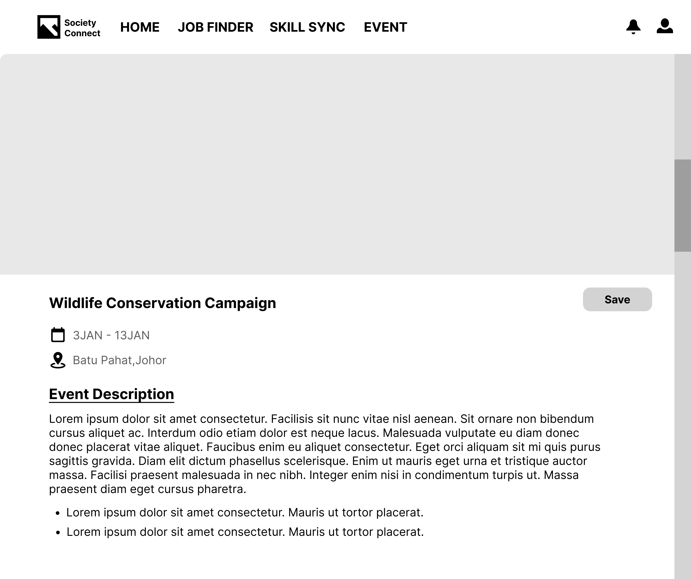

Figure 20: Event Review Page

The image provides a guide for crafting the Event Review Page, tailored for users to share and explore reviews. This dedicated space fosters a community where users can contribute and benefit from shared experiences for future reference.

### 2.3.19 Job Review Page

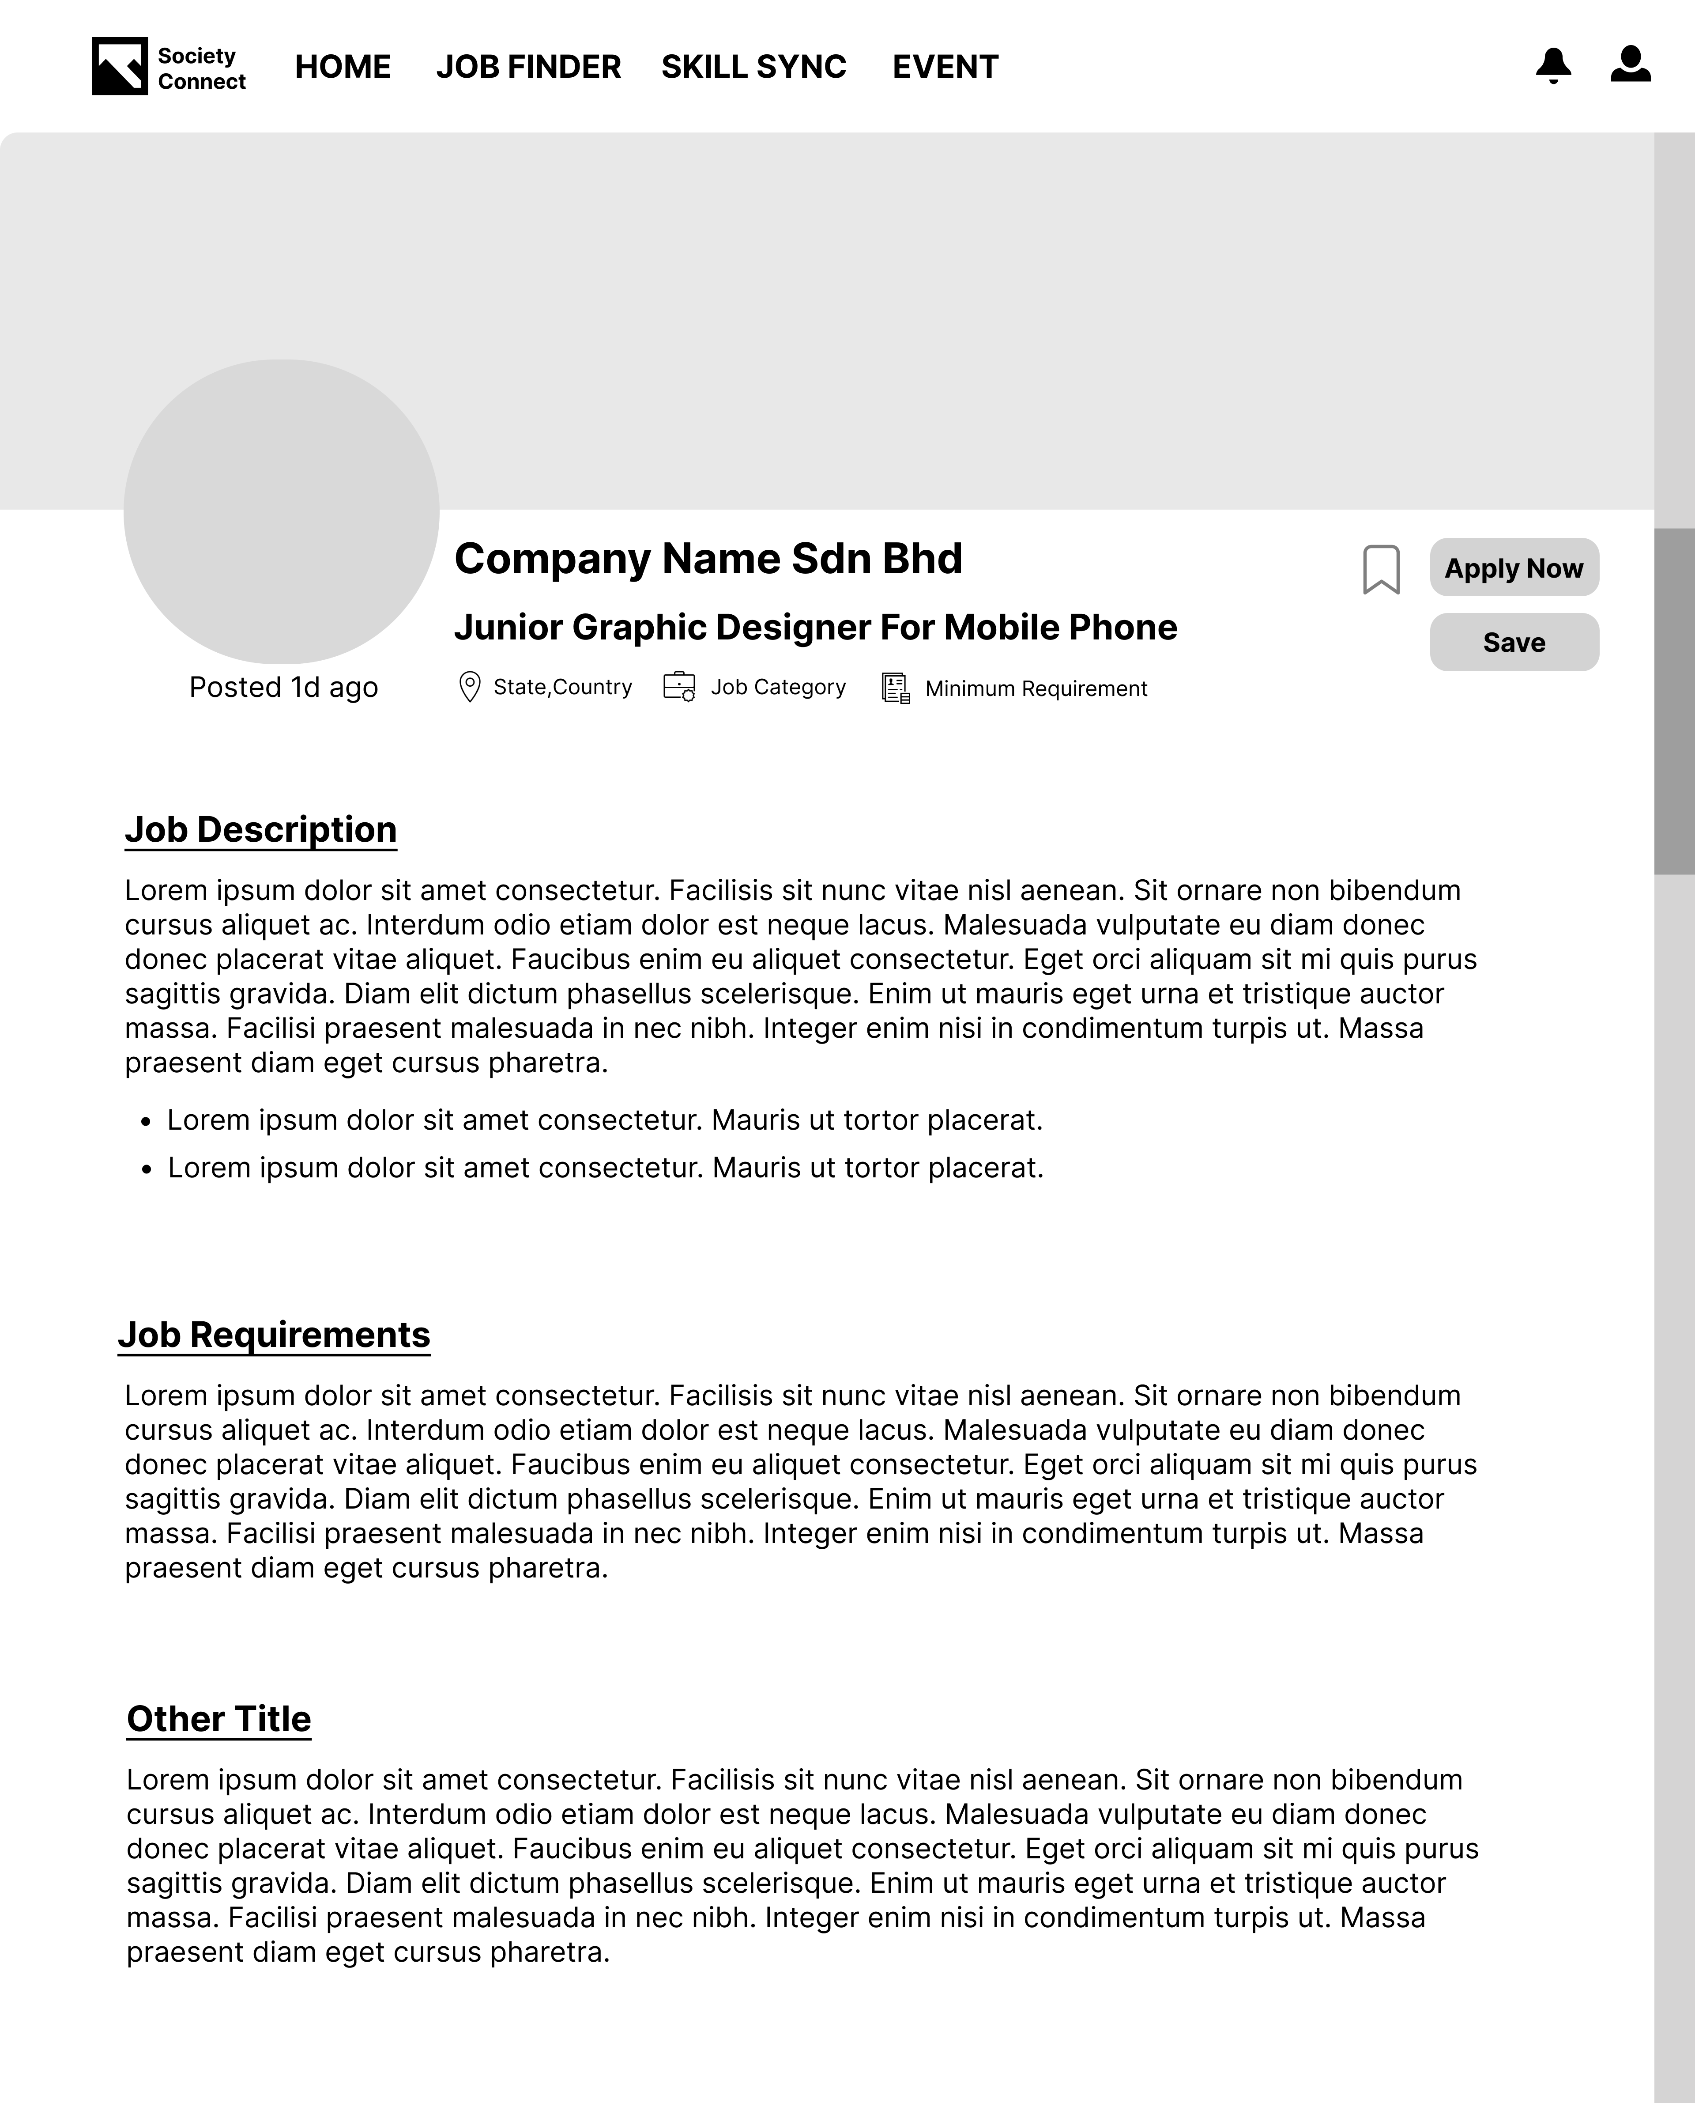

Figure 21: Job Review Page

The picture above serves as a blueprint for Review Page before we develop the website. This web page specialized for user to review or see other user review for future reference.

### 2.3.20 Course Review Page

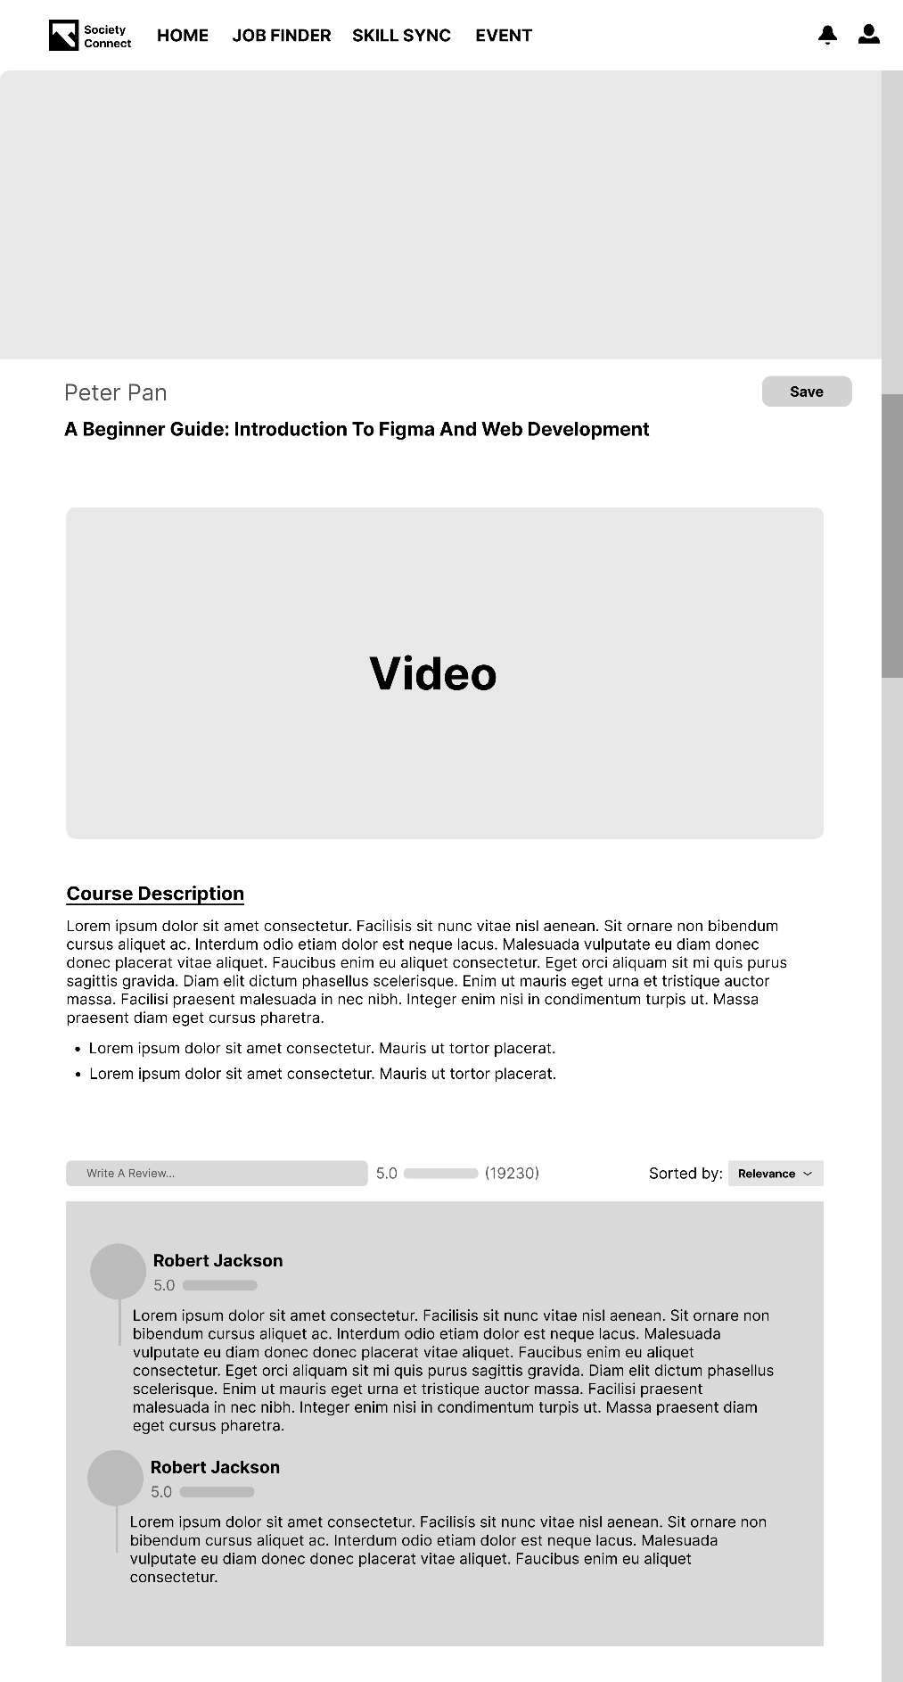

Figure 22:Course Review Page

The picture above serves as a blueprint for Course Review Page before we develop the website. This web page specialized for user to review or see other user review for future reference.

### 2.3.21 Admin

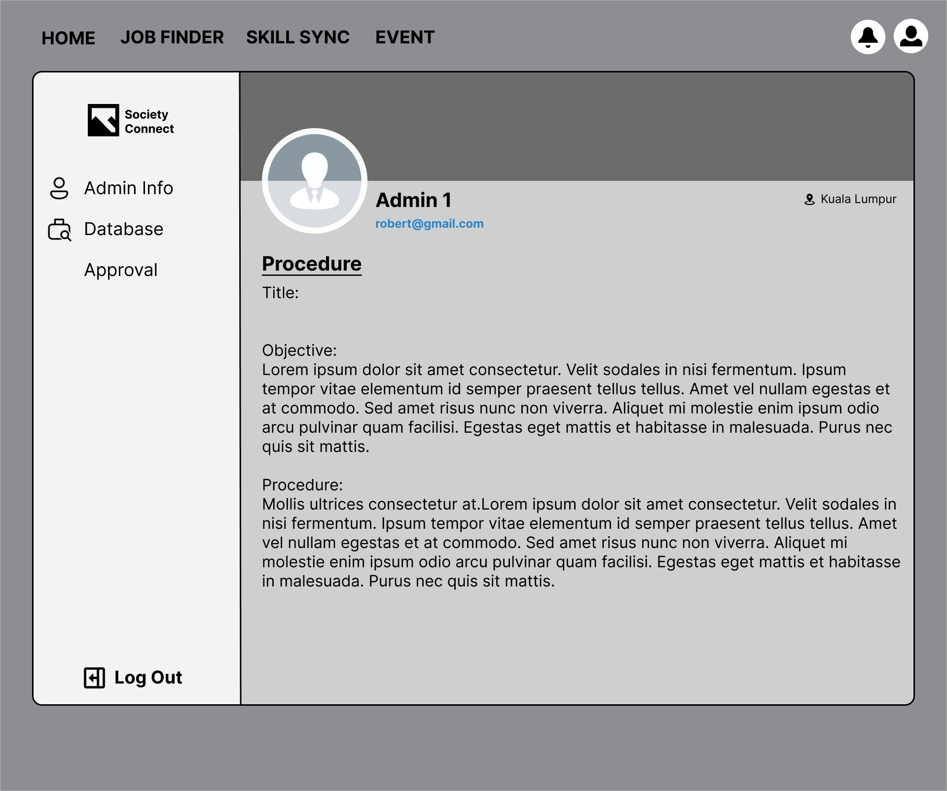

Figure 23: Admin Page

The wireframe above shown the admin information page which if an admin login their account. They will have the access to this page and all sort of tool to manage the database and the web post.

### 2.3.22 Admin information

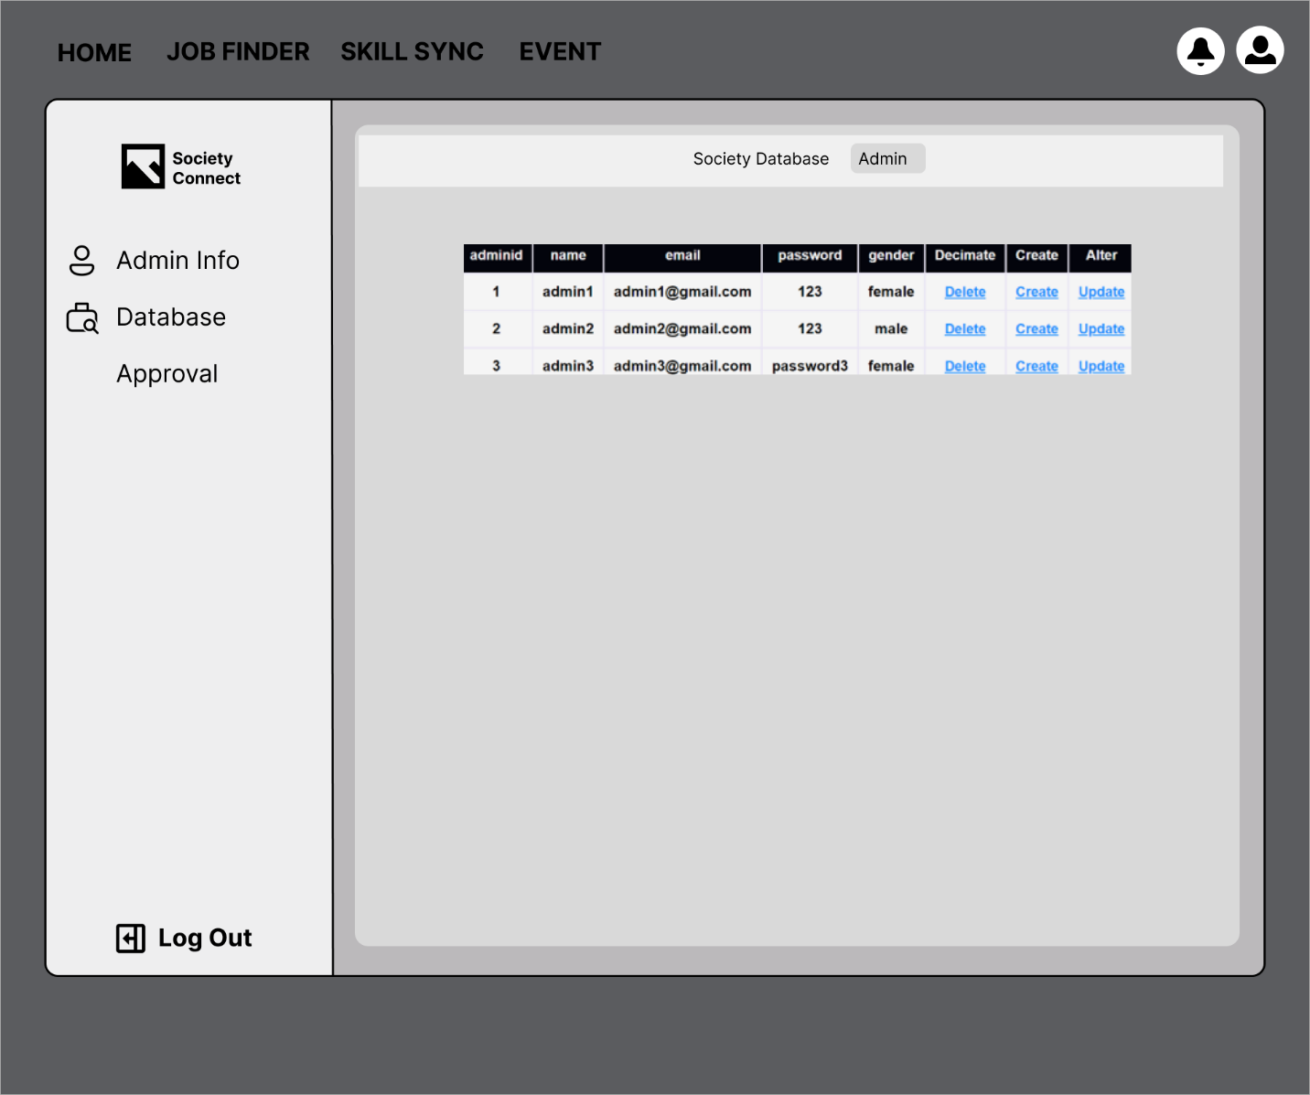

Figure 24: Admin Information Page

This wireframe here is designed for the admin to manage the database. Admins are able to view all of the database and update the database just like the wireframe above shown. System will display the form according to the database row admin selected.

### 2.3.23 Admin Update data

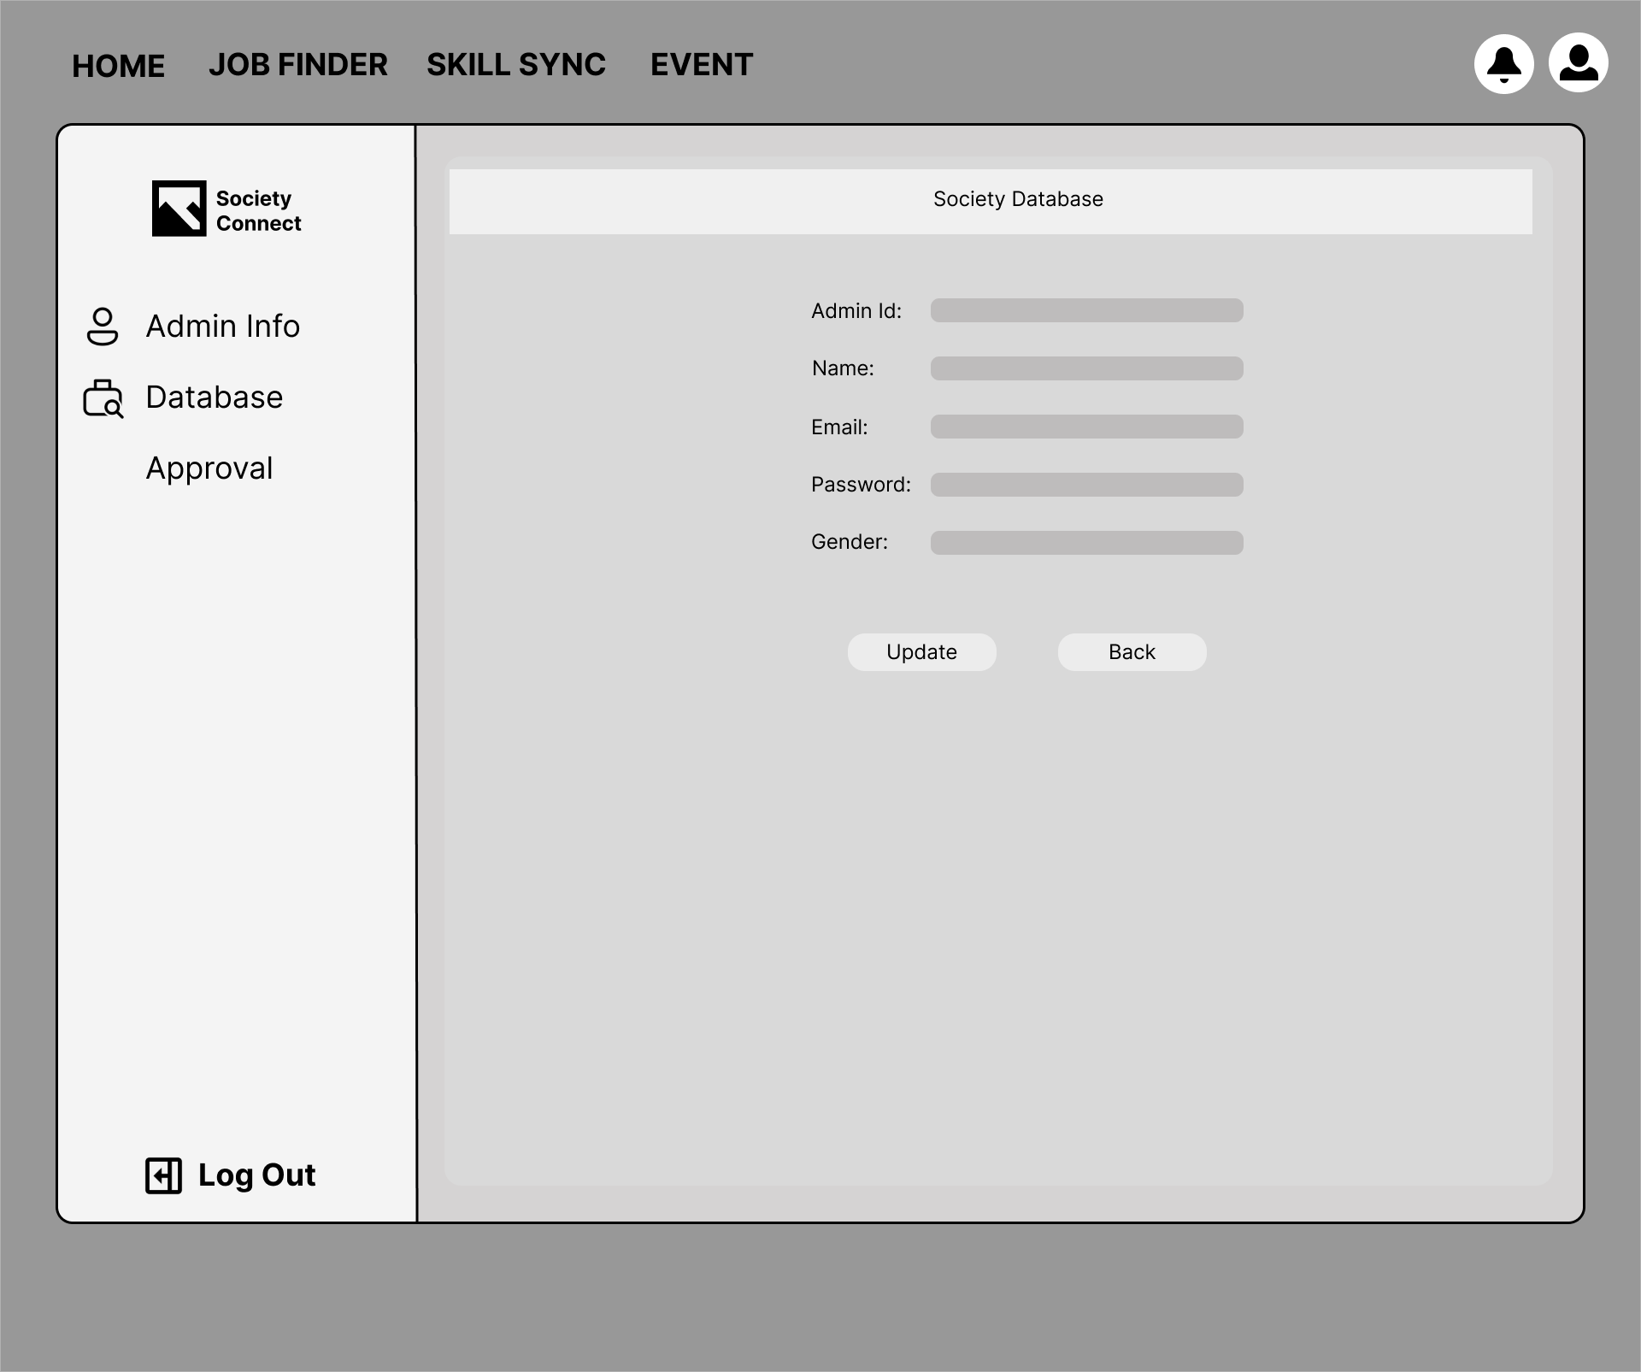

Figure 25: Admin Update Data

This wireframe here is designed for the admin to manage the database. Admins are able to update all of the database information by simply clicking the update hyperlinks. System will display the form according to the database row admin selected just like the picture above shown.

### 2.3.24 Admin Approval or Reject User Post

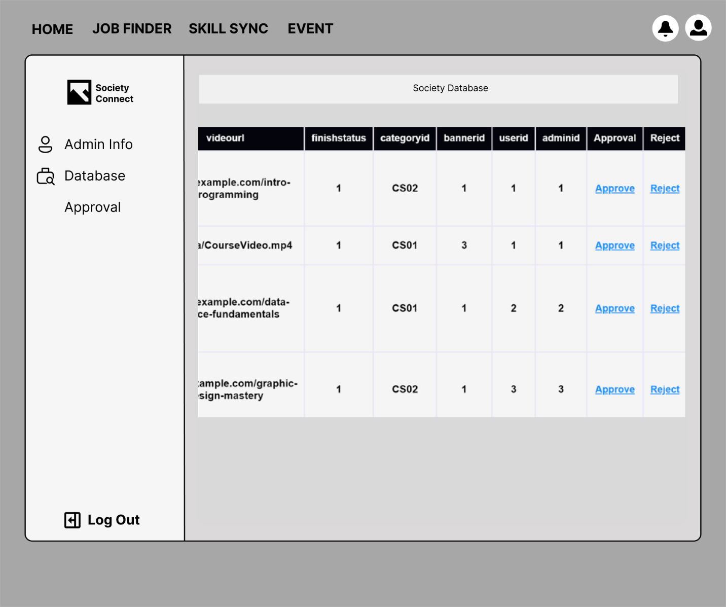

Figure 26: Admin Approval or Reject User Post

The wireframe is designed for the admin approval page. This page will feature the post approval system for the admin. This feature and wireframe will only be displayed for the admin who login their account.

## 2.4 Website Navigational Structure

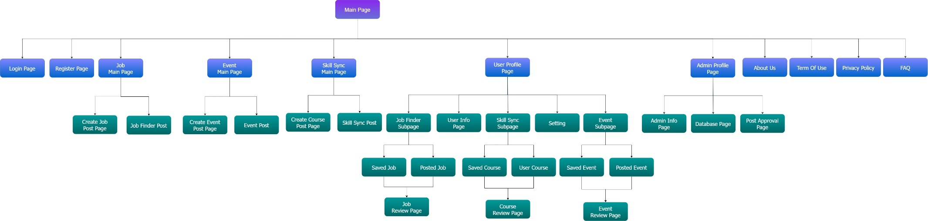

Figure 27: Website Navigational Structure

The website structure of the society can be divided into 6 main parts, User Authentication, Job finder, Skill sync, Event, User Profile, Admin Profile and Footer section. For the user authentication, the users are able to access the sign in and sign-up page by pressing on the main page button. Furthermore, users also can access to the three-core page of our website which is the Job Finder, Event and Skill Sync page. At there, users are able to browse the post depend on the page users have selected (Job Finder Post, Event Post, Skill Sync Post). They can also access to the create post page(create job post page, create event post page and create course post page) if they have login their account. For the login user, they can also access to the user profile page. At there, they can see their own user information and as well as the post they have created (Posted Job, User Course, Posted Event) or they have bookmarked (Saved Job, Saved Course, Saved Event). Then, the users are able to access the setting page via the user profile page. They can change their information whatever they like.

For the admin, they won’t have access to the user profile page. Instead, they are direct to the admin profile page which this page is specialized for managing the web and the database. Admin will also be able to view their information via the profile page. However, they have only two remaining page which is the database page and the approval page. The database page is provided for the admin to alter the database while the approval page is given for the admin to approve or reject the post in the web.

Lastly, the last four pages, which is the about us, term of use, private policy and FAQ page are categorized to the footer page category. This category can be accessed through the main page as well as the footer. These pages are designed for providing essential information and resources for users to understand our company, its operations, and their rights and responsibilities while using our services.

# **3.0 System Implementation**

## 3.0.1 Login Functionality

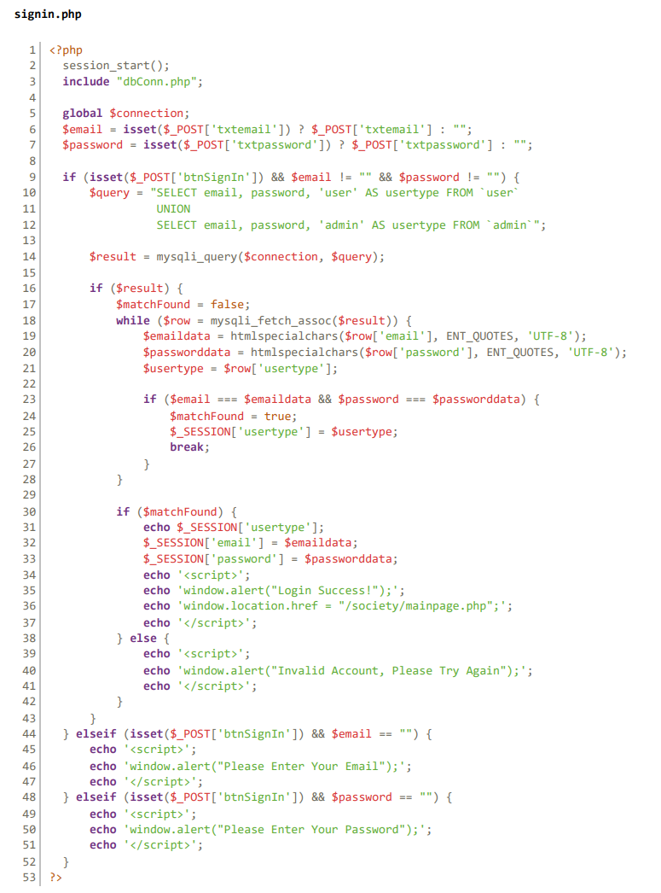

Figure 28.1 - Login Functionality Code

The sign in functionality source code is located in the signin.php file. The provided PHP code segment is responsible for handling user authentication within a web application. It begins by getting all necessary input value from the <form> input. Two variables, $email and $password, are assigned values from the $_POST super global array, representing the user's input for email and password.



Figure 28.2 - Login Functionality Code

If the sign-in form (btnSignIn) is triggered and both $email and $password is not equal empty, the code will proceed to execute a SQL query that retrieves email and password data from both the user and admin tables using a UNION operation. This allows for a single query to check both user and admin credentials.



Figure 28.3: - Login Functionality Code

The query is then iterated over the "while" loop to compare the user input with the actual value in database. If a match is found, the php will assign the corresponded value to the $_SESSION[]. Three value, $email, $password and $usertype will be obtained from this loop. Lastly, a JavaScript code will display a success message to the user and the user will be redirected to the main page of the application.



Figure 28.4 - Login Functionality Code

If there is not match found, the JavaScript will alert the user an error messages and redirect the user to the sign in form again.

## **3.0.2 Register Functionality**

A register functionality is implemented for those users who desired to access more features on our platform.

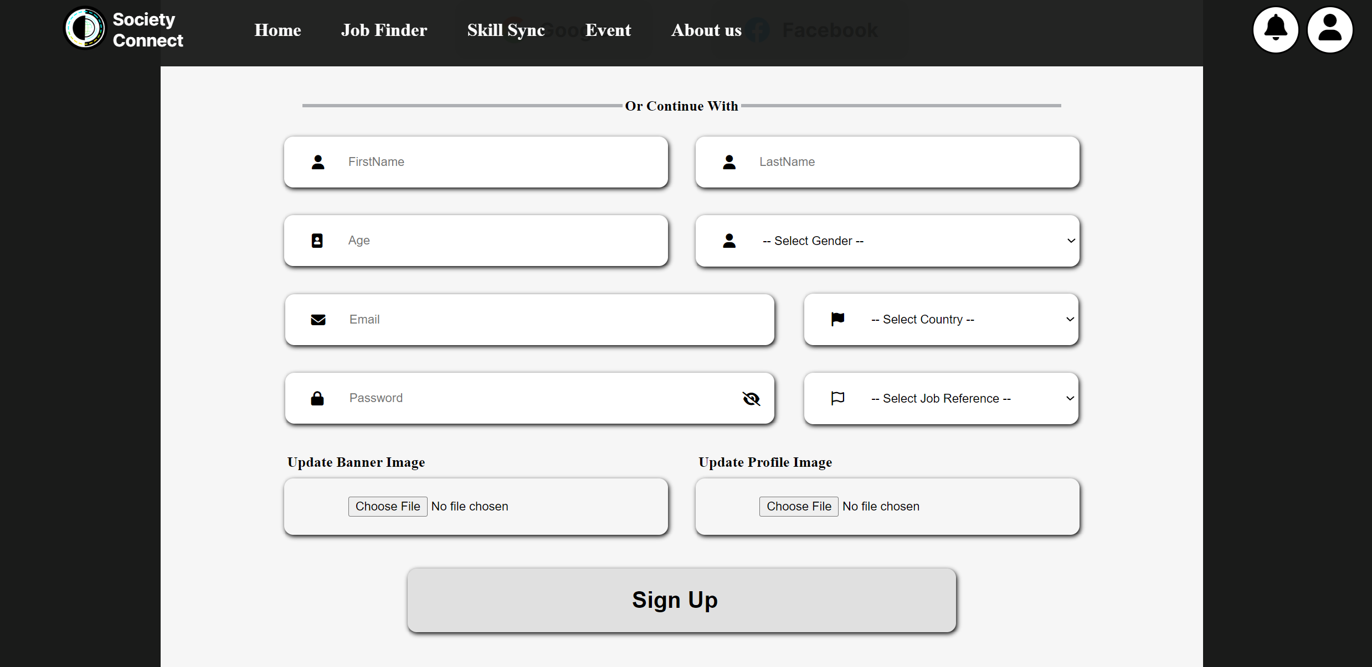

Figure 29.1 - Register Functionality Code

The PHP code signup.php built up the register functionality on our platform. The PHP code starts with initializes variables to store form data such as event title, start date, end date, country, and event description. These variables are populated with values submitted through the POST requests. If the variables are unavailable, they will be set to empty strings. The code then handles the logic for posting based on button clicks.

The code then checks if the "Sign Up" button is clicked and ensures that all required fields are filled. It verifies the uniqueness of the email by querying the database for existing email addresses. If the email is unique, the code proceeds to upload and insert profile and banner images if provided, storing their paths in the database.

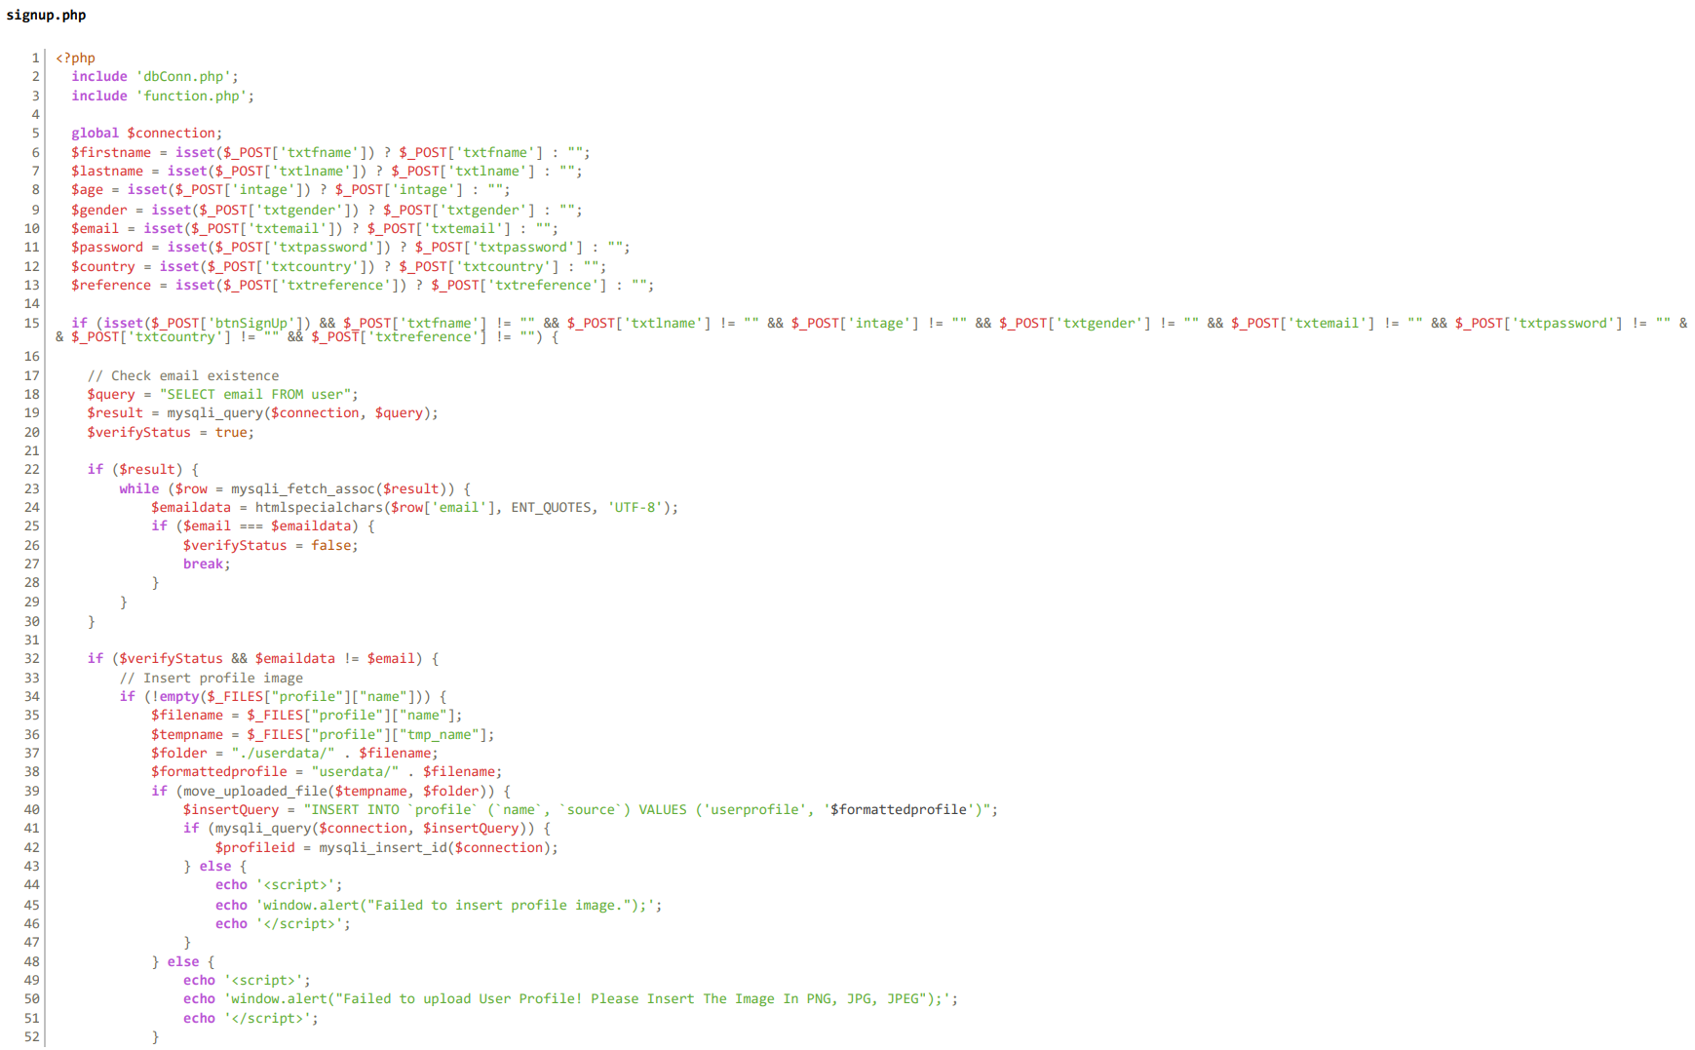

Figure 29.2 -Register Functionality Code

Next, the code prepares an SQL INSERT statement to add the user's data into the user table in the database. It binds the variables to the statement parameters and executes the query. If the insertion is successful, a success message is displayed, and the user is redirected to the main page. Otherwise, error messages are displayed, and the user is redirected back to the sign-up page.

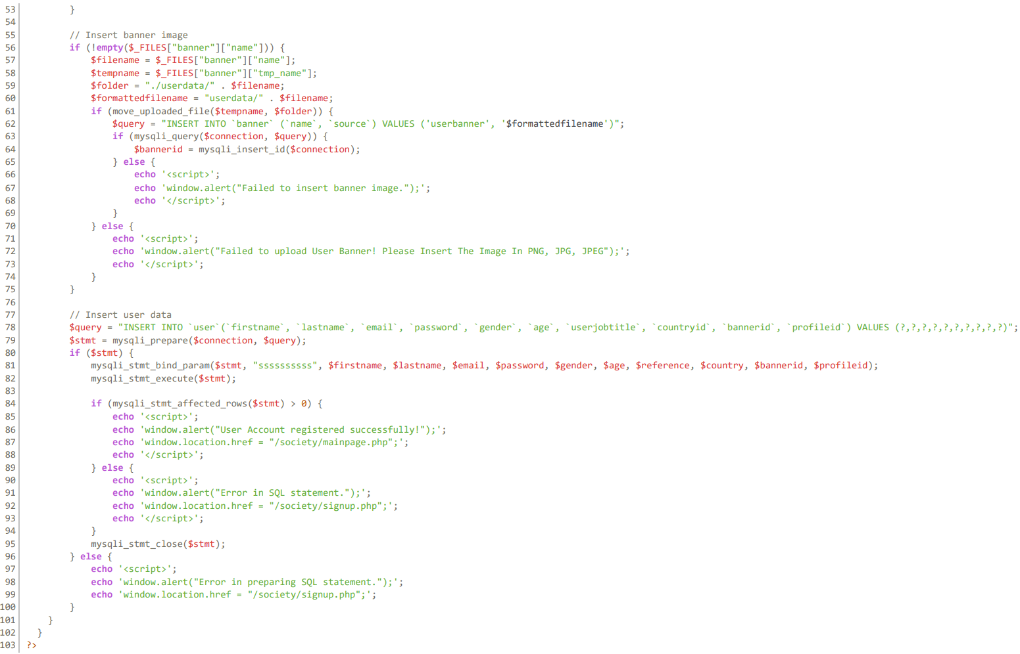

Figure 29.3 - Register Functionality Code

## **3.0.3 Search Functionality**

Our website has three main search bars, which these three are located in the job finder, skill sync and event page. The search bars can be classified into two categories. The first category structure is a three-column style search bar that the picture shown below. This type of bar is located in the job finder and the event page.

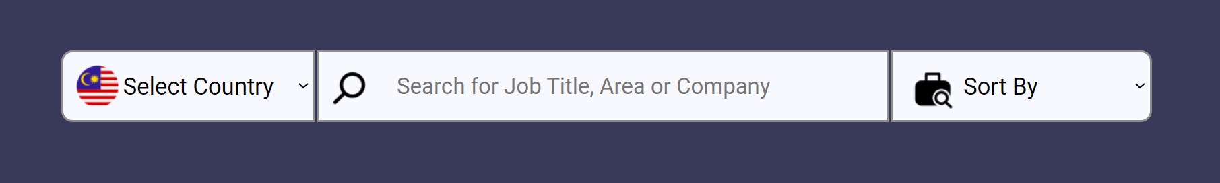

Figure 30.1 - Search Functionality Design

The program logic started by fetching the user input from the html <form> attributes. With the help of the JavaScript function. Below is the example of the event.php search functionality.

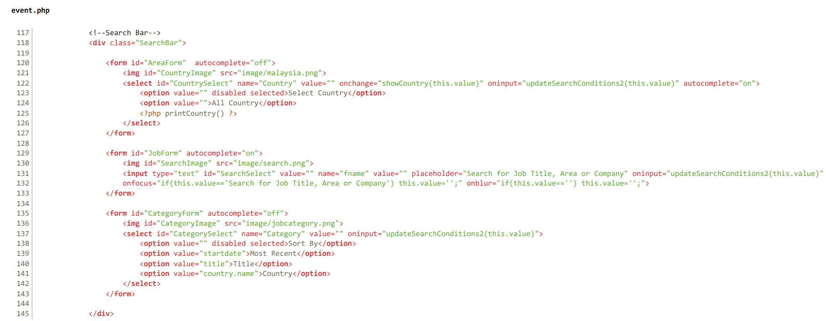

Figure 30.2 - Search Functionality Code

The updateSearchConditions2() function combine the user input and pass it to the executeQuery2() function. The executeQuery2() function will fetch the post from database that match the user input.

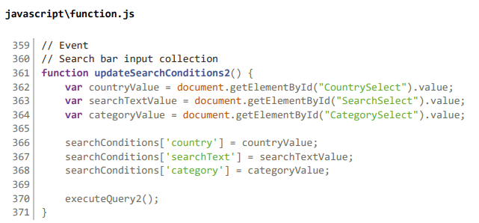

Figure 30.3 - Search Functionality Code

The executeQuery2() function is to construct a query that match the user search input. The function begins by constructing a SQL query string to select data from the eventpost table, joining it with the country table based on matching countryid values. The query filters records where the finishstatus column is '1' (indicating the user finish the post) and the adminid column is not empty (indicating the post is approved by admin).

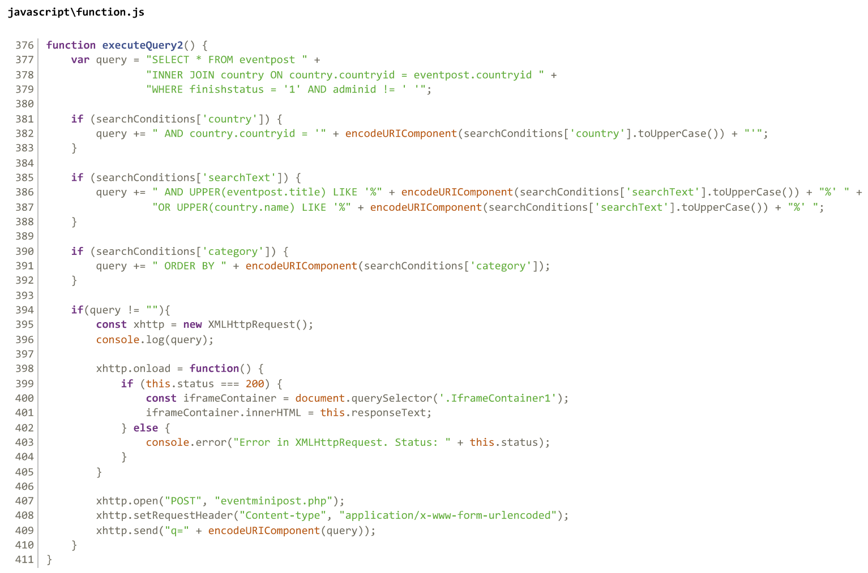

Figure 30.4 - Search Functionality Code

The conditional statements are then used to dynamically append additional criteria to the base query based on search conditions provided in the searchConditions object. If a country value is specified in the search conditions, the query filters result to match the selected country. If a search text is provided, the query filters records where the event title or country name contains the search text, both converted to uppercase for case-insensitive comparison. If a category is specified in the search conditions, the query is ordered by the specified category. The constructed query string is then logged to the console for debugging purposes. Next, an XMLHttpRequest is created to send the query to the server.

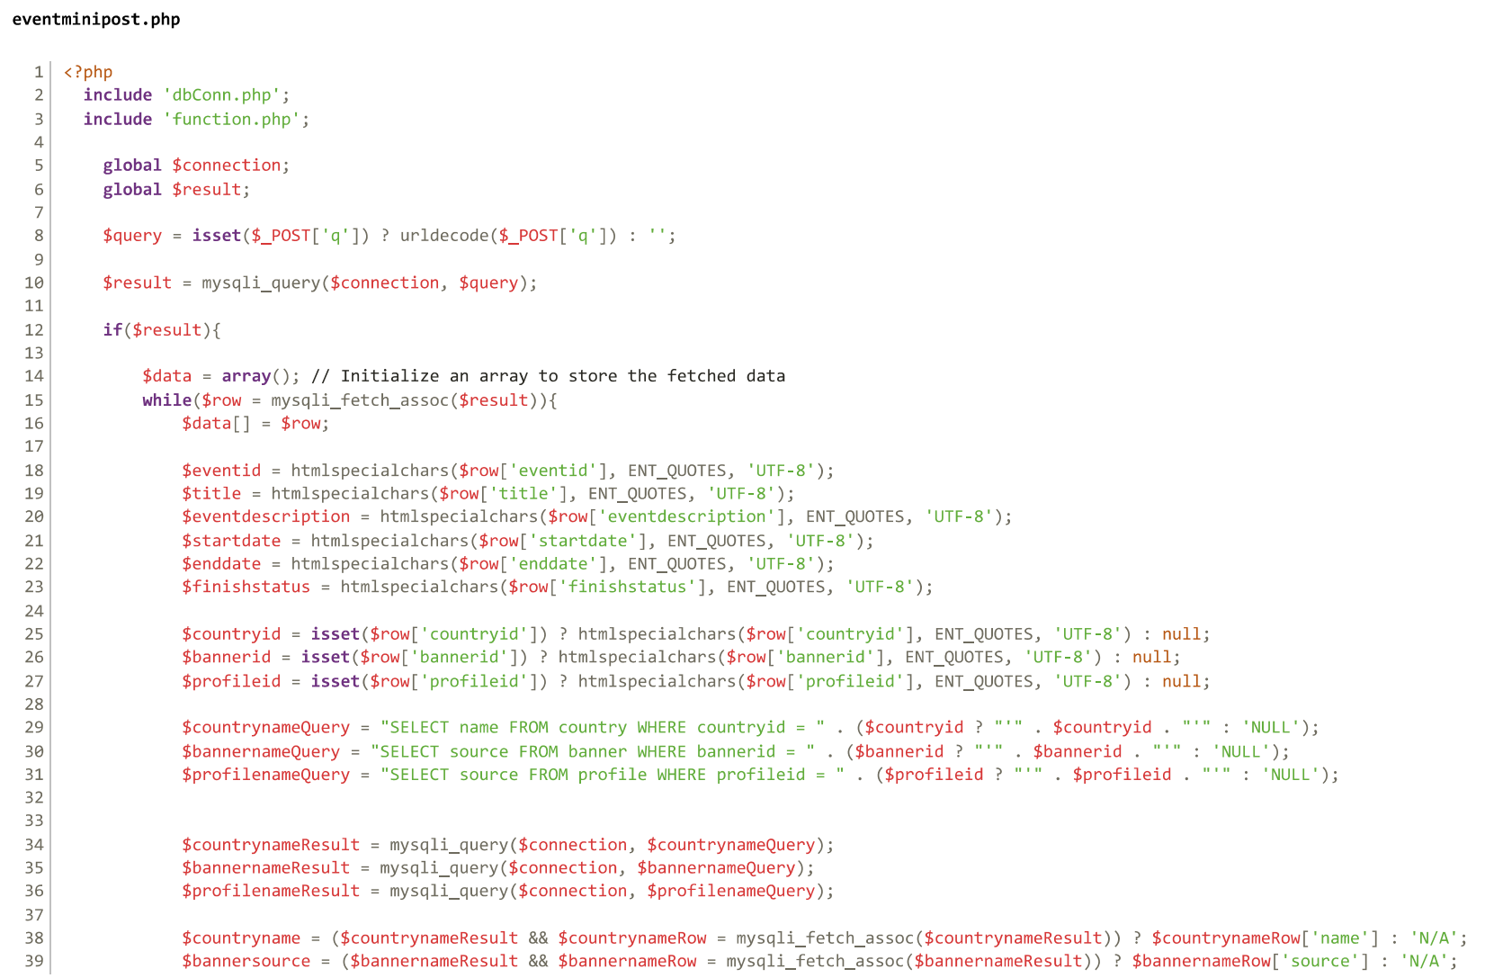

Figure 30.5 - Search Functionality Code

The constructed query will then be sent to the eventmininpost.php. The query then being executed and the matched value are being echo out. The result will then be sent back to the JavaScript function.

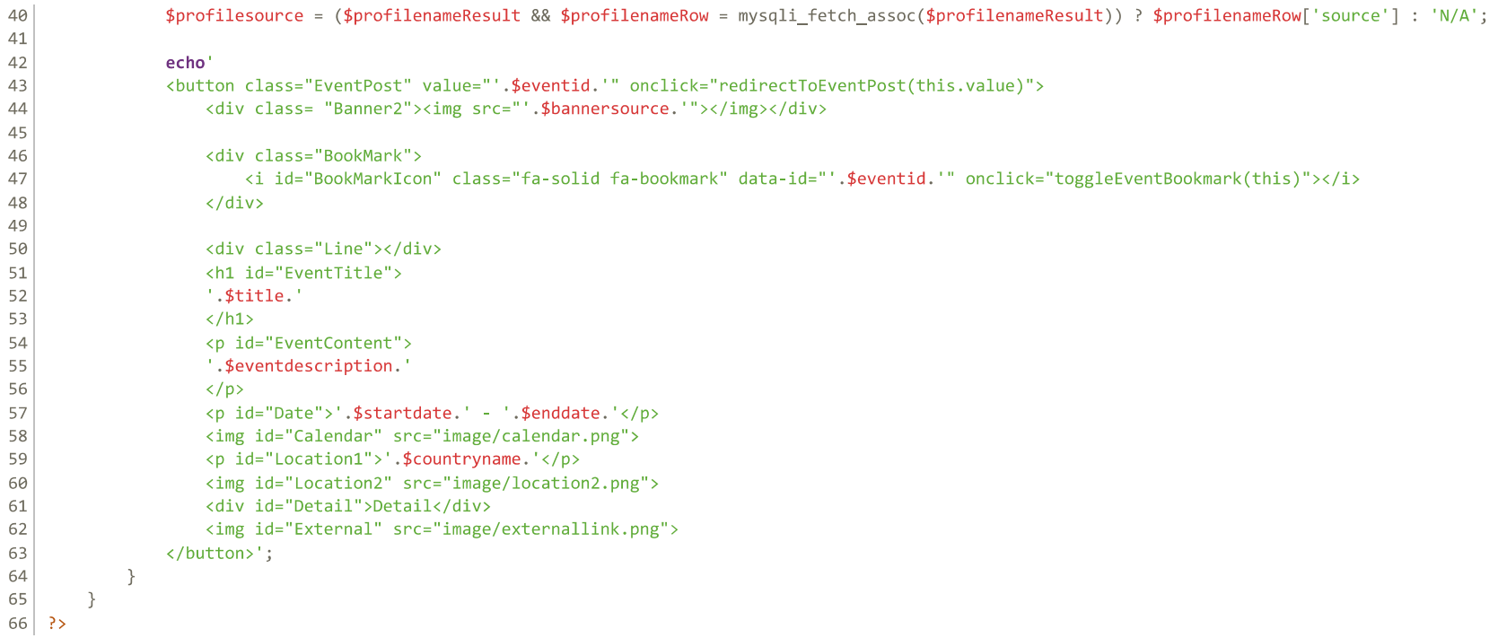

Figure 30.6 - Search Functionality Code

Upon the successful response (status code 200), the content of an HTML element with the class .IframeContainer1 is updated with the received response text(from the eventminipost.php), typically containing dynamically generated HTML content. If the XMLHttpRequest encounters an error, an error message is logged to the console.



Figure 30.7 - Search Functionality Code

Another type of search bar located in the skill sync page. The structure of the search bar is shown below.

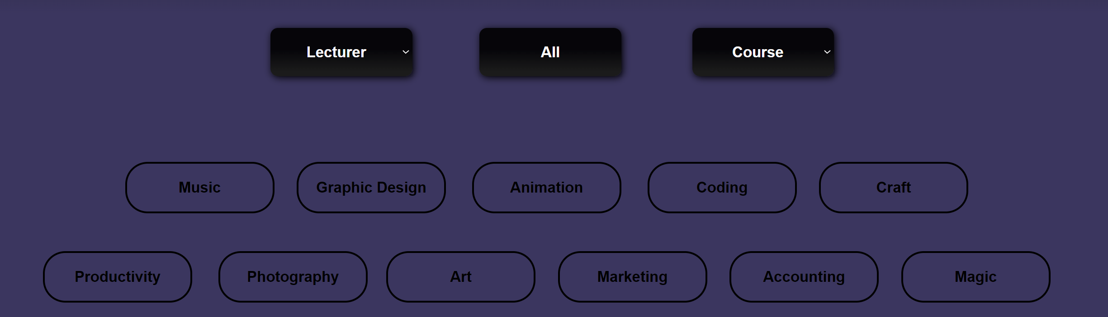

Figure 30.8 - Search Functionality Design

The program logic started by fetching the user input from the html <button> attributes. Whenever a button is clicked, it will trigger their corresponded JavaScript to display the skill sync post according to the button pressed. There is four types of JavaScript involve in the code, updateLecturer(), updateTop(), updateCourse() and updateCategory().

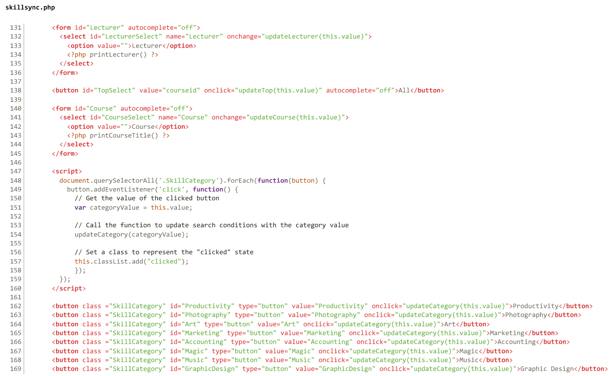

Figure 30.9 - Search Functionality Code



Figure 30.10 - Search Functionality Code

The three function updateLecturer(),updateCourse() and updateCategory() are similar to each other. The only different is the query constructed. While for the updateTop(), it acts as a reset button for the search bar. Once clicked, the system will reset all of the button and display all the post from the database. The four functions have similar code structure too, below are the sample code of the updateLecturer() function.

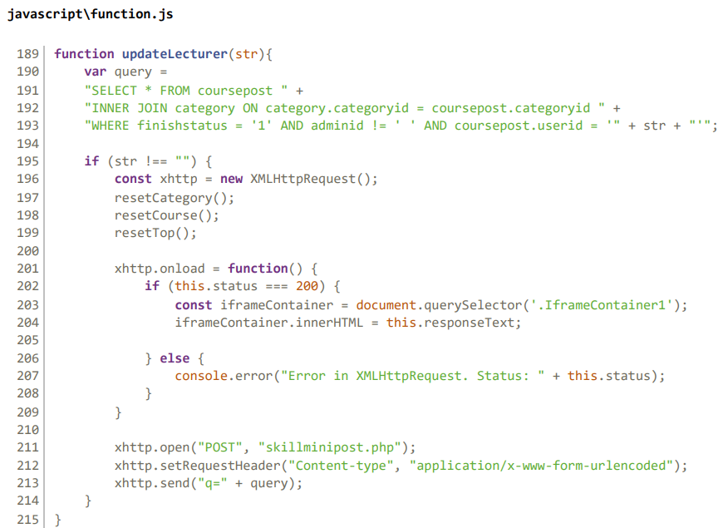

Figure 30.11 - Search Functionality Code

The function starts by contracting a query based on the clicked button. In this case, the lecturer button is selected. Then, the resetCategory(), resetCourse() and resetTop() function are used to reset the other three type of search bar to default value. These four functions have a similar code structure and below is the sample code of the resetLecturer() function.

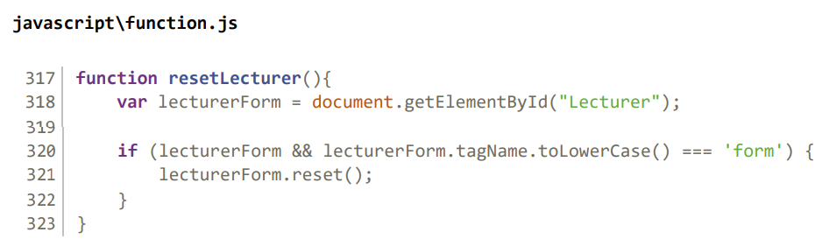

Figure 30.12 - Search Functionality Code

After resetting the form of others, the constructed query is sent to skillminipost.php by XMLHttpRequest. The skillminipost.php are similar to the eventminipost.php, which both of their jobs are to display the post to the web layout based on the query constructed.

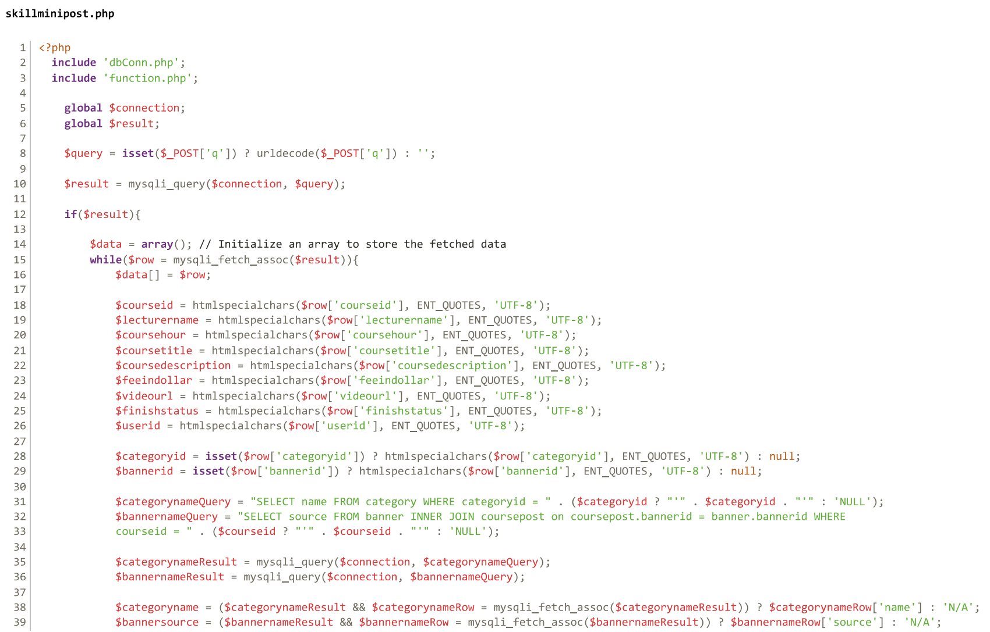

Figure 30.13 - Search Functionality Code

The constructed query will then be sent to the skillmininpost.php. The query then being executed and the matched value are being echo out. The result will then be sent back to the JavaScript function.

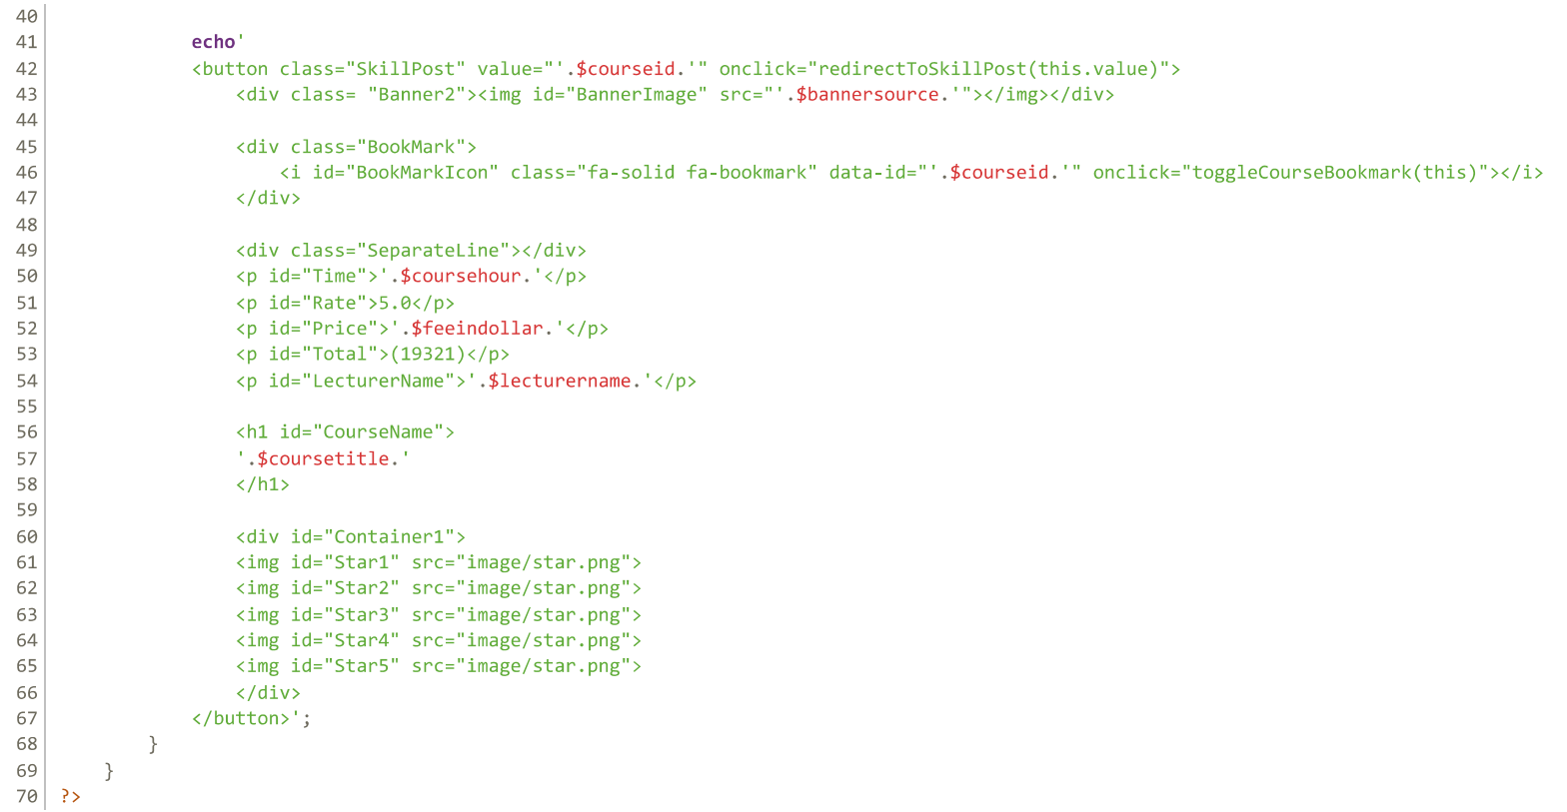

Figure 30.14 - Search Functionality Code

Upon the successful response(status code 200), the content of an HTML element with the class .IframeContainer1 is updated with the received response text(from the skillminipost.php), typically containing dynamically generated HTML content. If the XMLHttpRequest encounters an error, an error message is logged to the console.



Figure 30.15 - Search Functionality Code

## **3.0.4 Bookmark functionality**

The bookmark functionality features the ability for users to save and organize specific post. The job finder, skill sync and event post have the bookmark functionality implemented to enhance user experience and facilitate efficient organization of important information. Below picture below show the event post accompany by the grey clickable bookmark, which located in the right section of each event post.

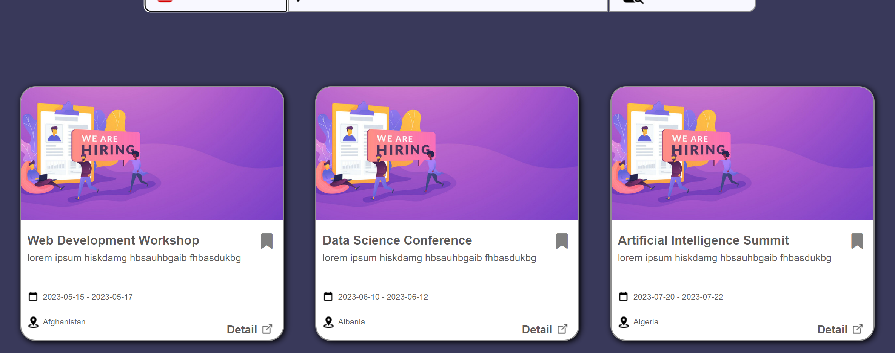

Figure 31. 1 - Bookmark Functionality Design

A bookmark div, along with its corresponding course id value, is dynamically generated and displayed each time a post is displayed on the web. This action happens in the eventminipost.php, skillminipost.php and jobminipost.php, which the program code is previously mentioned in the 3.2 search functionality. Each type of post has the correspond JavaScript Function. In this case, the skill sync post has the toogleCourseBookmark().



Figure 31.2 – Bookmark Functionality Code

Every time when the bookmark is clicked, it will trigger the toggleCourseBookmark() function. The function starts by extracting the unique identifier (ID) of the course from the custom data attribute associated with the icon element. It then checks whether the icon element has the "active" class, which indicates that the course is already bookmarked. If the icon is marked as active, the function calls the removeCourseBookmark(id) function to remove the course from the user's bookmarks. Inversely, if the icon is not active (indicating that the course is not yet bookmarked), the function calls the addCourseBookmark(id) function to add the course to the user's bookmarks.

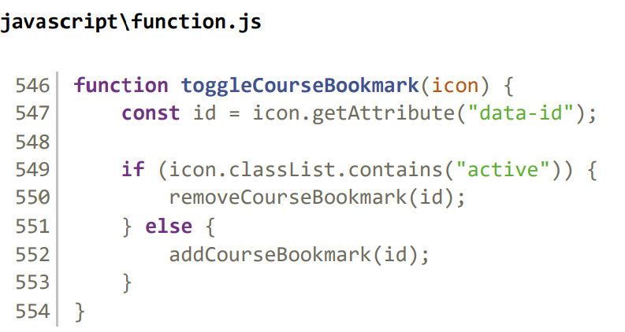

Figure 31.3 - Bookmark Functionality Code

The addCourseBookmark(id) function first selects the icon element associated with the specified ID using a query selector. Then, It creates a new instance of the XMLHttpRequest object to communicate with the server.

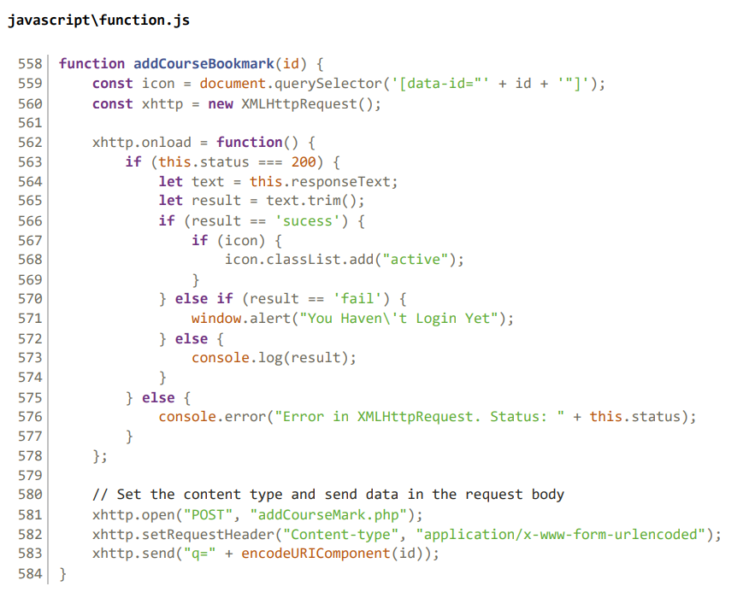

Figure 31.4 - Bookmark Functionality Code

The addCourseMark.php then process the request and add the bookmark information to the database. The information will then be used in the user profile for reviewing purposes. The script then retrieves the course ID from the POST request data and decodes it using urldecode() function.

Next, the system checks if the user is logged in by verifying the existence of session variables for email and password. If the user is logged in, the system retrieves the user's email and password from session variables and proceeds to query the database for user information. If the user is not logged in, the script echoes 'fail' to indicate that the operation have failed

If a matching user is found in the database, the script extracts the user ID associated with the logged-in user. It then constructs a query to insert a new row of record into the `savedcourse` table, specifying the course ID, user ID, and setting the 'isPin' field to '1' (indicate that the course is bookmarked). Once success, the system echoes 'success' to indicate the process was successful.

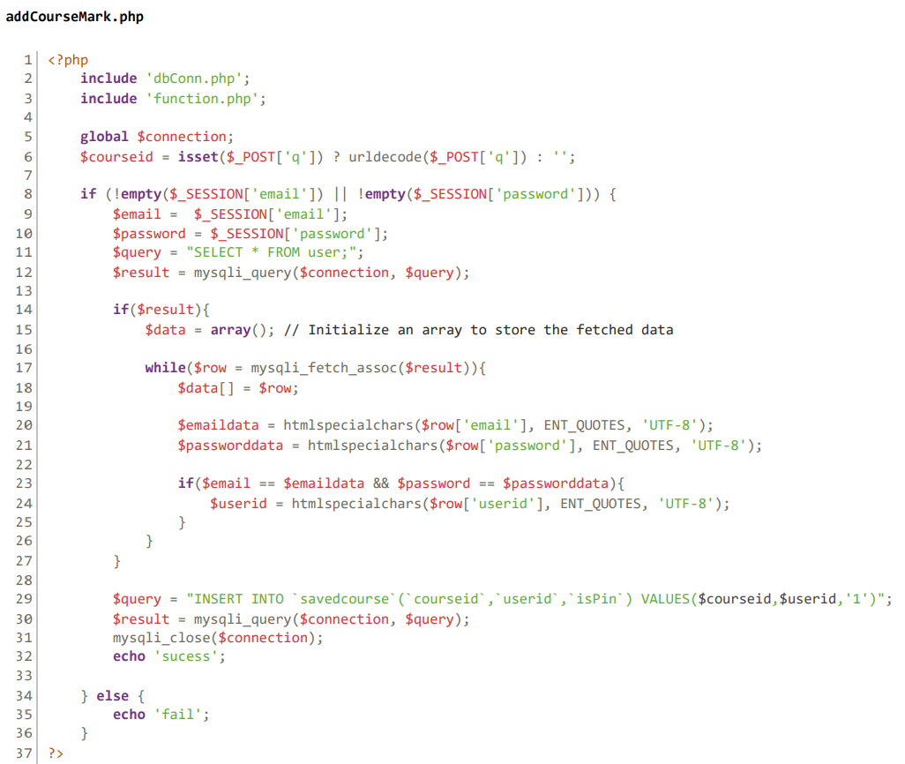

Figure 31.5 - Bookmark Functionality Code



Figure 31.6 - Bookmark Functionality Code

Upon successful response from the server (status code 200), the function evaluates the response text to determine the outcome of the bookmark addition attempt. If the response indicates success ('success'), the function adds the "active" class to the icon element, visually indicating that the course has been bookmarked. If the response indicates failure ('fail'), the function displays a message alerting the user that they haven't logged in yet. Any other response is logged to the console for debugging purposes. In case of an error during the XMLHttpRequest, an error message is logged to the console.

For the removeCourseBookmark(id) function, the structure is same as the addCourseBookmark(id) function but different for several details. The removeCourseBookmark(id) function have different php called removeCourseMark().

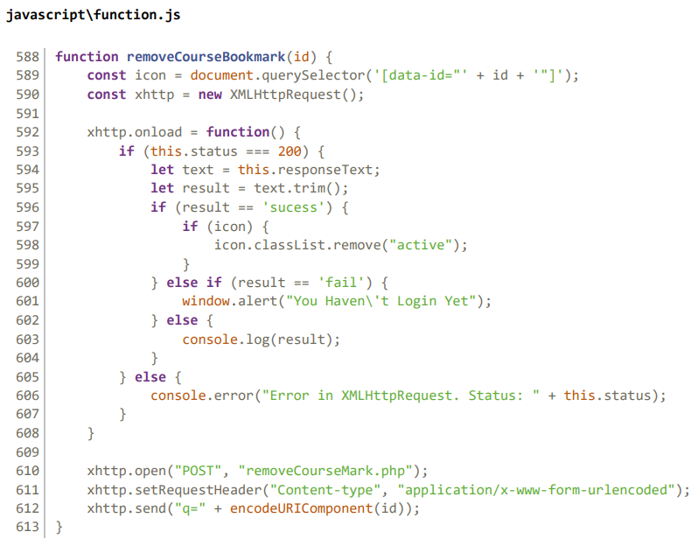

Figure 31.7 - Bookmark Functionality Code

The removeCourseMark.php structure is same as the addCourseMark.php, the only different is the query executed to the server.

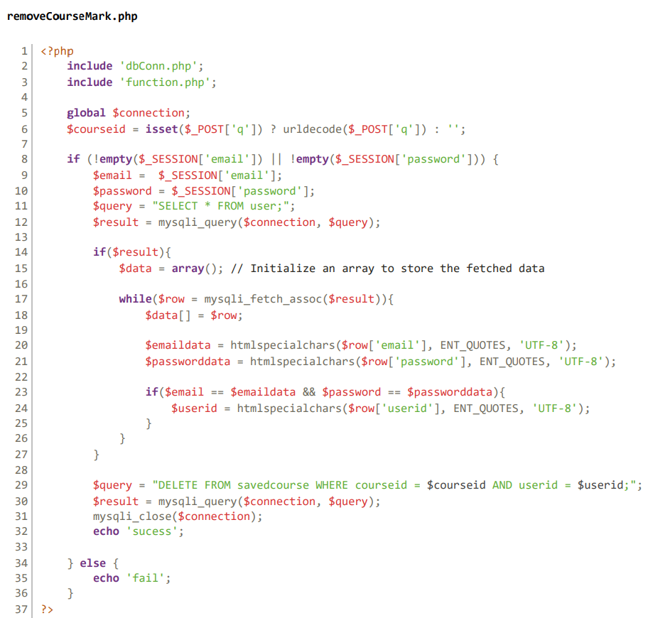

Figure 31.8 - Bookmark Functionality Code

Overall, this functionality enables users to easily bookmark the post on the platform by simply clicking on the corresponding icon. The bookmark post will then be shown in the user profile for reviewing purposes.

## 3.0.5 Create and Save Post functionality

There are three types of posts available on our platform: job finder, skill sync, and event post. The "create and save post" functionality is provided for users who are interested in sharing opportunities related to job openings, skill development, and upcoming events.



Figure 32.1 – Create and Save Post Functionality Design Page

This feature allows users to create new posts in any of these categories and save the unfinished post for later reference. Whether users are looking to advertise job vacancies, showcase their classes, or promote events, they can easily create or save the posts to connect with others and contribute to the diverse content of the platform’s ecosystem.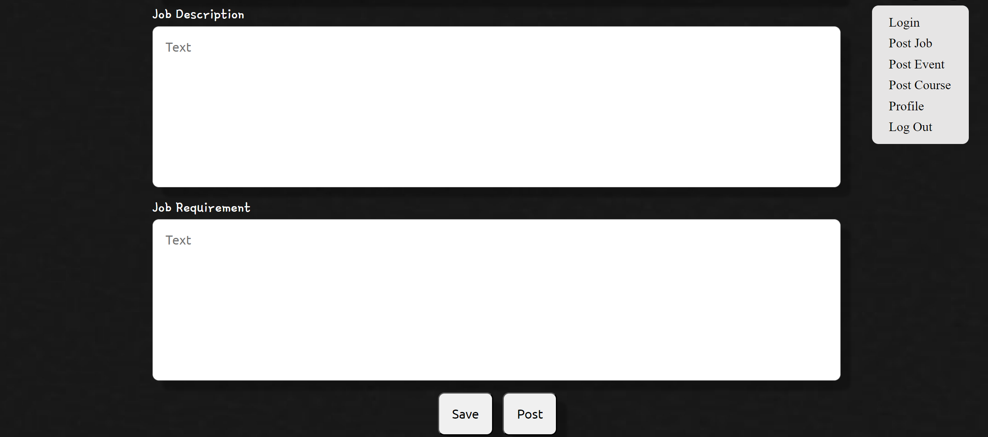

Figure 32.2 - Create and Save Post Functionality Design Page

For these three types of post, they have similar code structure. In this case, postjob.php is responsible for processing the user posting information. The program begins by fetching the user input value from the html <form> located in postjob.php.

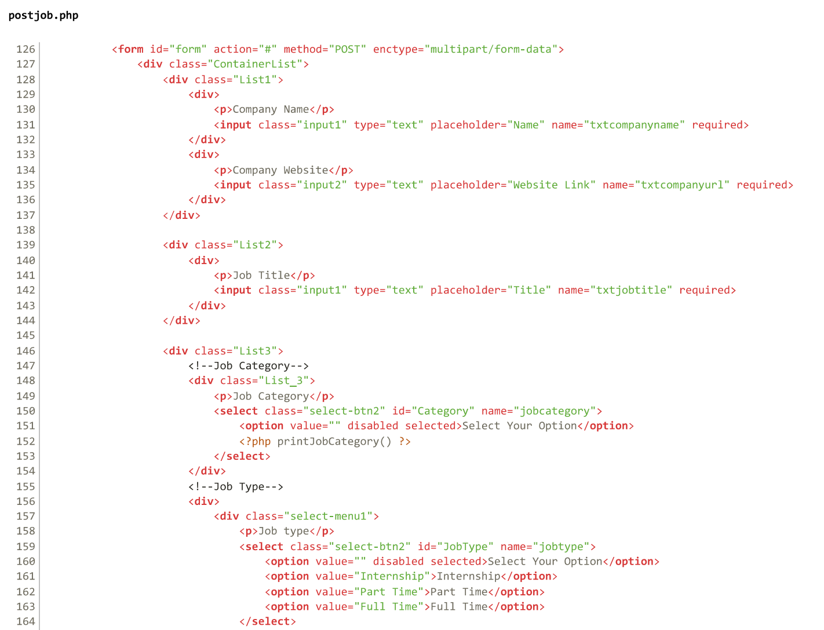

Figure 32.3 - Create and Save Post Functionality Code

Then, the PHP will then include necessary files 'dbConn.php' and 'function.php' to establish a database connection and access required functions. Global variables are then declared to store various parameters related to the job post, such as company name, job title, category, location, deadline, salary range, job description, and job requirements.

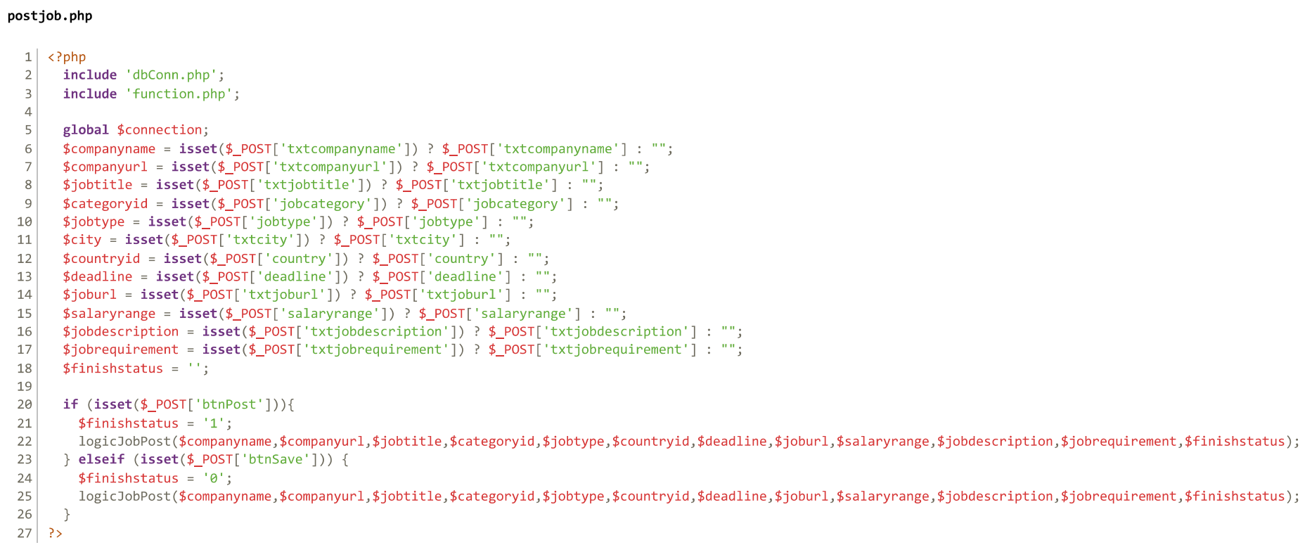

Figure 32.4 - Create and Save Post Functionality Code

Upon form submission, the script checks which button was clicked -- either the post button ("btnPost") or the save button ("btnSave"). Depending on the button clicked, the 'finishstatus' variable is set accordingly to indicate whether the job post is finished or saved as a draft.

Subsequently, the script calls the 'logicJobPost()' function from the included 'function.php' file, passing all relevant parameters to handle the logic of job posting. This function processes the job post data and inserts it into the database table dedicated to storing job posts.

The logicJobPost() php function manages the submission of job posts on our platform. It begins by checking if the user is logged in and determines their user type—either 'user' or 'admin'—based on their session credentials. The function retrieves the corresponding identifier column and table name from the database.

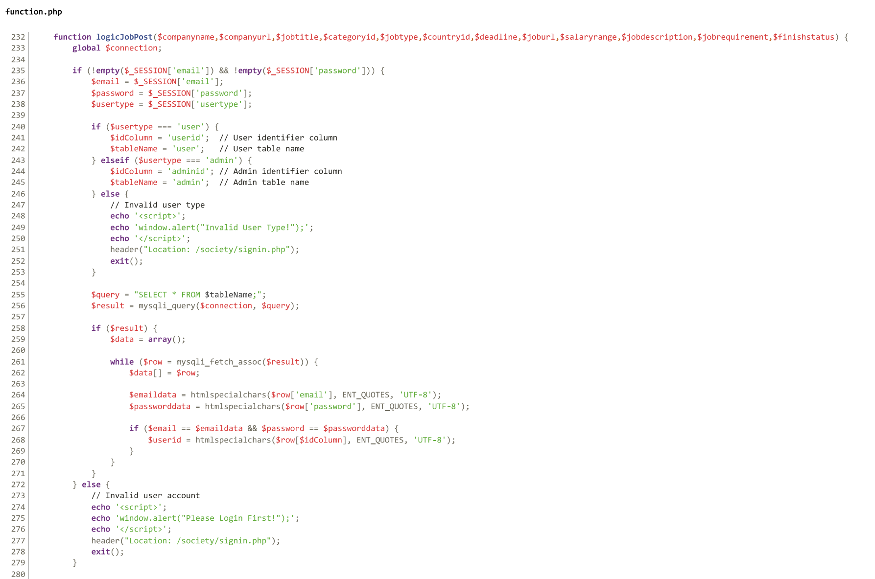

Figure 32.5 - Create and Save Post Functionality Code

If the user is authenticated, the function processes any uploaded images for the company profile and banner, inserting them into the respective database tables and retrieving their IDs for reference. It also formats the provided deadline date if available.



Figure 32.6 - Create and Save Post Functionality Code

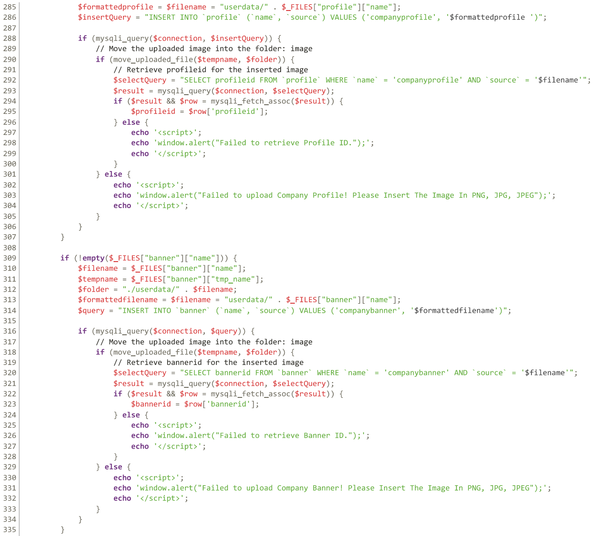

Figure 32.7 - Create and Save Post Functionality Code



Figure 32.8 - Create and Save Post Functionality Code

Using prepared statements, the function inserts the job post details into the 'jobpost' table, binding parameters securely to prevent SQL injection. The insertion query is customized based on the user type, and all necessary parameters are included.

After executing the insertion query, the function checks for successful execution and displays appropriate success messages. If the job post is saved as a draft, the user is redirected to their profile page; otherwise, they are redirected to the job finder page.

In case of any errors during the SQL statement preparation or execution, relevant error messages are displayed to the user via JavaScript alerts.

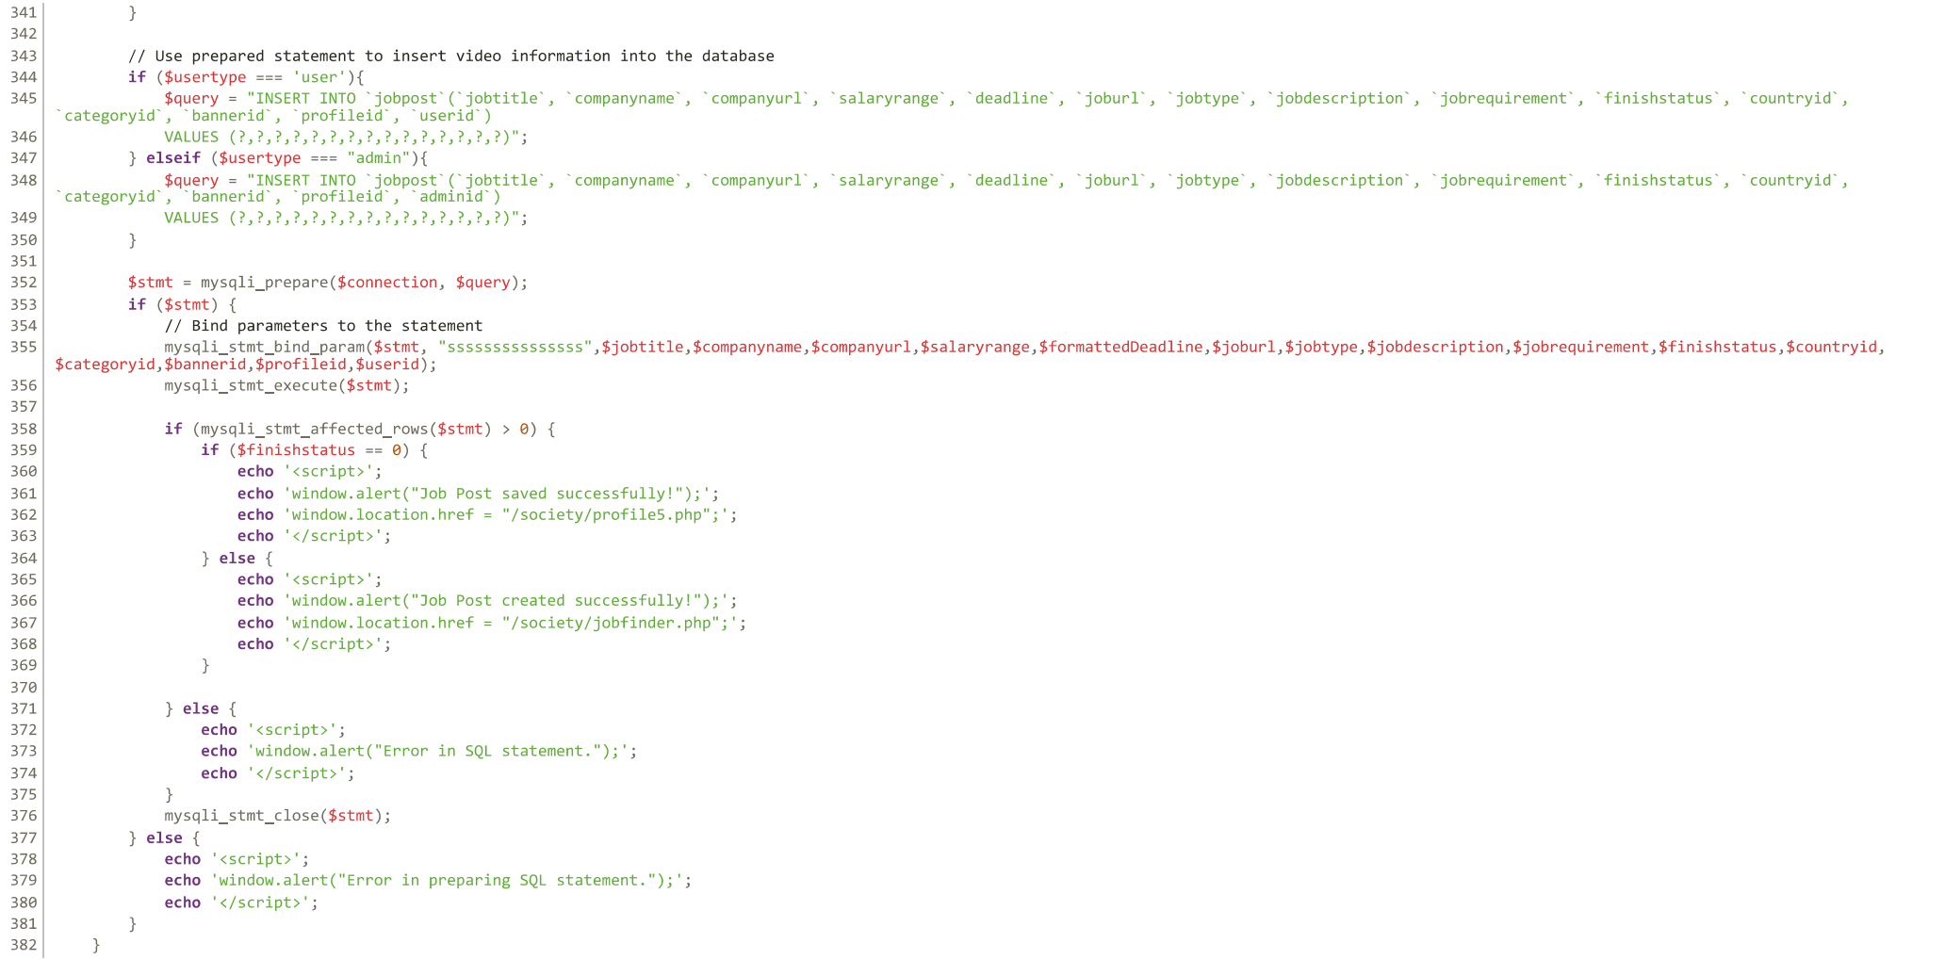

Figure 32.9 - Create and Save Post Functionality Code

3.0.6 User profile functionality

The user profile functionality aims to offer users a comfortable space for organizing and reviewing their posts. This functionality involves storing bookmarked posts, saved posts, and posts that the user has submitted.

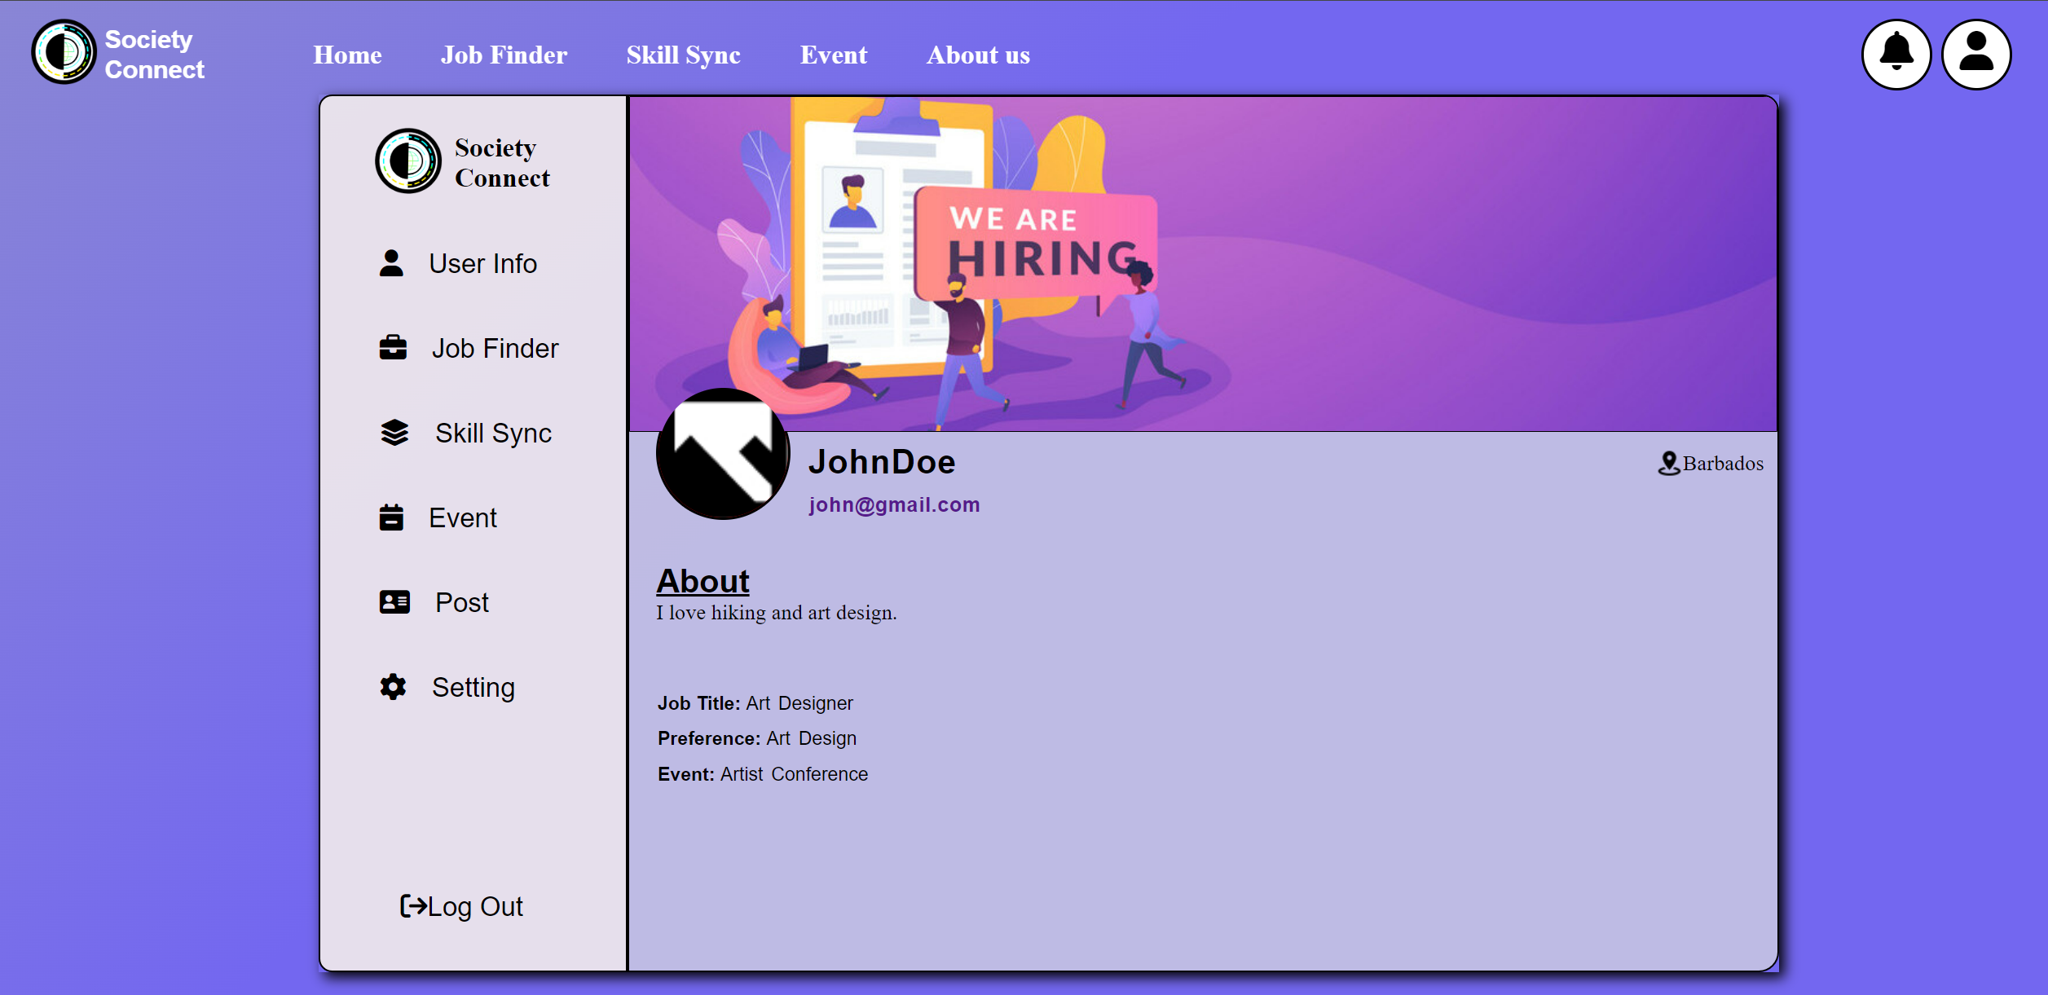

Figure 33.1 – User Profile Functionality Design Page

In order to access the user profile, users will need to login their account. Once success, the user can have access to the profile main page and the system will display their information according to the email and password they type. Below is the program for the user profile main page.

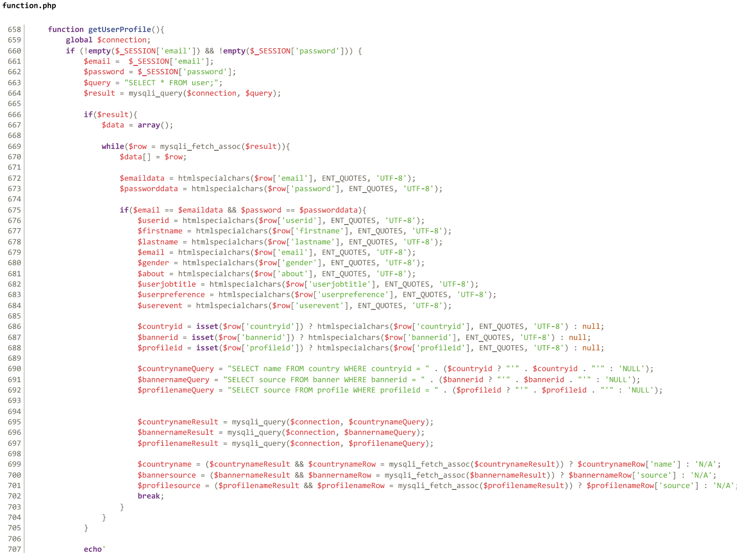

Figure 33.2 – User Profile Functionality Code

The getUserProfile() function retrieves and displays the user's profile information from the database. First, it checks if the user is logged in by verifying the existence of session variables containing the user's email and password. If the user is logged in, the function retrieves the user's details from the user table in the database, such as their first name, last name, email, gender, about section, job title, preference, and events. It also retrieves associated data such as the country name, banner image, and profile image by querying related tables (country, banner, profile).

The retrieved profile information is then displayed on the user's profile page in a structured format using HTML and embedded PHP variables. This includes the user's name, email, country, about section, job title, preference, events, and profile images. Additionally, links to different sections of the user's profile (e.g., user info, job finder, skill sync, event, post, setting) are provided for easy navigation. If the user is not logged in, an alert message prompts them to log in, and they are redirected to the login page.

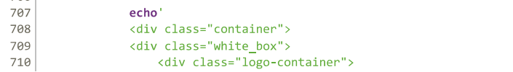

Figure 33.3 - User Profile Functionality Code

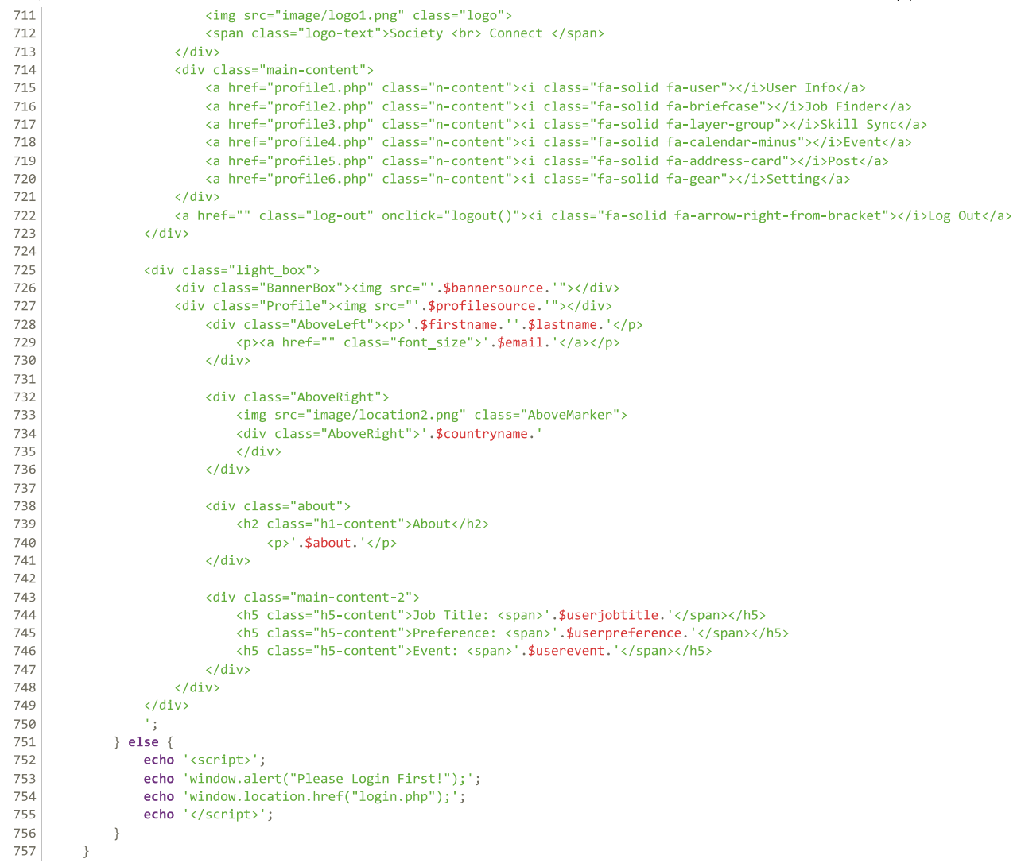

Figure 33.4 - User Profile Functionality Code

For the job finder, skill sync and event option on the left bar provide similar functionality for the users. It stores and display the bookmarked posts and posts that the user has submitted (post is approved by the admin). Below are the showcases of the web layout after clicking the event option.

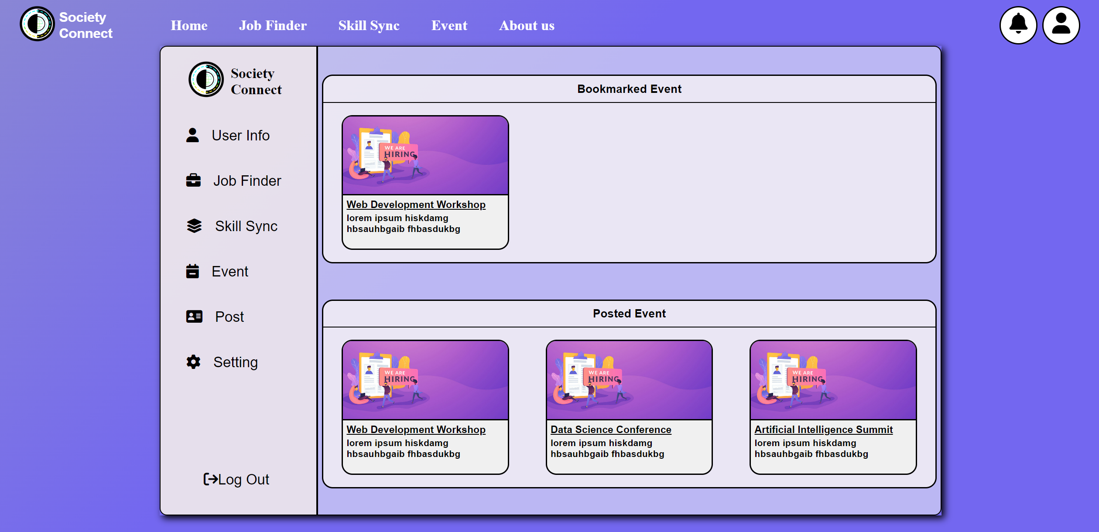

Figure 33.5 User Profile Functionality Design Page

There are two PHP function involve in this page which is the getSavedEvent() and getPostEvent(). The image below shows the html for the event profile page. The job finder and skill sync profile page also have similar program structure like the event profile page. These two PHP functions are used to display the post from the database.

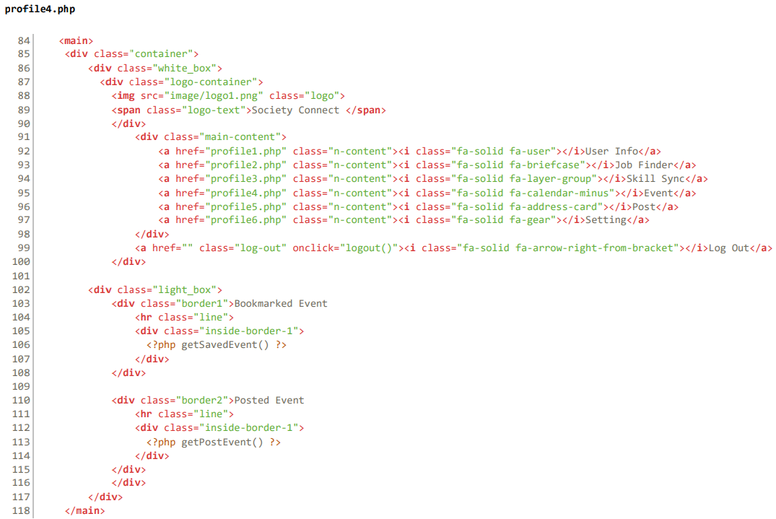

Figure 33.6 - User Profile Functionality Code

The getSavedEvent() function retrieves and displays the events post bookmarked by the logged-in user. It first checks if the user is logged in by verifying the existence of session variables containing the user's email and password. If the user is logged in, it retrieves the user's ID from the user table in the database based on the provided email and password.

Then, it queries the savedevent table to retrieve the saved events associated with the user's ID. For each saved event, it retrieves the event title, description, and banner image from the event post table by joining it with the banner table.

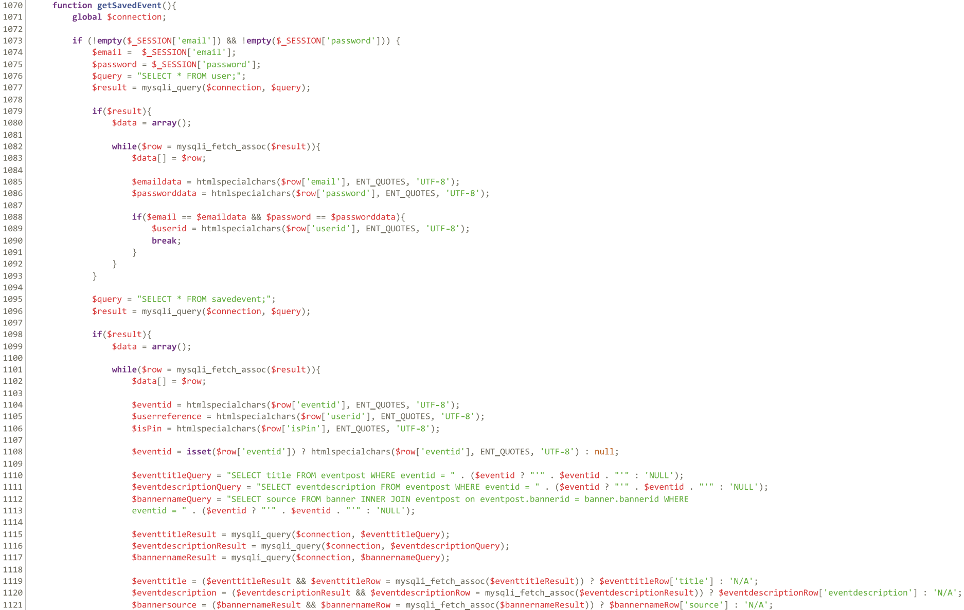

Figure 33.7 - User Profile Functionality Code

If the saved event is marked as pinned (isPin = 1) and is associated with the current user, it generates HTML content to display the event information. This includes a button with the event banner image and title. Clicking on this button triggers a JavaScript function to redirect the user to the detailed event post page. If the user is not logged in, an alert message prompts them to log in, and they are redirected to the login page.

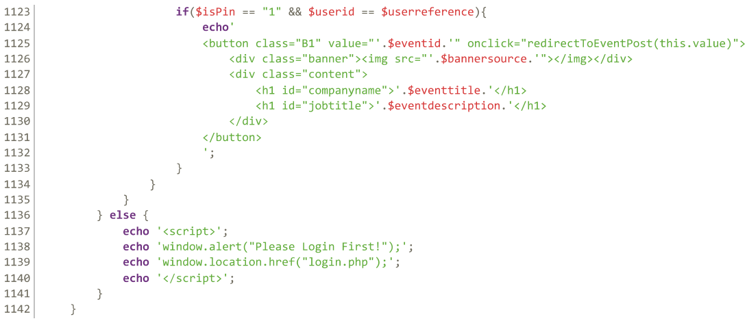

Figure 33.8 - User Profile Functionality Code

For the getpostevent() function, the structure is the same. The difference is the query constructed. The query selected out all the event post from eventpost table where the posts are approved by the admin(adminid != ' ';). The function also checks the user credential at the start to prevent any system error. If the user is not logged in, an alert message prompts them to log in, and they are redirected to the login page.

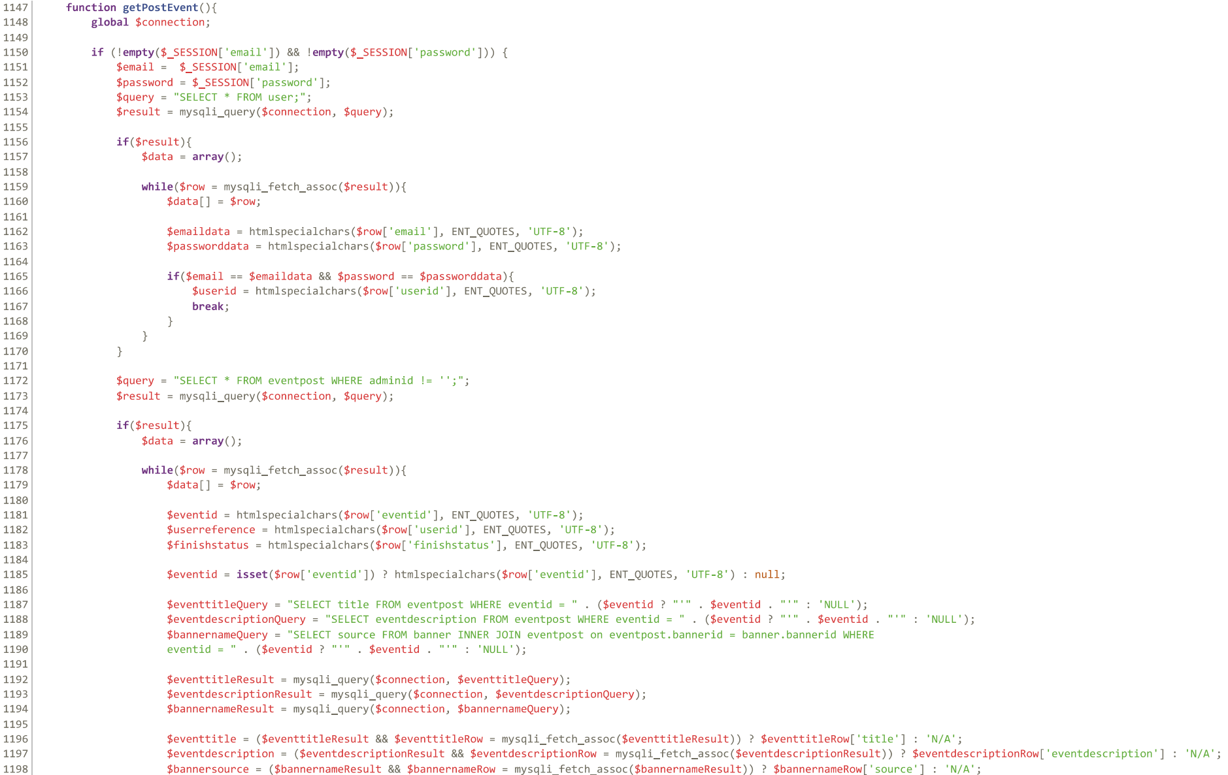

Figure 33.9 - User Profile Functionality Code

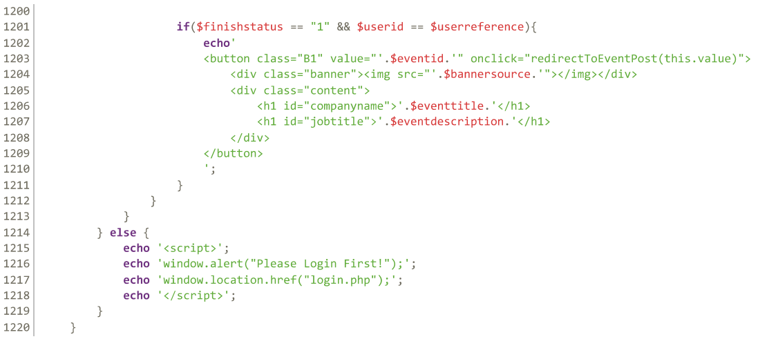

Figure 33.10 - User Profile Functionality Code

For the fourth section "post", it provides users a clearer view of their unfinished post and their posts that are in the waiting list (waiting for admin approval). Below are the image showing the post profile page.

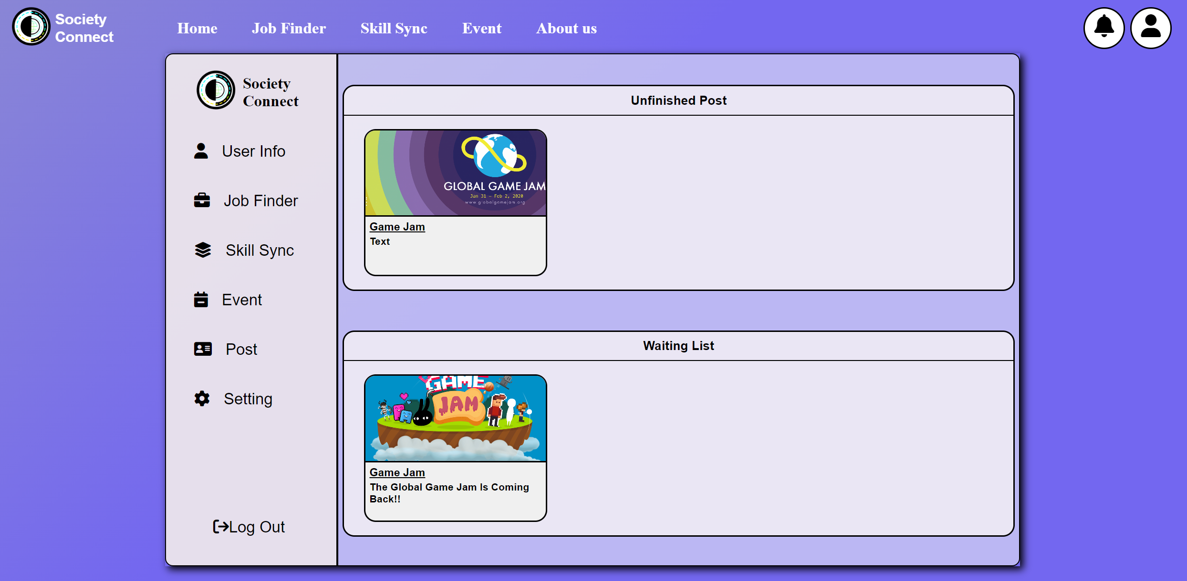

Figure 33.11 - User Profile Functionality Design Page

The html structure of the post profile page contains of two functions, getunfinishedpost() and getwaitingpost(). These two functions have a similar structure, only the query constructed are different.

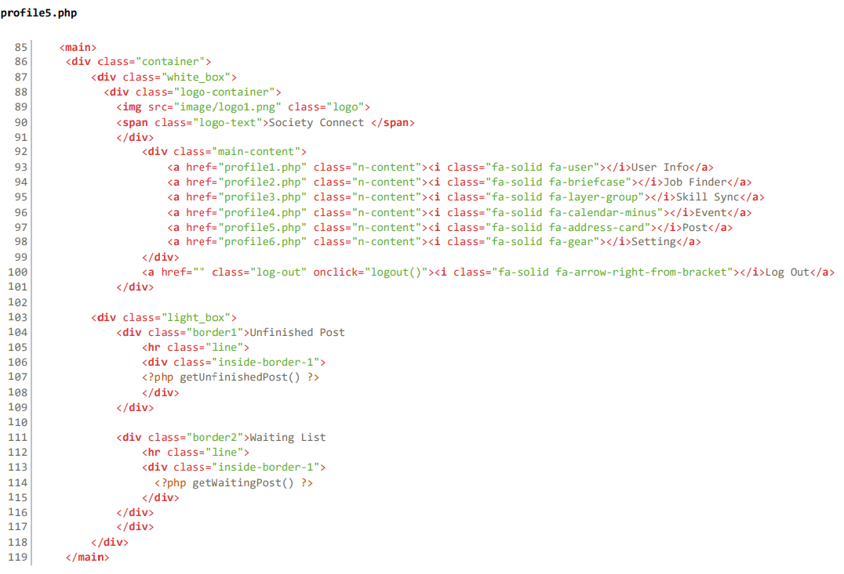

Figure 33.12 - User Profile Functionality Code

In this example, getwaitingpost() function is showcased. The getwaitingpost() function retrieves unfinished job posts from the database where the admin ID is NULL and the finish status is set to '1'.

First, it checks if the user is logged in by verifying the existence of session variables for email and password. Then, it fetches the user's ID from the database based on their email and password.

Next, the function constructs a SQL query to select all job posts where the admin ID is NULL. It executes this query and iterates over the result set, extracting relevant information such as the job ID, user reference, finish status, company name, job title, and banner source for each job post.

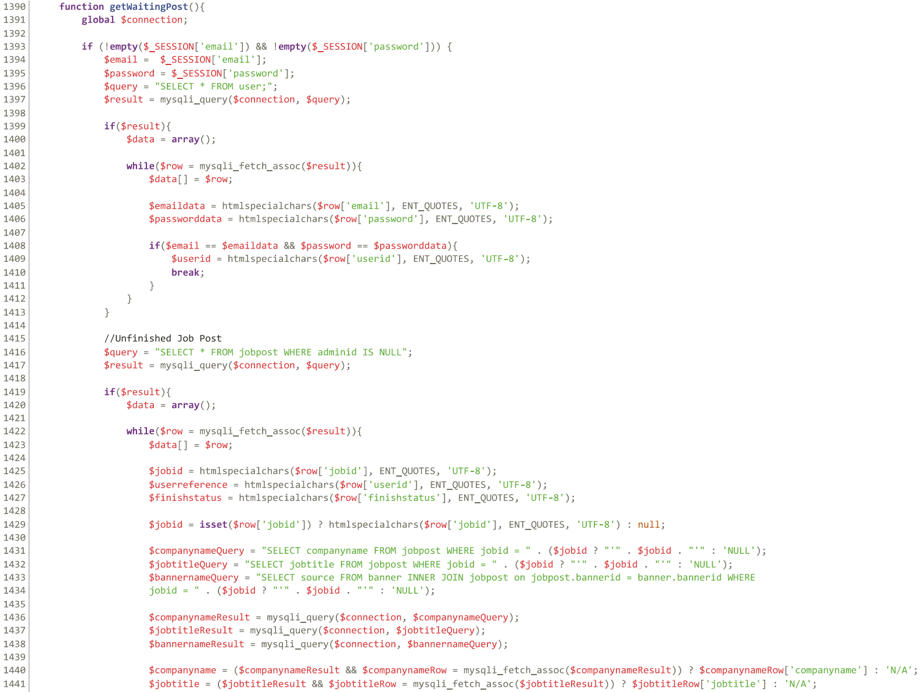

Figure 33.13 - User Profile Functionality Code

For each job post that meets the criteria of having a finish status of '1' and matching the user's reference ID, it dynamically generates HTML buttons displaying the company name, job title, and banner image. Each button is associated with the jobConfirm() function and includes the job ID as its value, allowing users to interact with the job post

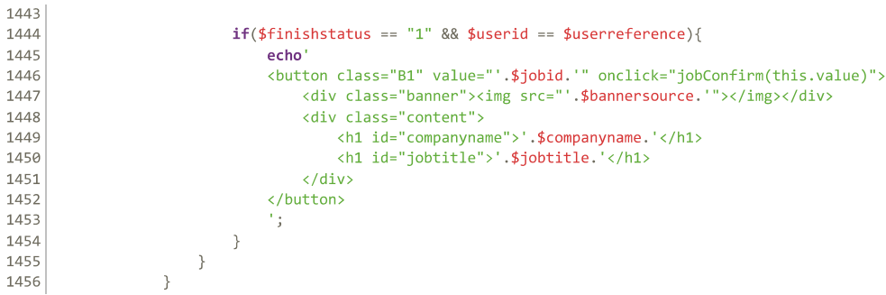

Figure 33.14 - User Profile Functionality Code

At the last section of the user profile features an update profile system for the user. Simply click the "Setting" option, the users are able to change their profile description such as their first name, last name, gender, age and etc. The code that responsible to this functionality is the profile6.php.

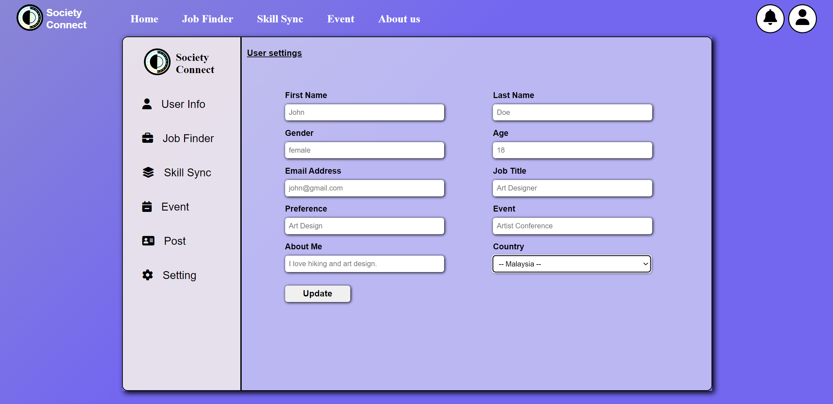

Figure 33.15 - User Profile Functionality Design Page

In profile6.php, it consists of two sections of the php code. The first one is for processing the update change to the database while second one (getUserInformation()) is for displaying the current user information value in the <input> form.

The getUserInformation() function retrieves user data from the database based on the current session's email and password. It begins by checking if the session variables for email and password are not empty, indicating that a user is logged in. If they are not empty, the function retrieves the user's data from the user table using a SELECT query.

If the query is successful, the function populates variables with the user's information, such as first name, last name, age, gender, email, job title, preference, event, and about me. It also retrieves related data such as country name, banner source, and profile source using additional SELECT queries based on foreign keys.

The function then generates HTML input fields with placeholders set to the retrieved user data, allowing users to see their information displayed within input fields on a web page. This enables users to easily view and potentially edit their profile information.

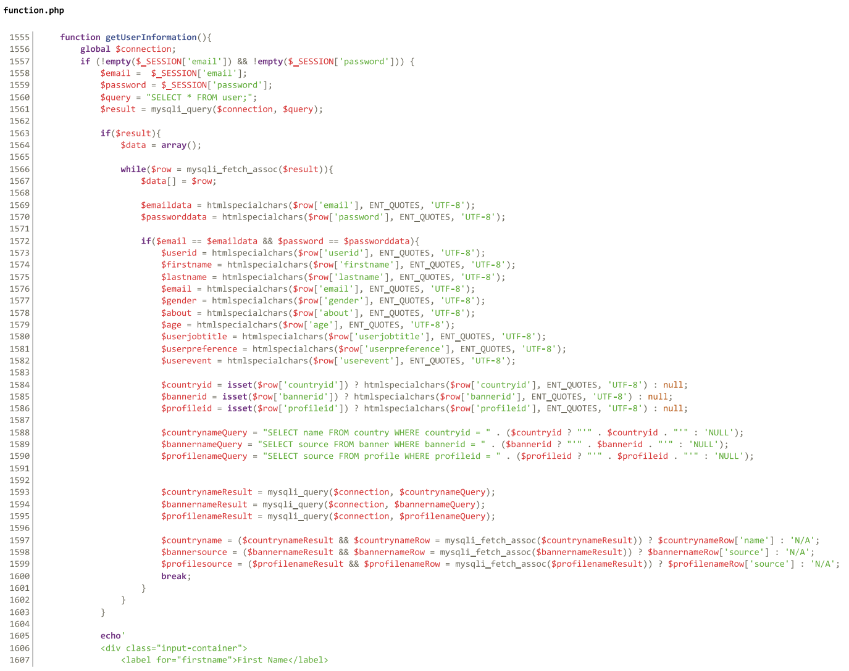

Figure 33.16 - User Profile Functionality Code

However, if the session variables for email and password are empty, indicating that no user is logged in, the function displays a JavaScript alert notifying the user to login first and redirects them to the login page.

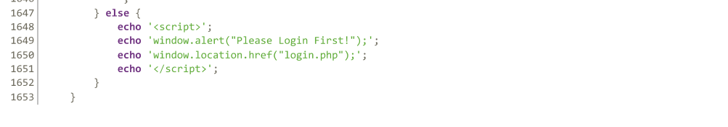

Figure 33.17 - User Profile Functionality Code

Next, the other PHP section will be fetching the user input value to the database. It checks if the form button "btnUpdate" is set, indicating a request to update user information. Then, the system retrieves form data such as first name, last name, age, gender, email, country ID, about, job title, preference, and event from the POST request.

The code further verifies if the user is logged in by checking session variables for email and password. If logged in, it retrieves the user's ID from the database based on the session email and password.

Subsequently, the code executes a series of UPDATE queries to modify user information in the database. Each field's update is conditioned on the presence of new data from the form, ensuring that only fields with provided data are updated. The queries update corresponding columns in the "user" table based on the retrieved user ID.

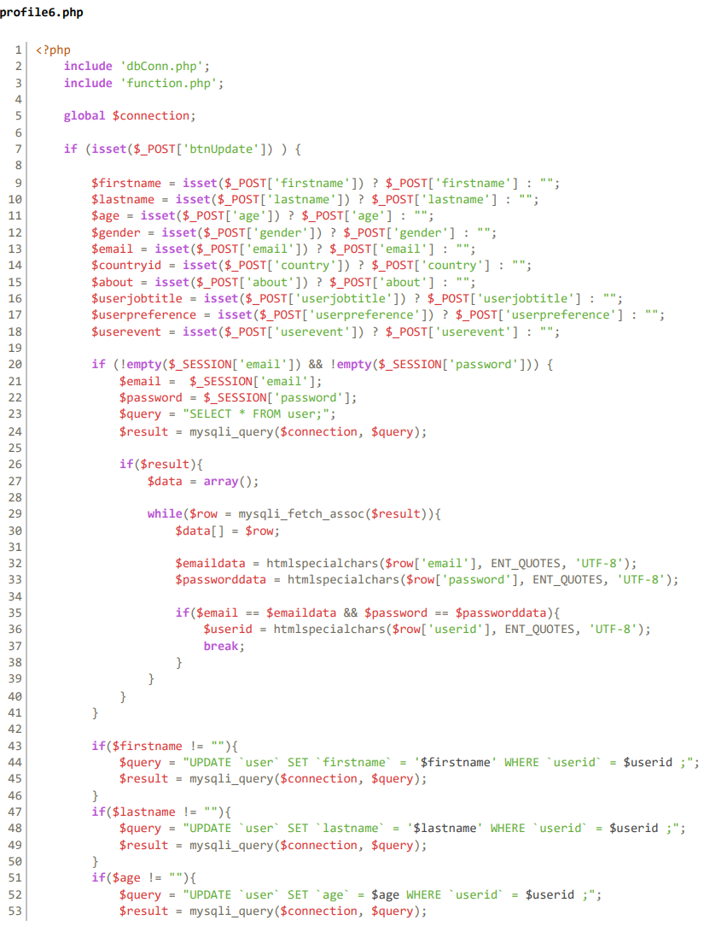

Figure 33.18 - User Profile Functionality Code

3.0.7 Post Review functionality

Every time when users click on the post in their profile page. The system will automatically direct user to the larger post review page whereas user could view the detail of the post in that page. In this case, a post named "web development" are being showcased.

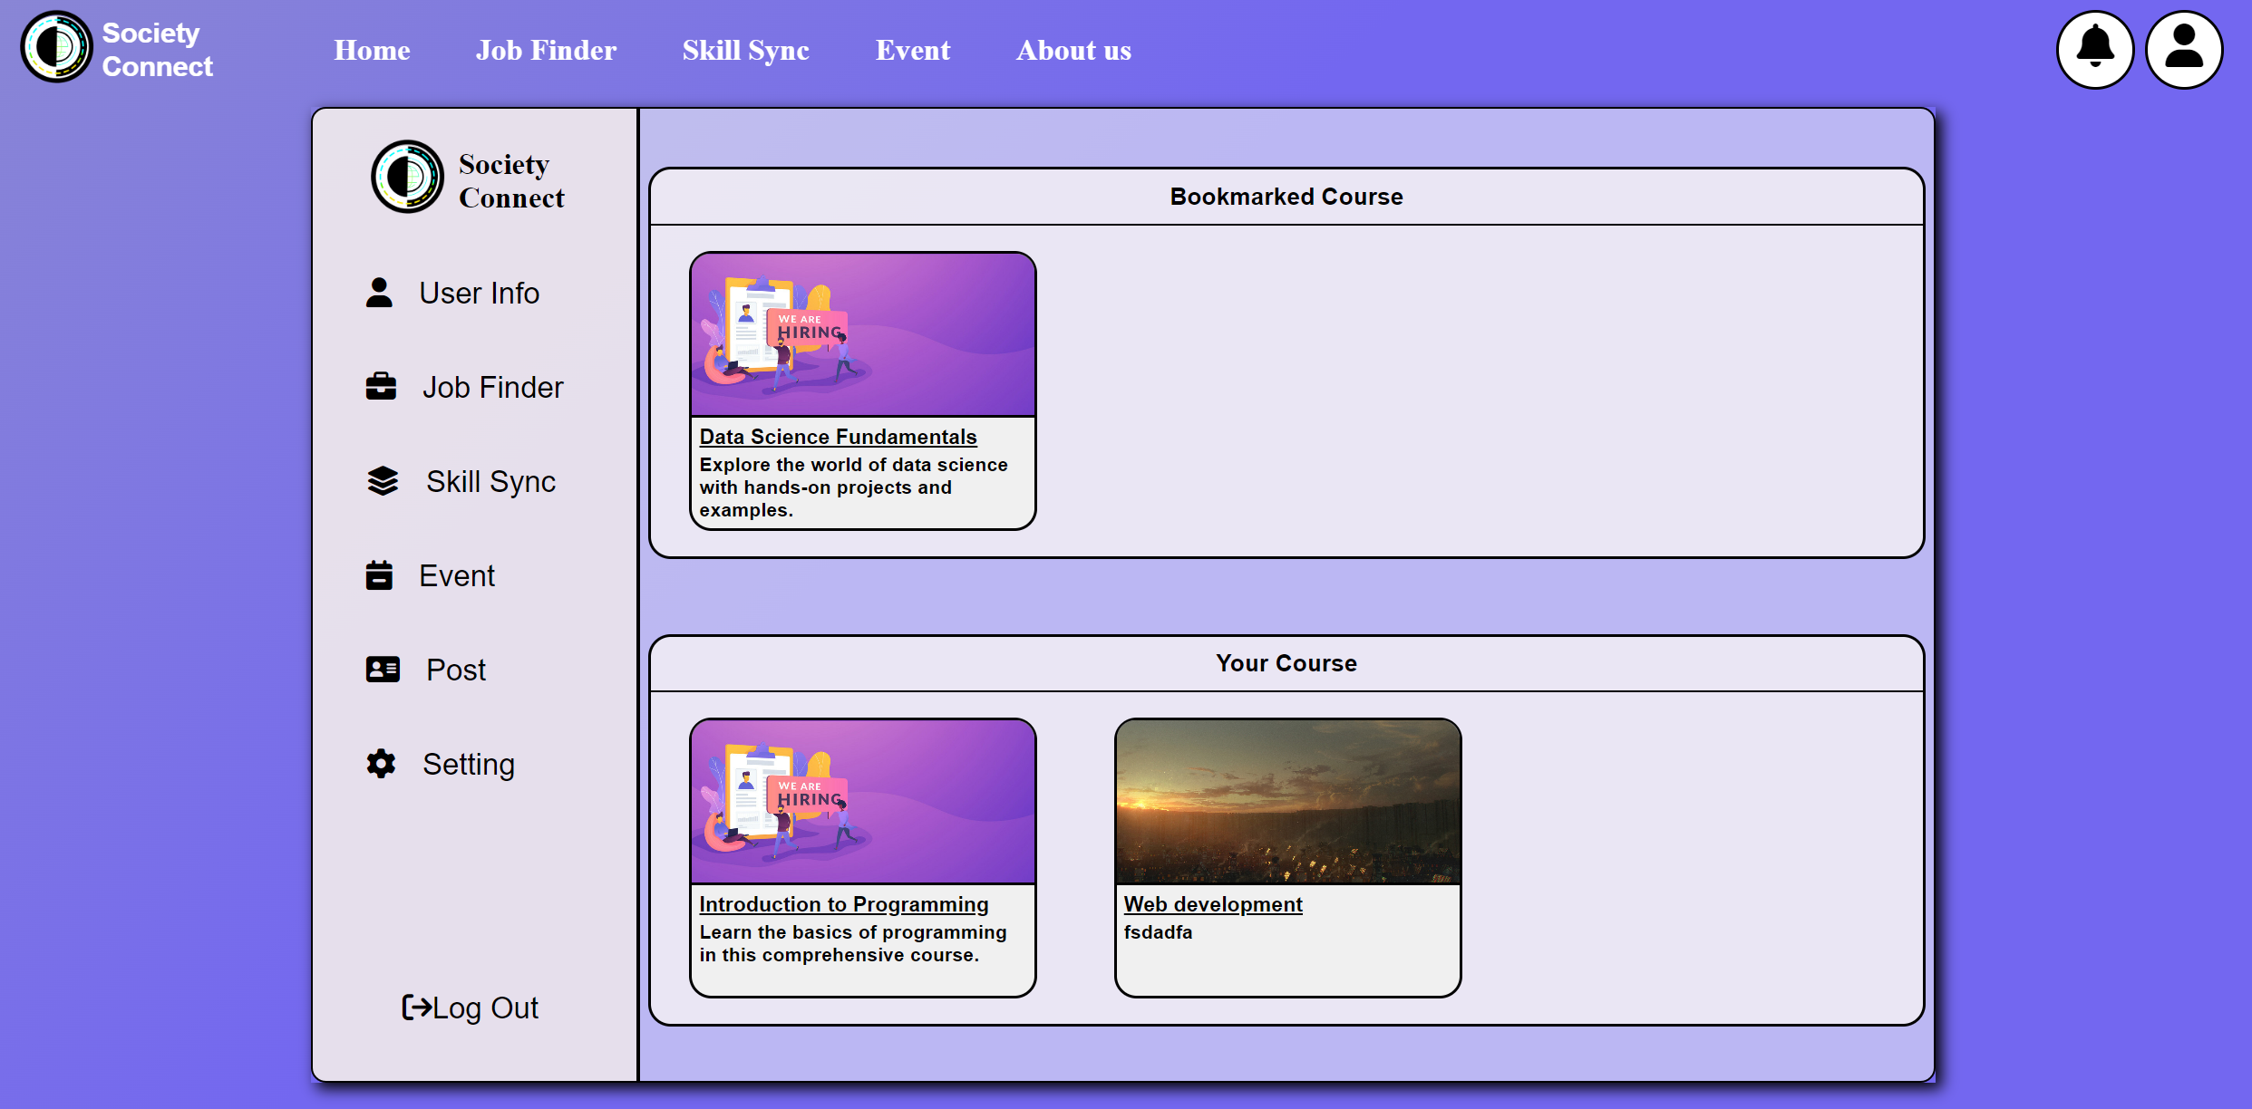

Figure 34.1 – Post Review Functionality Design Page

Once the users click on the post, the system will direct user to a new page as the picture shown below. The system will retrieve the post information from database and display them to this page. The code that handling this functionality is jobreview.php, skillreview.php and eventreview.php (depend on the type of post). These three PHP codes have a similar structure and function.

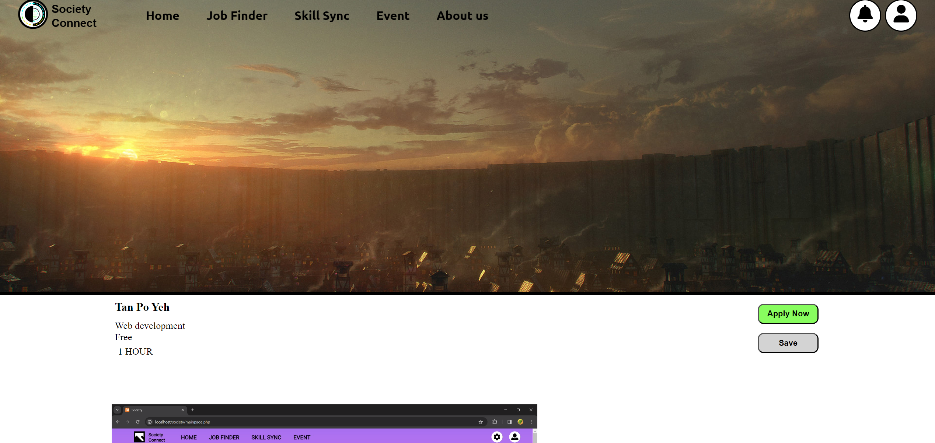

Figure 34.2 - Post Review Functionality Design Page

In this case, the eventreview.php is showcased to demonstrate how the system fetch and display post information from the database according to the post selected.

The eventreview.php code starts retrieving the "id" parameter from the URL using "$_GET", which is then used to fetch data from the `eventpost` table in the database. The code prepares and executes a parameterized SQL query to select the event details based on the provided `eventid`.

After fetching the data, it iterates through the result set and store each value in variables. The PHP also retrieves additional information such as the country name and banner source by executing separate SQL queries based on the `countryid` and `bannerid`.

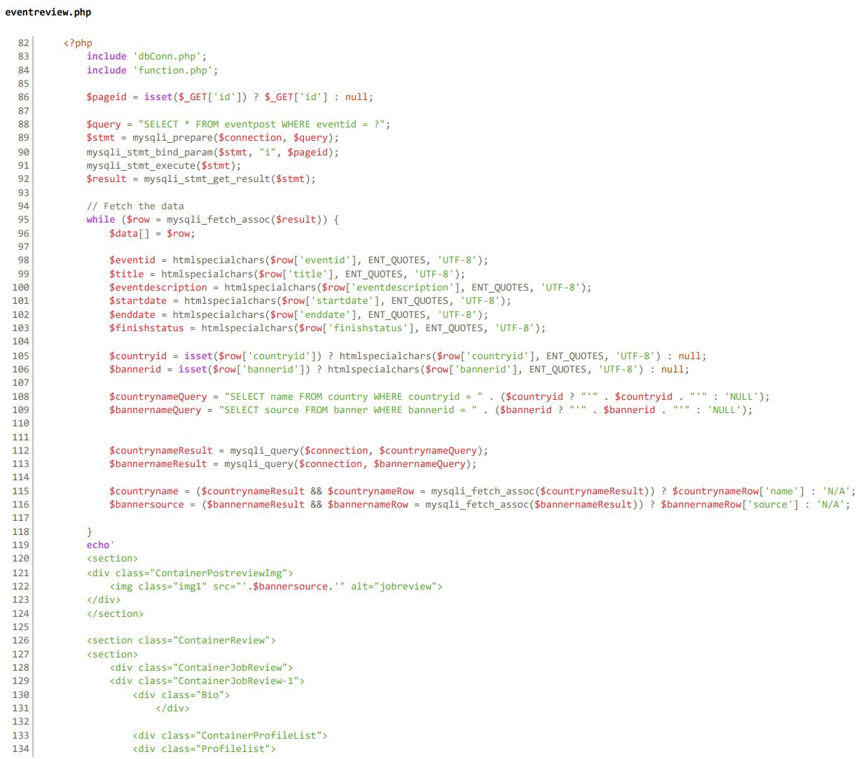

Figure 34.3 - Post Review Functionality Code

The fetched data is then used to generate HTML content within the "echo" statement. It built up sections and div to organize the layout, including displaying event details like title, start and end dates, country name, and event description and buttons.

While for the unfinished post, the users can continue editing their post by simply click on the mini post in the "unfinished post" section. For this kind of post, the system will fetch all of the previous key in information from the database.



Figure 34.4 - Post Review Functionality Design Page

The system will then direct users to the posting page with the previous key-in information filled inside the form.

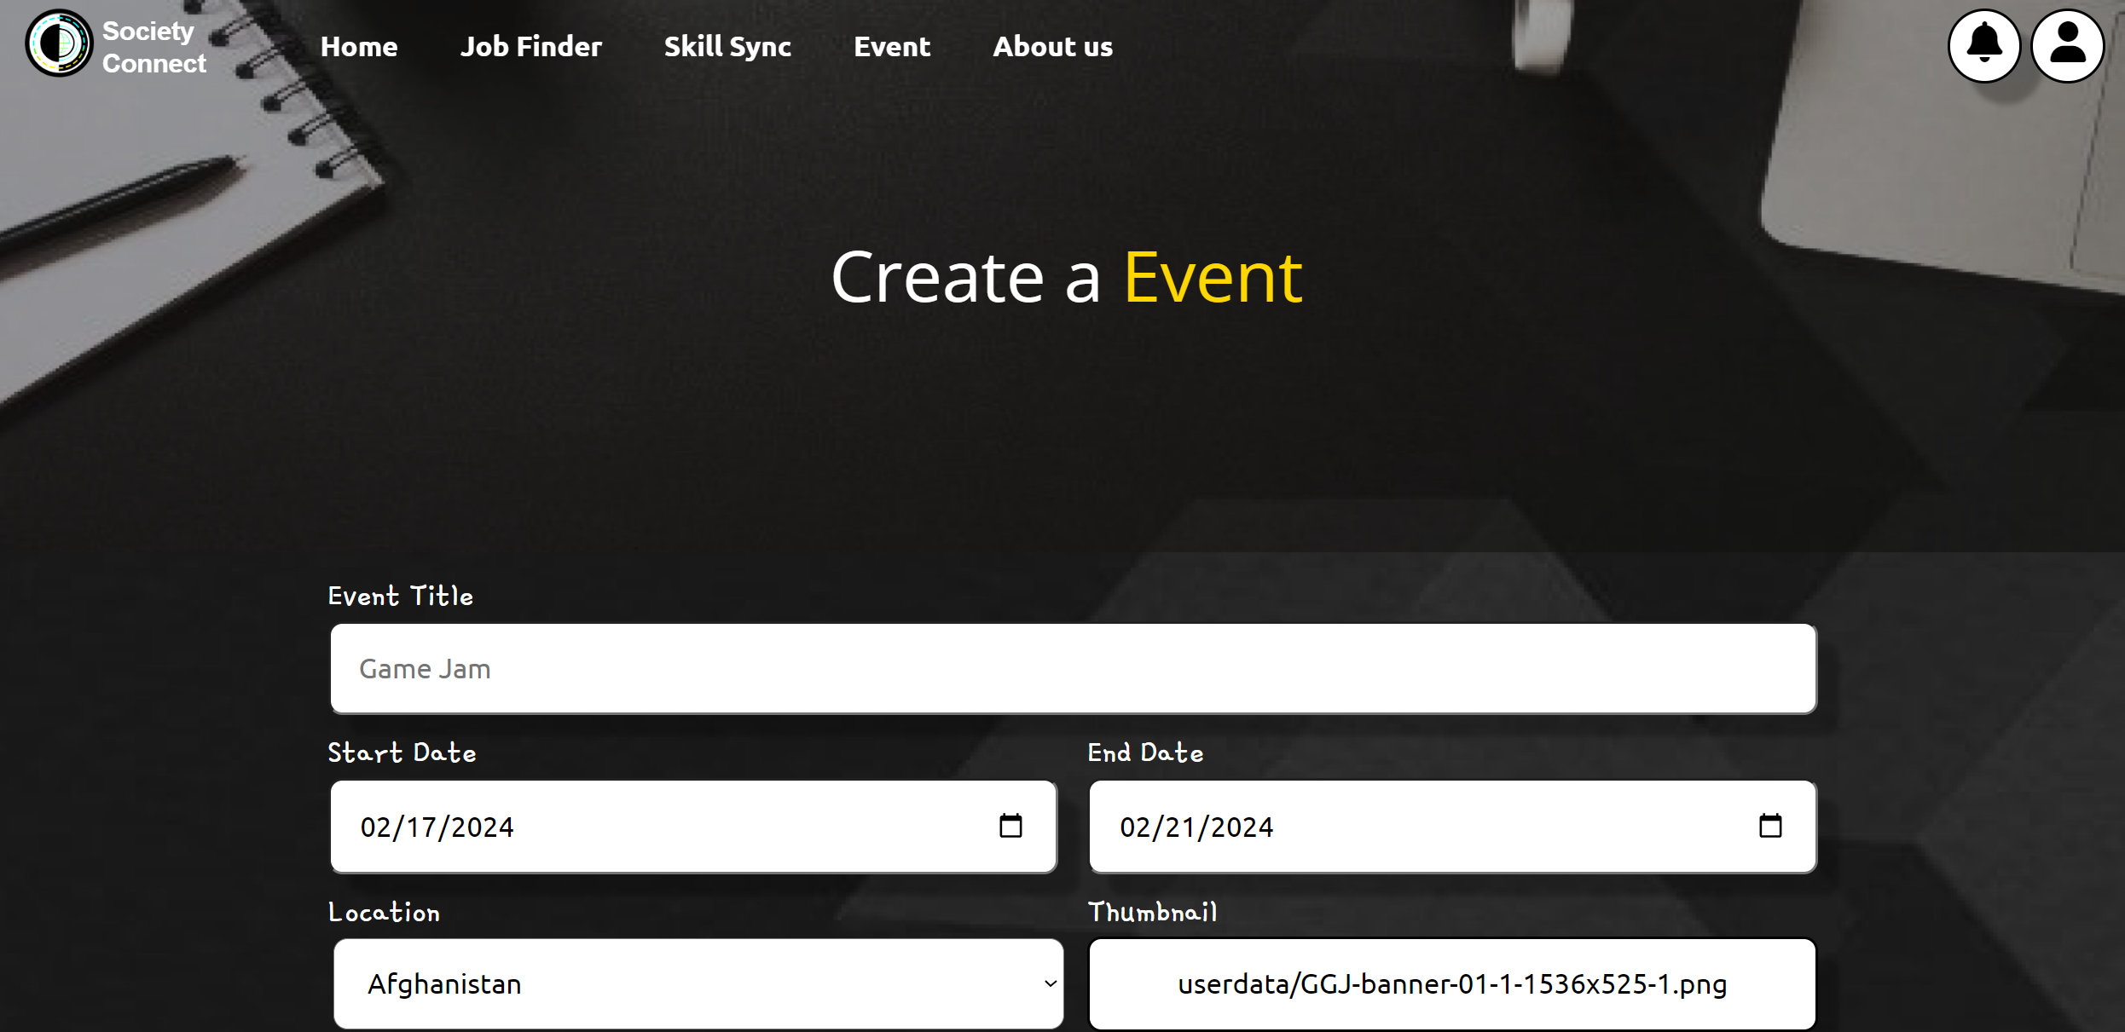

Figure 34.5 - Post Review Functionality Code

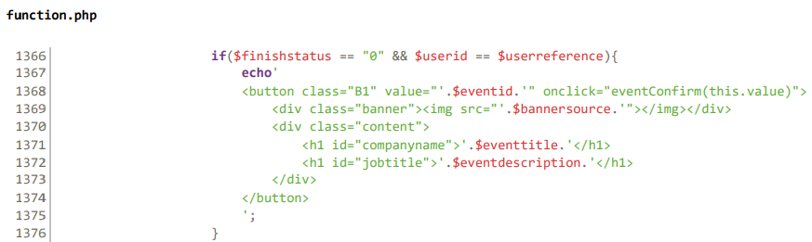

Figure 34.6 - Post Review Functionality Code

The code starts from the JavaScript function, every time when user click on the mini post in the profile page. The eventConfirm() function (e.g. jobComfirm() for job finder post while skillConfirm() for skill sync post) will be triggered and system will redirect user to jobconfirm.php with the corresponded post id selected.

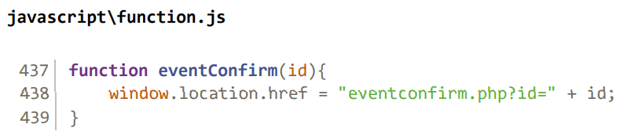

Figure 34.7 - Post Review Functionality Code

The eventconfirm.php code starts with including necessary files for database connection and additional functions. It initializes variables to store form data such as event title, start date, end date, country, and event description. These variables are populated with values submitted through POST requests if available, otherwise, they default to empty strings. The code then handles the logic for both posting and updating events based on button clicks.

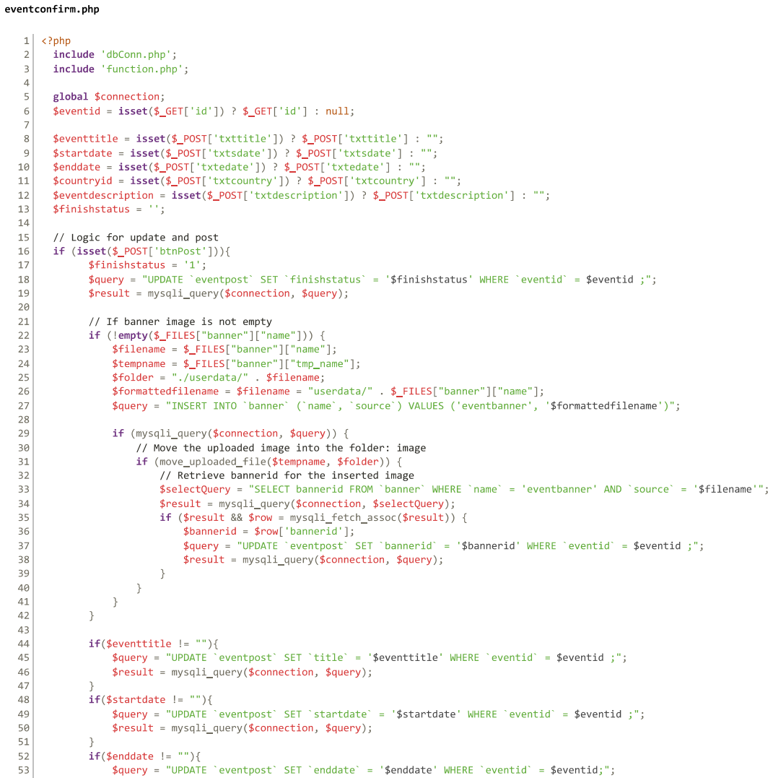

Figure 34.8 - Post Review Functionality Code

If the "Post" button is clicked, the finishstatus of the event is set to '1', indicating that the event is complete. The code updates the database with the new status and, if a banner image is uploaded, it processes the image and stores it in the appropriate directory. Additional database updates are made for event title, start date, end date, country, and event description if the corresponding fields are not empty.

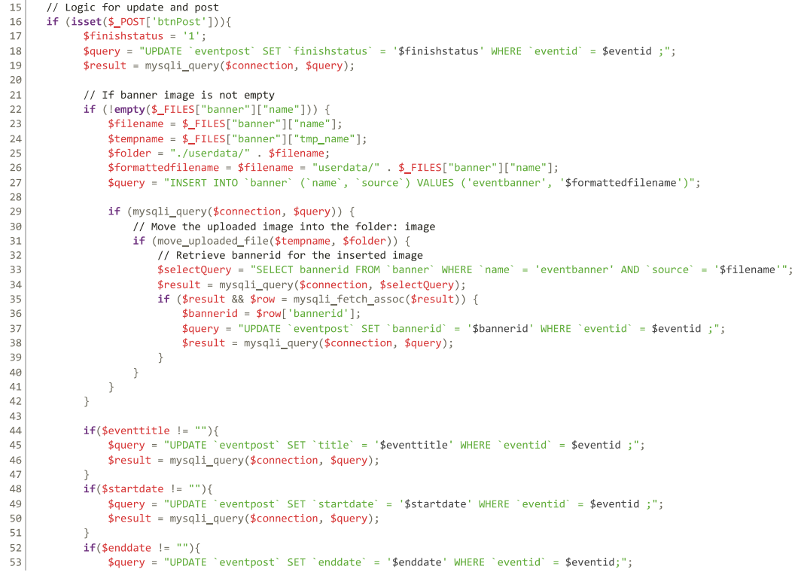

Figure 34.9 - Post Review Functionality Code

Similarly, if the "Save" button is clicked, the finishstatus of the event is set to '0', indicating that it's not complete. Again, the code updates the database accordingly and handles the banner image upload if available. Updates are made for event title, start date, end date, country, and event description if the corresponding fields are not empty.

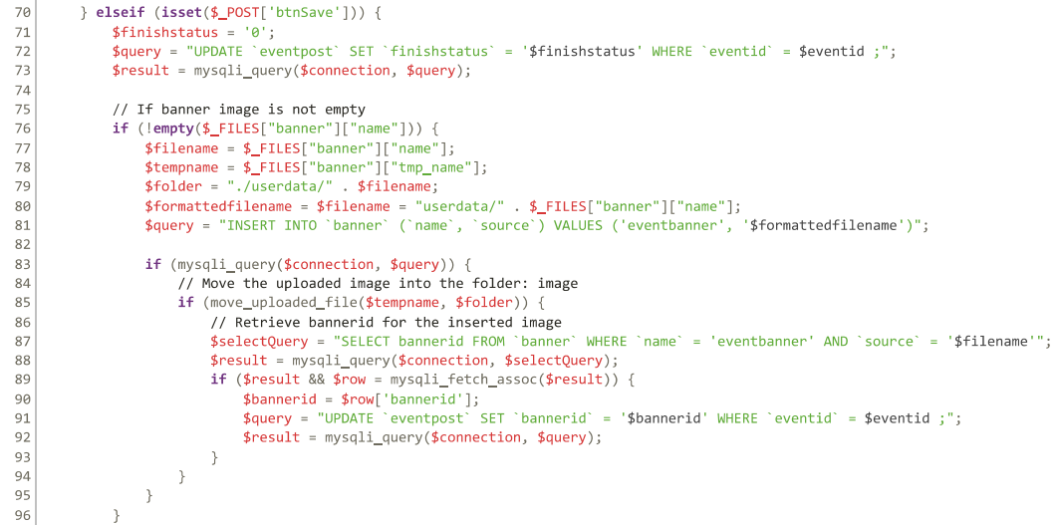

Figure 34.10 - Post Review Functionality Code

The HTML section below the PHP code constructs a form for users to input event details or update existing event information. It pre-populates the form fields with the fetched event data from the database if available. Users can enter or modify event details such as title, dates, location, thumbnail image, and description. The form includes "Save" and "Post" buttons for users to either save their changes or post the event, respectively. Additionally, JavaScript functions are included for client-side functionality and a link to a JavaScript file for header-related scripts.

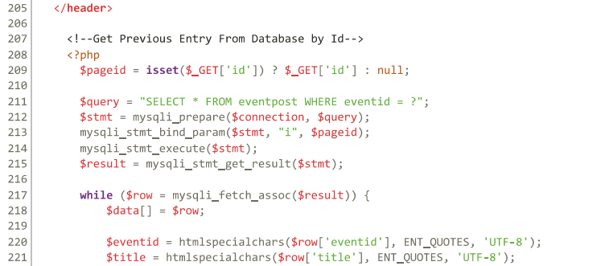

Figure 34.11 - Post Review Functionality Code

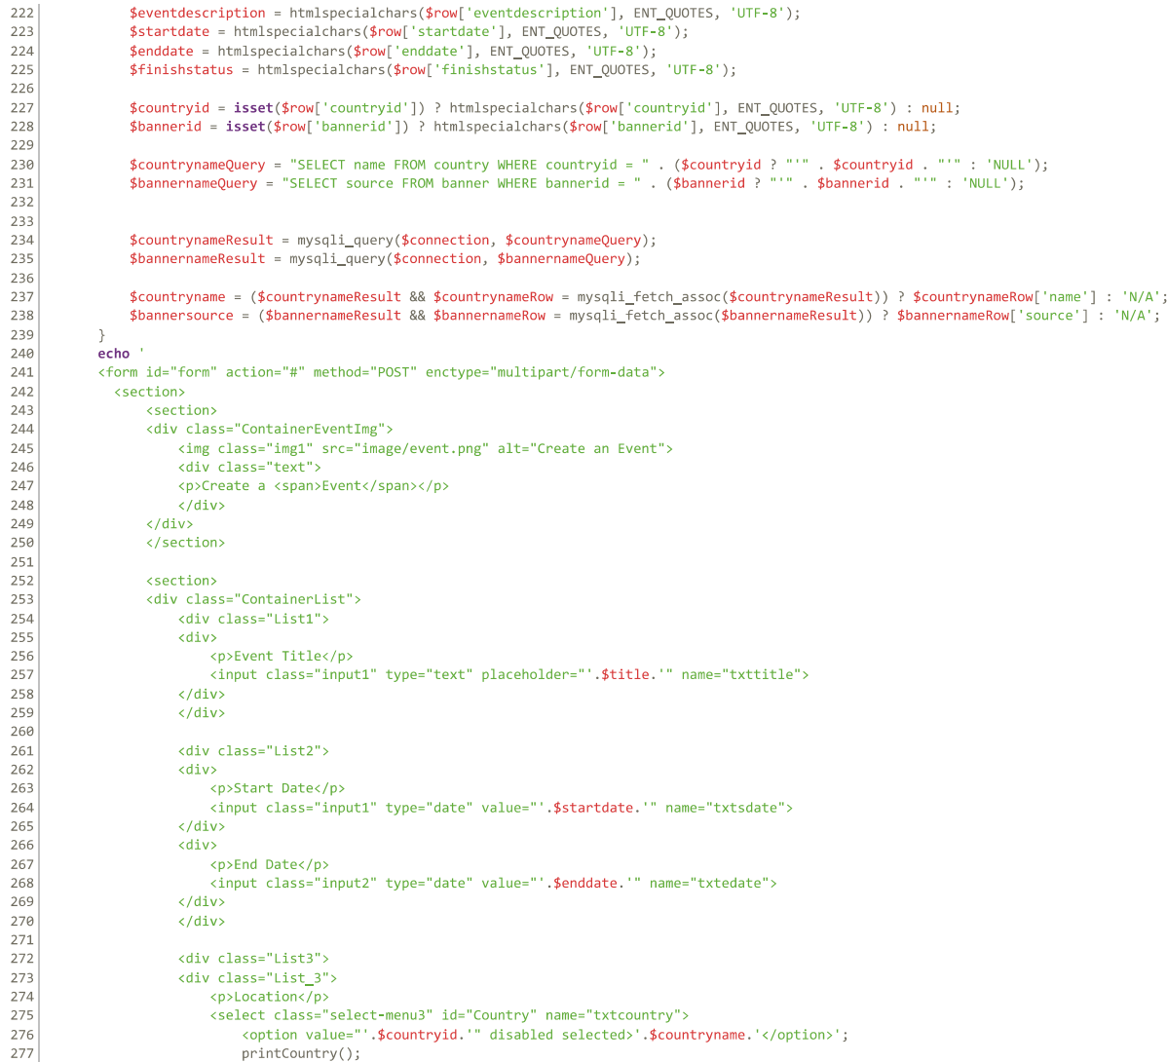

Figure 34.12 - Post Review Functionality Code

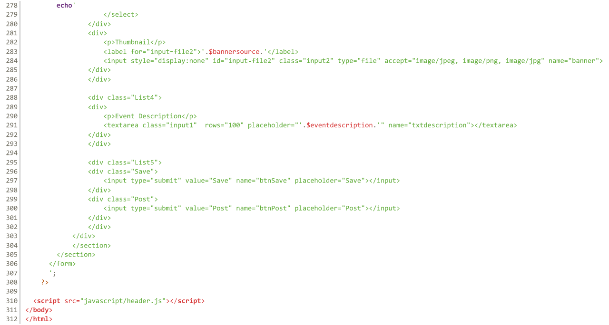

Figure 34.13 - Post Review Functionality Code

3.0.8 Admin profile functionality

The admin profile functionality aims to offer admin various tools to manage the platform and oversee its operations. This functionality involves editing the database to update user information, manage post approval, and handle any reported issues.

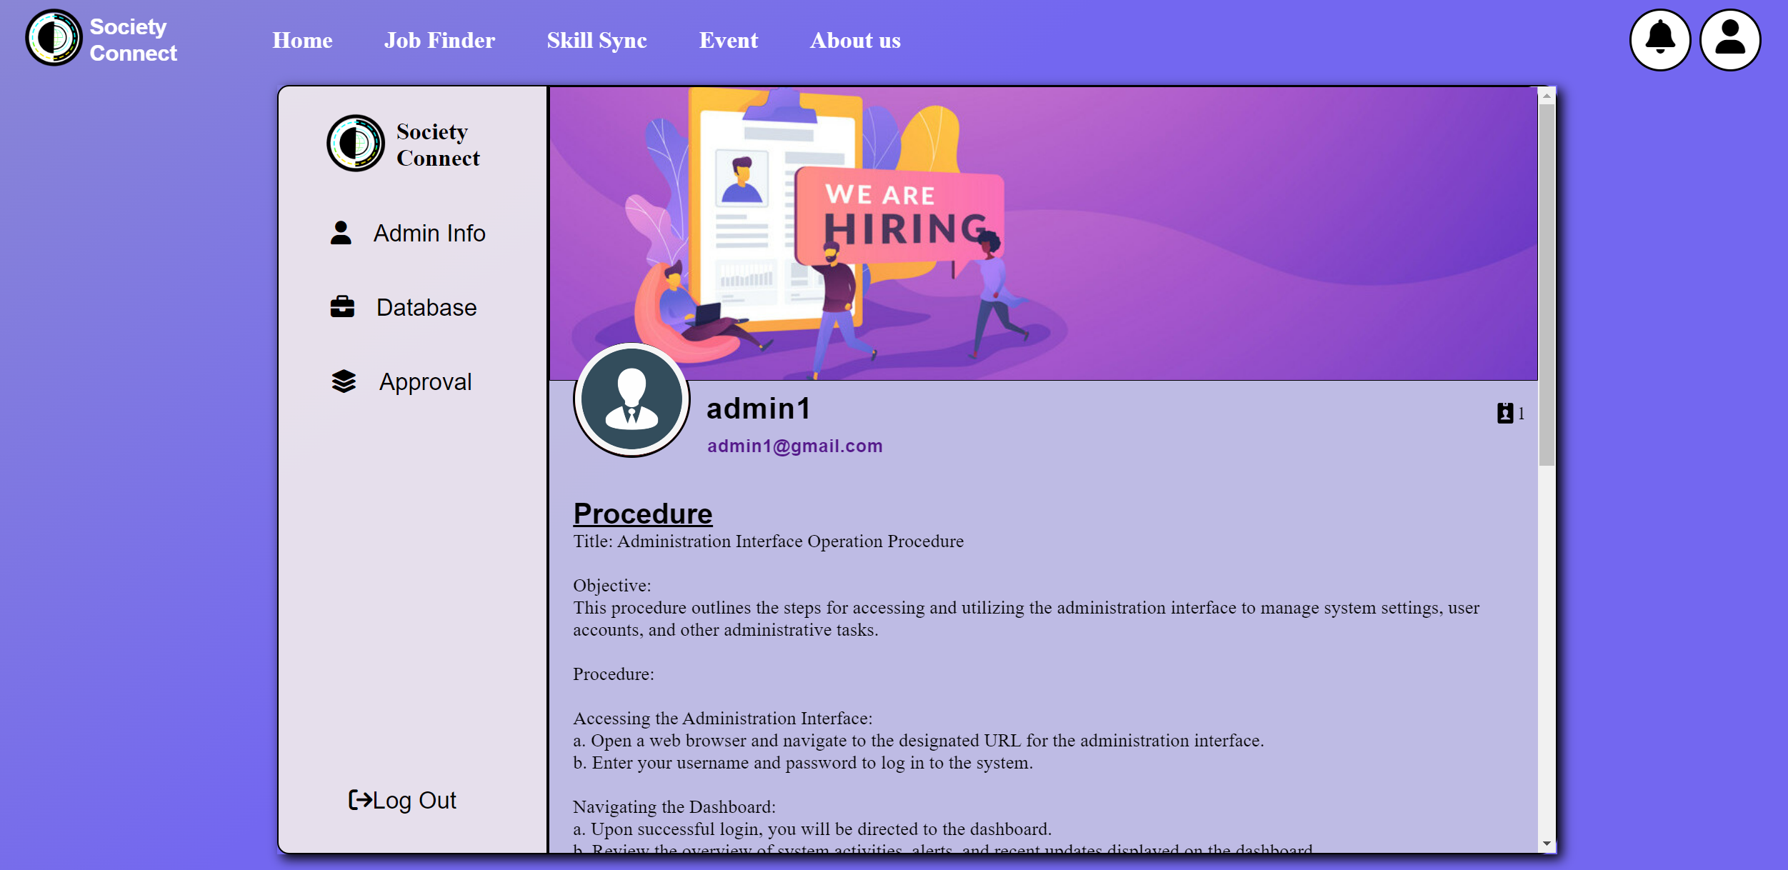

Figure 35.1 Admin Profile Functionality Design Page

Same as the user profile functionality, the admin needs to login their account in order to have access to the admin profile page. The getAdminProfile() PHP function will be responsible for verifying the admin credential and also displaying the admin information.

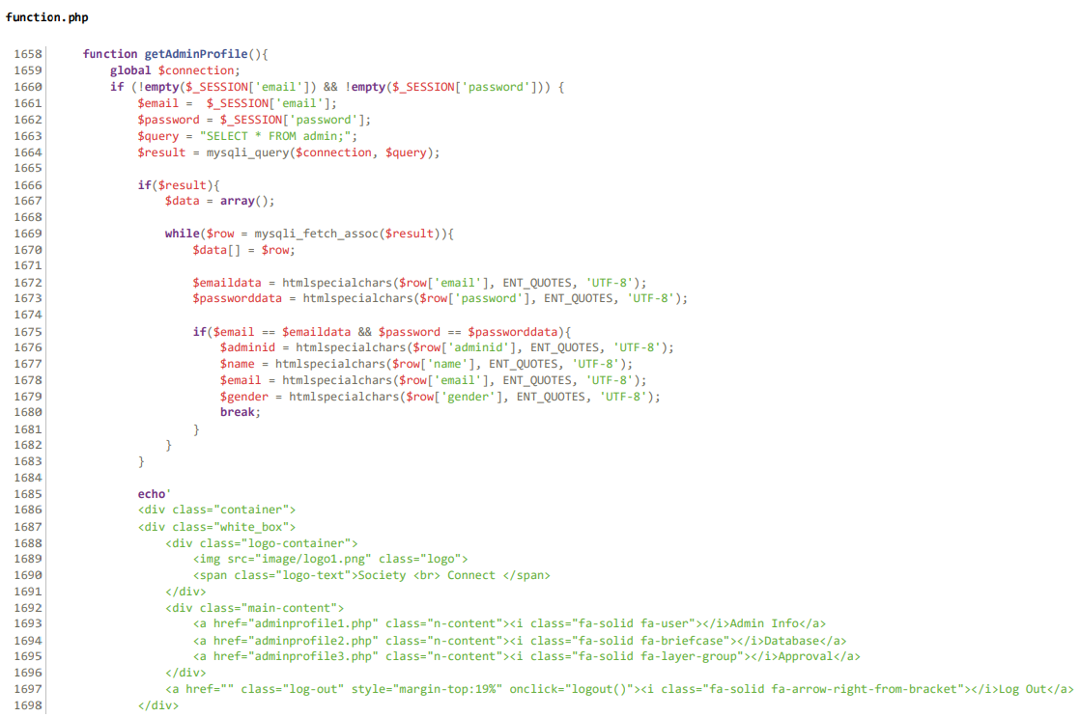

Figure 35.2 - Admin Profile Functionality Code

The second option with the label "Database" offer admins tools to delete, create or update the data in the database. By selecting the category located in the top of the table, admin is able to navigate around the database and change the database elements.

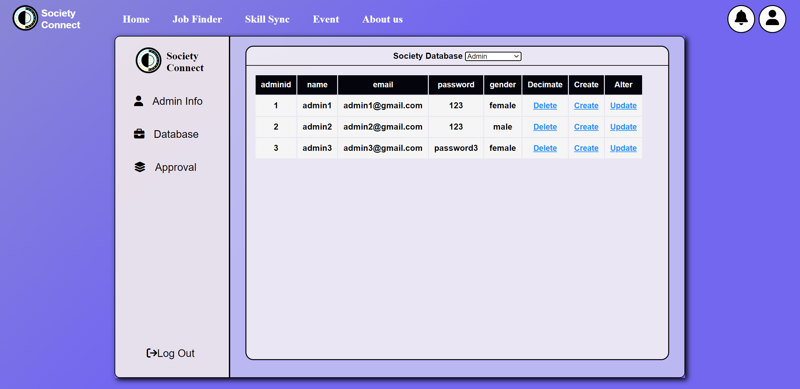

Figure 35.3 - Admin Profile Functionality Design Page

The PHP code starts by fetching the option value selected by the admin to the JavaScript function printDatabase(). The option including the admin, banner, category and etc which all of these values are corresponded to the society database table name.

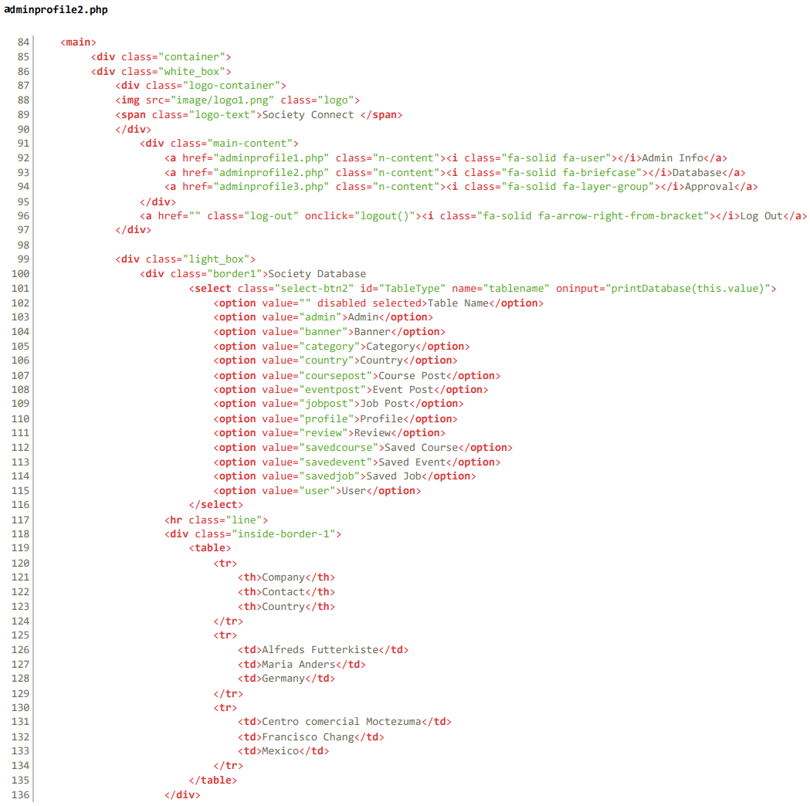

Figure 35.4 - Admin Profile Functionality Code

The JavaScript function printDatabase(tablename) facilitates the retrieval and display of database information on a web page. It utilizes an XMLHttpRequest object (xhttp) to send a request to a PHP script (getDatabase.php) asynchronously. The PHP script is responsible for querying the database based on the provided table name parameter, which specifies the table from which data should be retrieved.

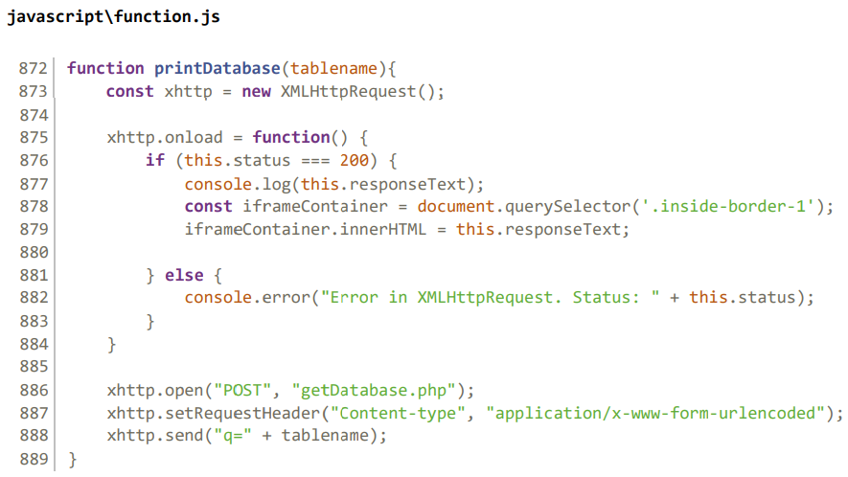

Figure 35.5 - Admin Profile Functionality Code

When the system receives a response from the PHP script, the JavaScript function's onload event checks the status of the response. If the status is 200 (indicating success), the response text which contains the database information, is logged to the console. Additionally, the response text is contrasted into the HTML element with the class. inside-border-1 so the system can displaye the database information on the web page.

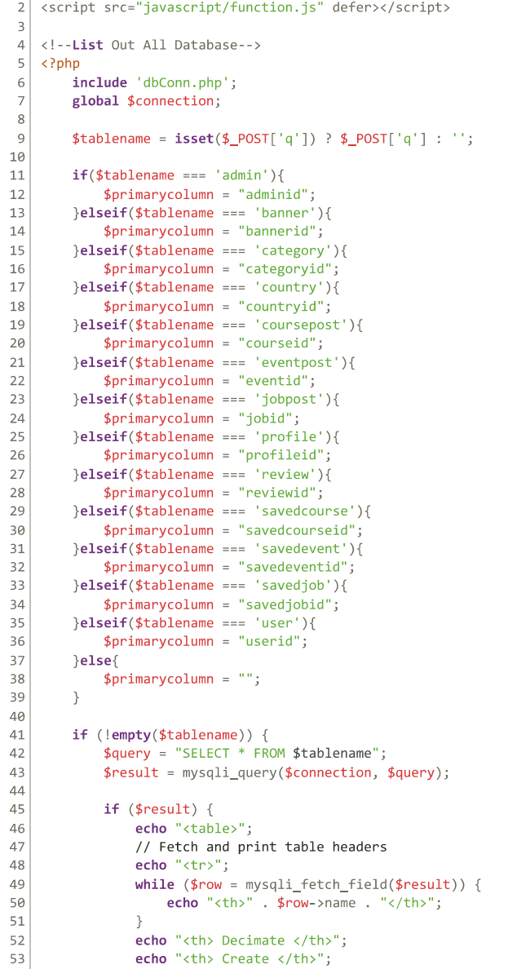The getDatabase() function consists of both PHP and JavaScript functionalities to interact with the database and display its contents on the web page. Firstly, the PHP script begins by checks if the table name ($tablename) has been provided through a POST request. Depending on the table name, the PHP determines the primary key column ($primarycolumn) for that table. This step is crucial for performing operations like deletion and updates later in the code.

Figure 35.6 - Admin Profile Functionality Code

If a table name is provided, the script proceeds to execute a SQL SELECT query to retrieve all records from the specified table. If the query is successful, the script generates an HTML table to display the retrieved data.

The code then outputting table headers based on the column names fetched from the database. Besides, it also includes three extra columns for each row: "Decimate" (for deletion), "Create" (for adding new records), and "Alter" (for updating existing records).

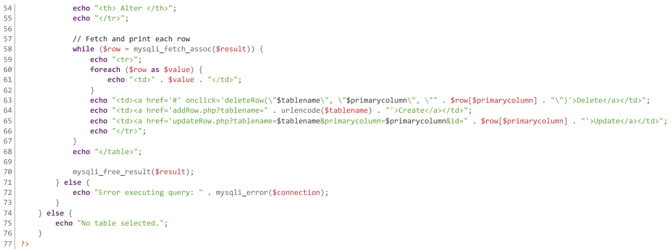

Figure 35.7 - Admin Profile Functionality Code

For each row of data retrieved from the database, the script generates the table rows (<tr>) and fills them with the corresponding values from the database. It also includes hyperlinks in the "Decimate," "Create," and "Alter" columns to allow users to perform these actions on individual records. Especially, the "Decimate"(Delete) column which contains a JavaScript function call (deleteRow()) with parameters specifying the table name, primary key column, and record ID to be deleted.

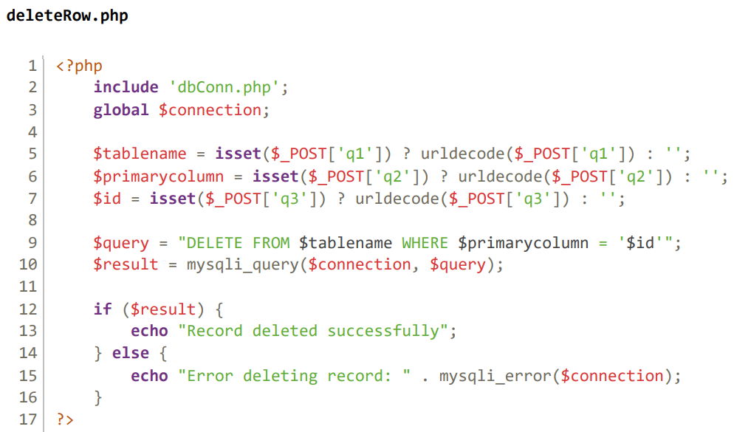

Figure 35.8 - Admin Profile Functionality Code

The JavaScript deleteRow() function is responsible for handling the deletion of records from the database. When users click the "Delete" link in the table, the deleteRow() function is invoked with the appropriate parameters to trigger the deletion process.

Next, the script retrieves data sent via a POST request. It expects three parameters:

q1: Represents the table name from which the record needs to be deleted.

q2: Represents the primary key column of the table.

q3: Represents the value of the primary key for the record to be deleted.

The script then constructs a DELETE query using the provided table name, primary key column, and record ID. The script then executes it using mysqli_query(), passing the database connection and the constructed query as arguments. If the query execution is successful, it prints a success message indicating that the record was deleted successfully. Otherwise, it outputs an error message containing details of the encountered error, retrieved using mysqli_error().

For the "update" and "create" links, the php will direct admin to another page associated with the $primaryid. The update and create have the same PHP structure. Picture below features the web layout of the update page.

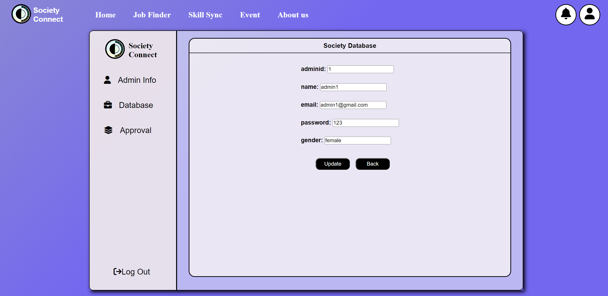

Figure 35.9 - Admin Profile Functionality Design Page

For the updateRow().php, it starts by retrieving parameters from the URL query string through the GET method, namely tablename, primarycolumn, and id, Then, the script constructs a SELECT query to fetch the record from the specified table where the primary key column matches the provided ID.

If the query execution is successful and returns one or more rows, it generates an HTML form with input fields pre-populated with the current values of the selected record. Hidden input fields are also included to pass the tablename, primarycolumn, and id values to the subsequent update operation. Additionally, the script provides buttons to either submit the updated values for processing or navigate back to the previous page.

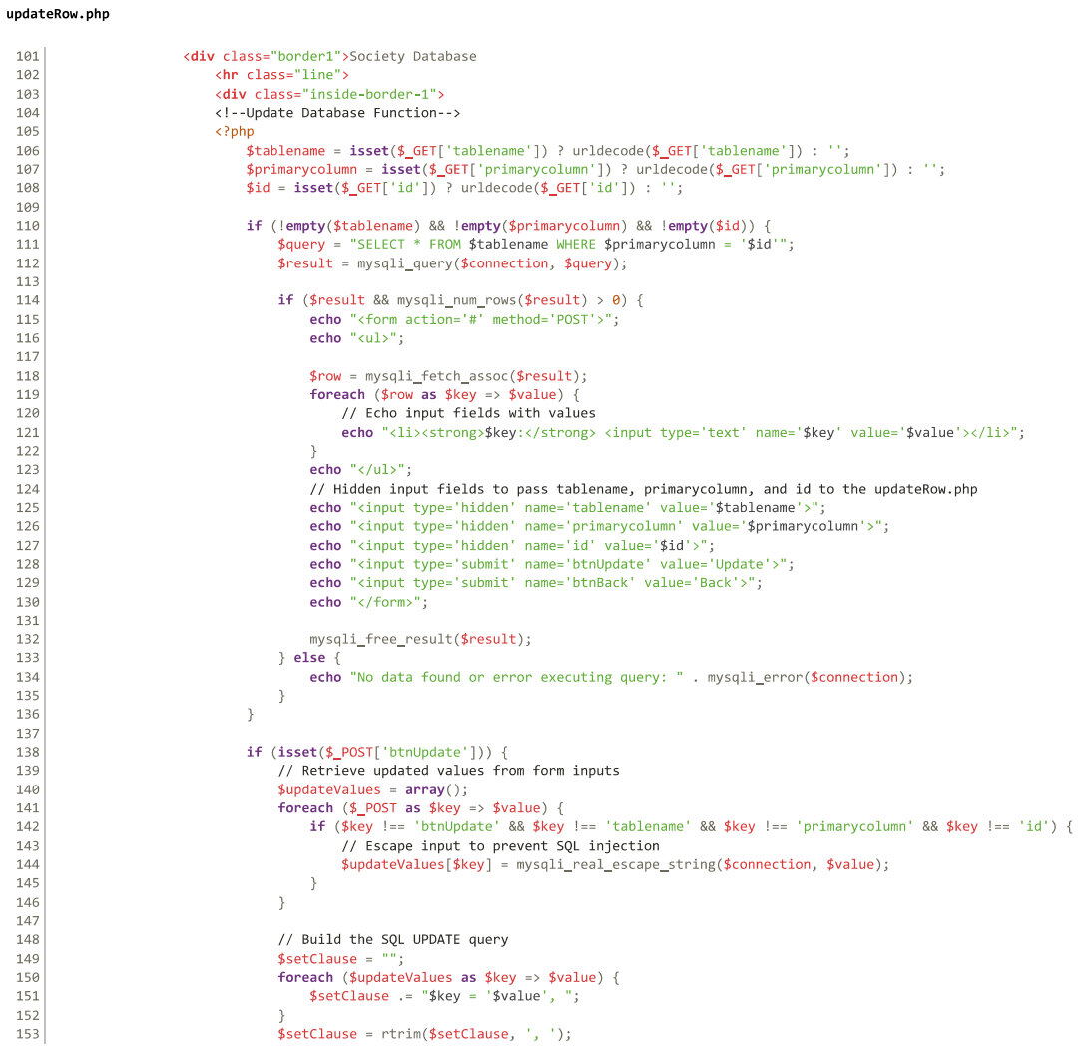

Figure 35.10 - Admin Profile Functionality Code

Upon submission of the update form, the script detects the presence of the 'btnUpdate' button in the POST request. It then retrieves the updated values from the form inputs and constructs an SQL UPDATE query to modify the corresponding record in the database. The script executes this query, and depending on the outcome, it displays a JavaScript alert message indicating the success or failure of the update operation. It then redirects the user to the appropriate page using window.location.href. Furthermore, the script handles the scenario where the user clicks the 'btnBack' button, triggering a redirection to the previous page.

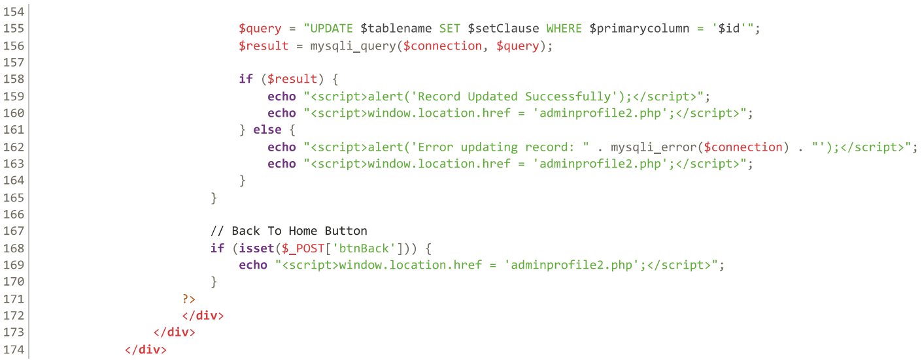

Figure 35.11 - Admin Profile Functionality Code

For the third option "approval" page, it features the post approval system on our platform. At here, admin is able to approve or reject a post.

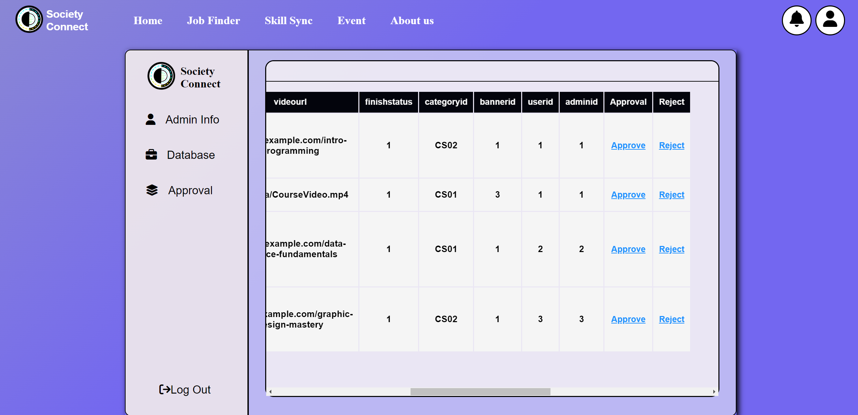

Figure 35.12 - Admin Profile Functionality Design Page

Every time when user choose the category, it triggers the printApproval() function.

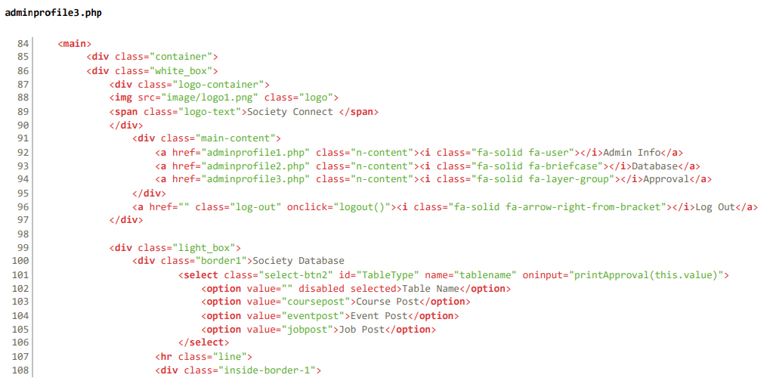

Figure 35.13 - Admin Profile Functionality Code

The JavaScript function printApproval(tablename) facilitates the retrieval and display of database information on a web page. It utilizes an XMLHttpRequest object to send a request to a PHP script (getApprovalPost.php) asynchronously. The PHP script is responsible for querying the database based on the provided table name parameter, which specifies the table from which data should be retrieved.

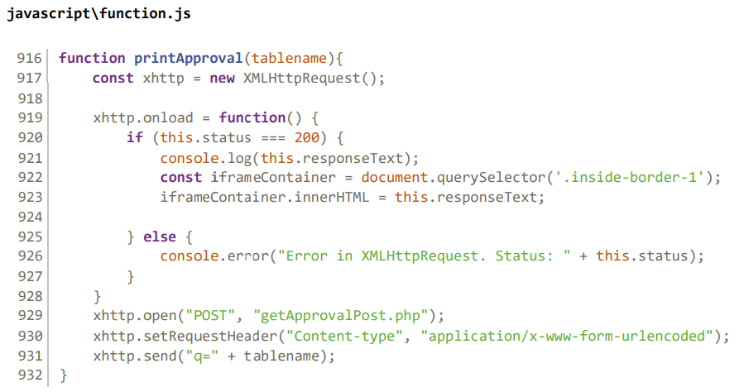

Figure 35.14 - Admin Profile Functionality Code

The code structure of the getApprovalPost.php is similar to the getDatabase() function. The code begins by including the dbConn.php file, establishes a connection to the database. Then the system initializes a variable $tablename to hold the name of the database table to be queried, obtained from the POST request parameter 'q'.

Based on the value of $tablename, the script determines the primary key column of the table ($primarycolumn) to be used later in the query. If the table is coursepost, eventpost, or jobpost, their respective primary key columns are set to "courseid", "eventid", and "jobid".

If $tablename is not empty, indicating that a table has been selected, the script constructs a SELECT query to retrieve all records from the specified table where the finishstatus column is set to '1', ordered by the adminid column in ascending order. It then executes this query using mysqli_query() and processes the result.

If the query execution is successful, the script generates an HTML table with headers corresponding to the columns of the result set. It iterates over each row of the result set, printing each column value within table cells. Additionally, for each row, it provides 'Approve' and 'Reject' links, which, when clicked, presumably trigger JavaScript functions (approveRow() and rejectRow()) defined in function.js to perform approval or rejection actions on the corresponding database entry.

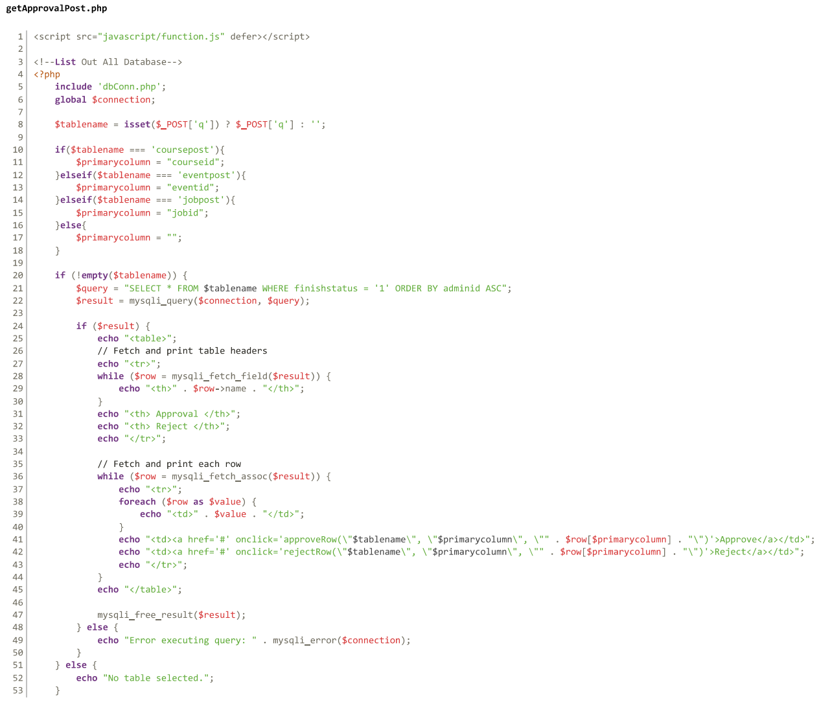

Figure 35.15 - Admin Profile Functionality Code

The JavaScript function, approveRow(tablename, primarycolumn, id) handle the approval action initiated by clicking the 'Approve' link in the table. When users click 'Approve', they will be receiving a confirmation dialog to ensure they intend to proceed. If confirmed, an XMLHttpRequest (XHR) object is created to send a request to the server to approve the corresponding database entry.

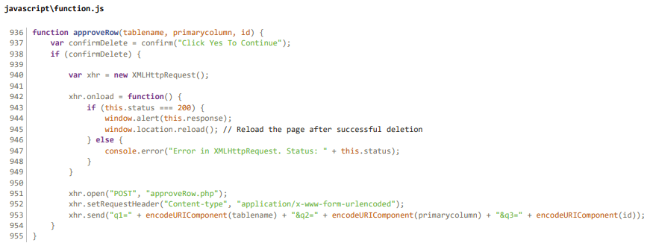

Figure 35.16 - Admin Profile Functionality Code

The approveRow.php will then retrieves the user's email and password from the session variables and queries the admin table in the database to fetch all admin records. It iterates through the result set and compares each admin's email and password with the session data to find a match. If a match is found, the corresponding admin ID is stored in the $adminid variable. Next, the script checks for the presence of POST variables (q1, q2, q3) that likely contain the table name, primary key column name, and ID of the record to be updated. These values are retrieved using isset() and urldecode() functions to ensure their existence and proper decoding.

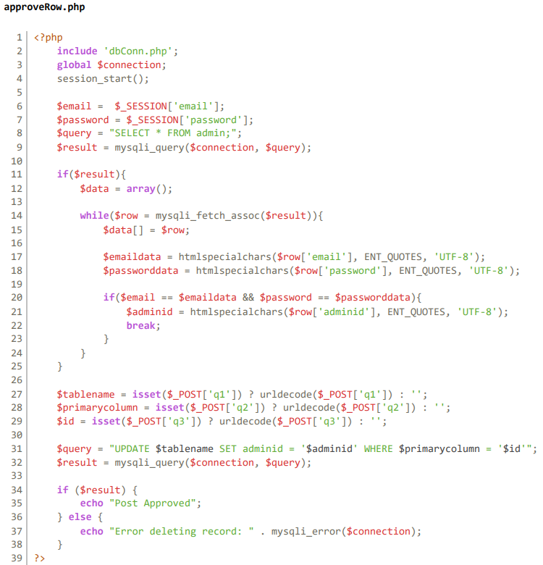

Figure 35.17 - Admin Profile Functionality Code

Using the retrieved table name, primary key column name, and ID, the script constructs an SQL UPDATE query to set the adminid field to the admin's ID for the specified record. This essentially marks the record as approved by associating it with the admin who approved it.

# 4.0 User Guidance

In this part we will guide the user through our website step-by-step, so the user can have a clear understanding of our website and how it works.

## 4.1 User Login

To access our platform extended features, users will need to create new account and login to their account. The user can access the login page by clicking on the main page button named "Sign In" or they can simply click any option on the small navigation bar in the top right corner.



User Guidance Figure

Some option on the top right corner like "Post Job", "Post Event", "Post Course" and "Profile". These options will make the system verify the user’s authentication. If the users haven’t login, system will display an error message to the user and automatically direct user to the login page.

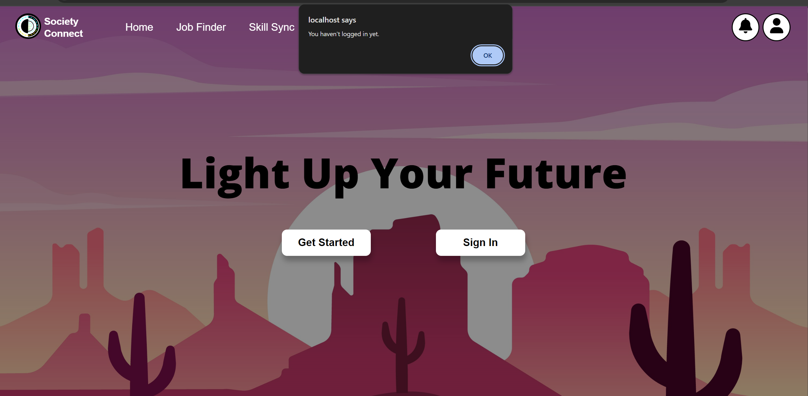

User Guidance Figure

If success, the users will be direct to the login page as the picture shown below. User will need to fill their email and password correctly. If not, the system will prompt an error to the users. If success, user will be redirect to the main page with a success message displayed.

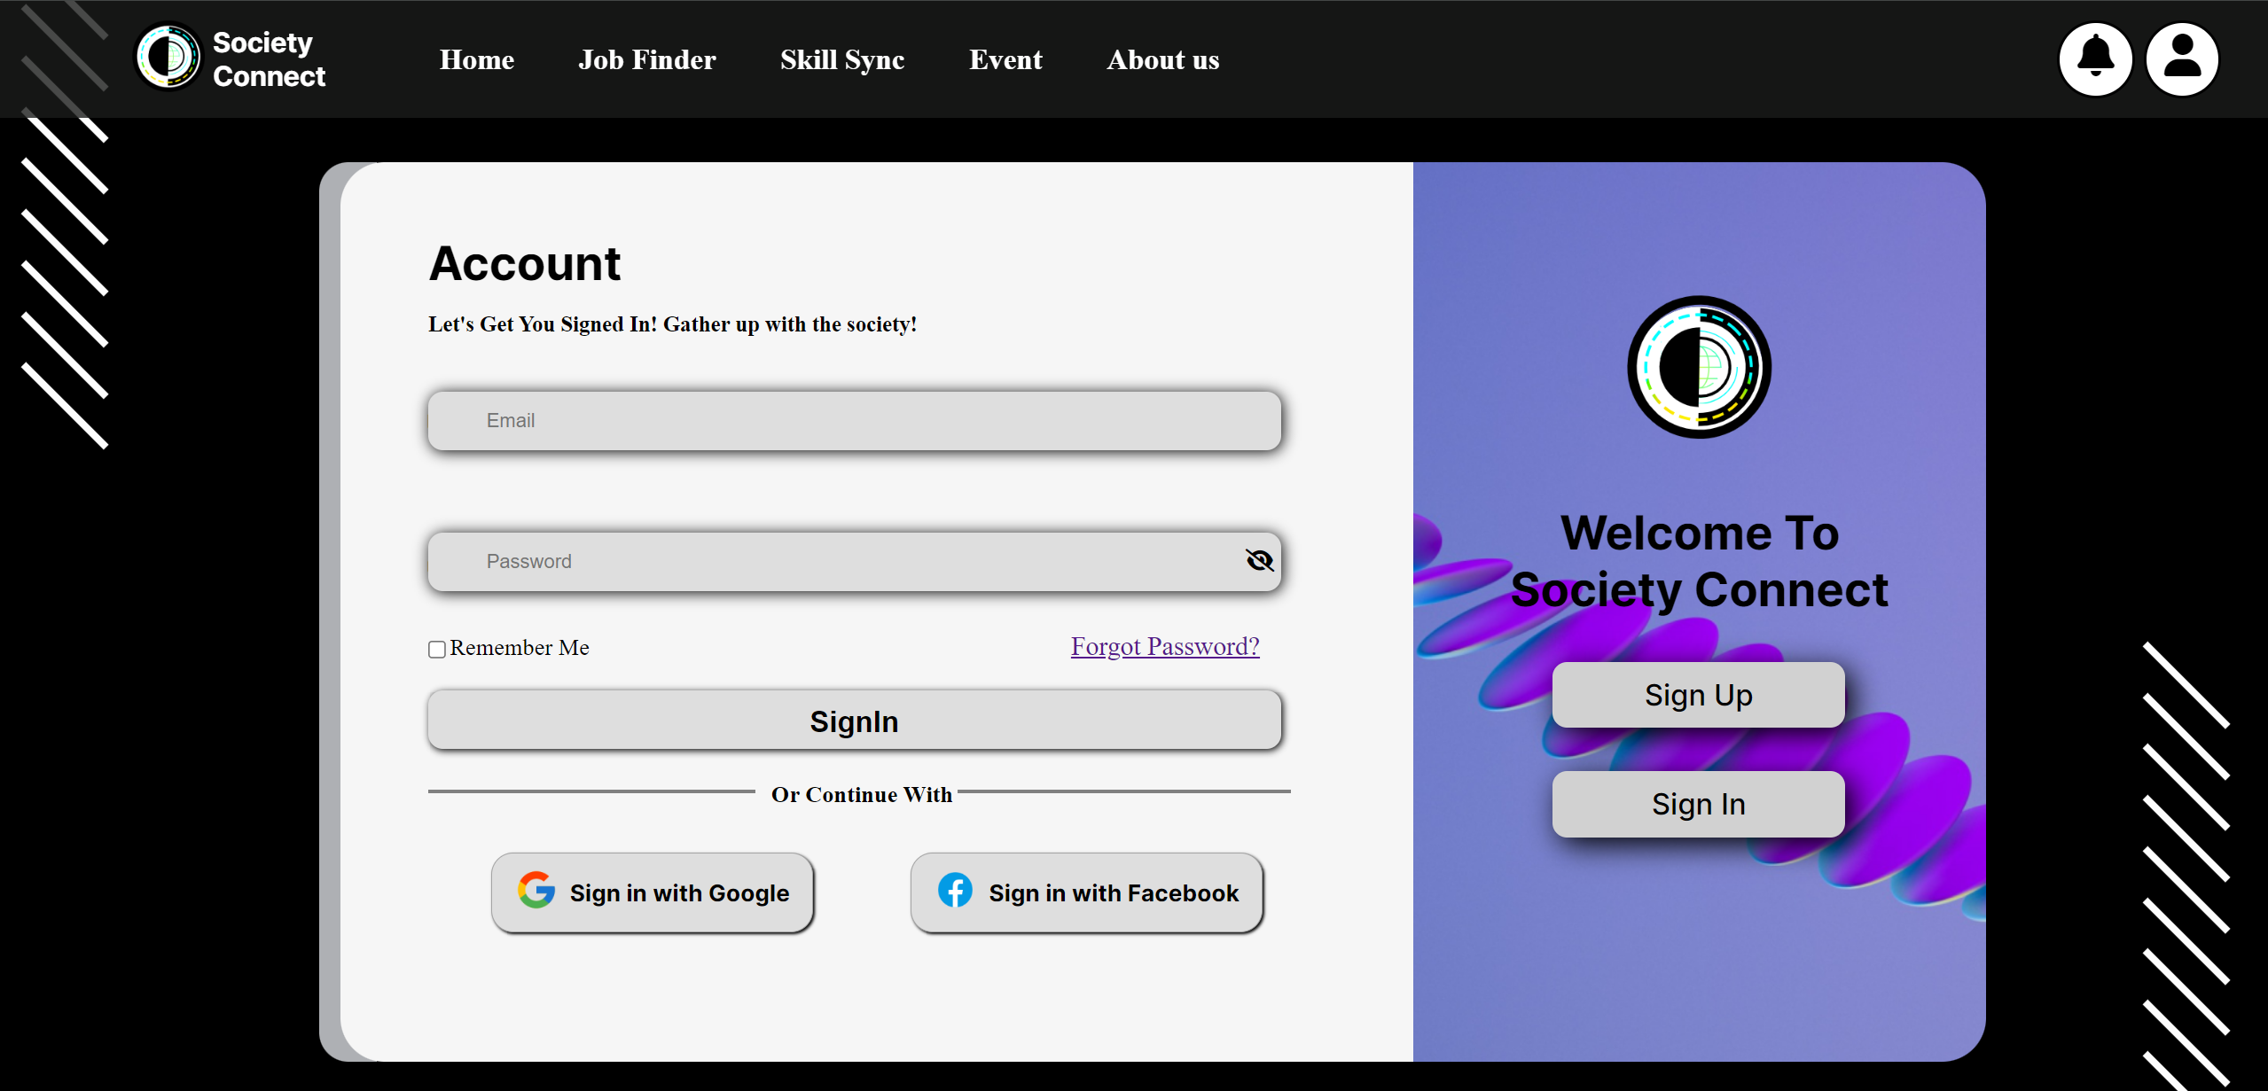

User Guidance Figure



User Guidance Figure

### 4.1.2 Users Sign Up

For registering a new account in our website, users must press the sign-up button for our system to direct the user to our register page. Then, users will fill in their information before accessing to our platform.



User Guidance Figure



User Guidance Figure

## 4.2 Main page



User Guidance Figure

Upon signing in, users will immediately direct to our main page, which has three main functionalities: Job Finder, Skill Sync, and Events. This intentional design empowers users to choose their path, whether it's exploring job opportunities, enhancing skills, or engaging in relevant events. This concise and strategic approach ensures users quickly access the features that meet their immediate needs by creating a seamless and empowering user experience.

## 4.3 Job Finder



User Guidance Figure

If the user chooses the JOB FINDER, the system will direct the user to the JOB FINDER main page as shown above. Here the user has two options find his/her jobs or hire an employee, In this case the user wants to find his/her jobs. In order to find jobs, the user must fill in the blank accordingly such as which country his/her want to work in and also the user must choose his/her Specialise field.

### 4.3.1 Create a Job

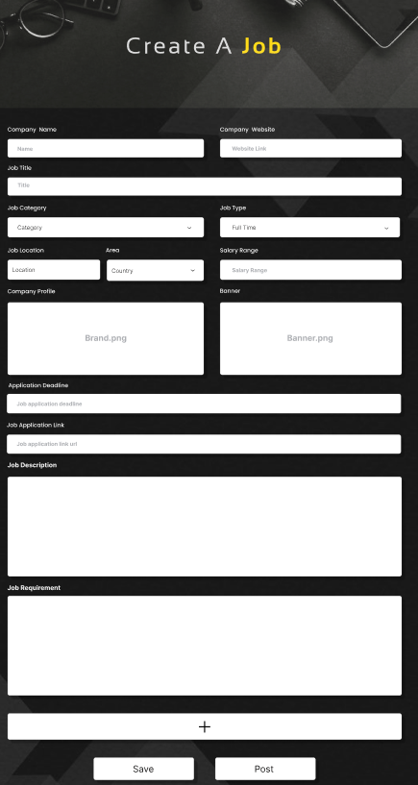

User Guidance Figure

If the user chooses to hire his/her employee the system will redirect the user to Create a Job or Post a Job for the employee. In order to do that, the user must fill in the blank as shown above such their Company Name, Location, Country, Company website and what type of job the user offer to the employee. After filling the blank the user can choose to post or save the Job information.

### 4.3.2 Review Post

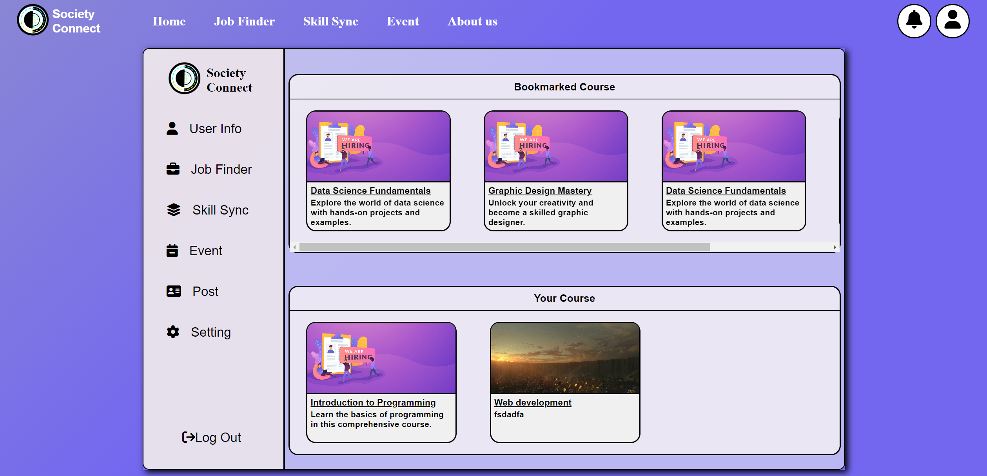

User Guidance Figure

If the user is still interested in this post, he/she can press the mini post display in the profile page to review the post. The system will direct users to a larger page where the users can have a clearer look inside the post detail. This feature is available for the job finder, skill sync and event post.

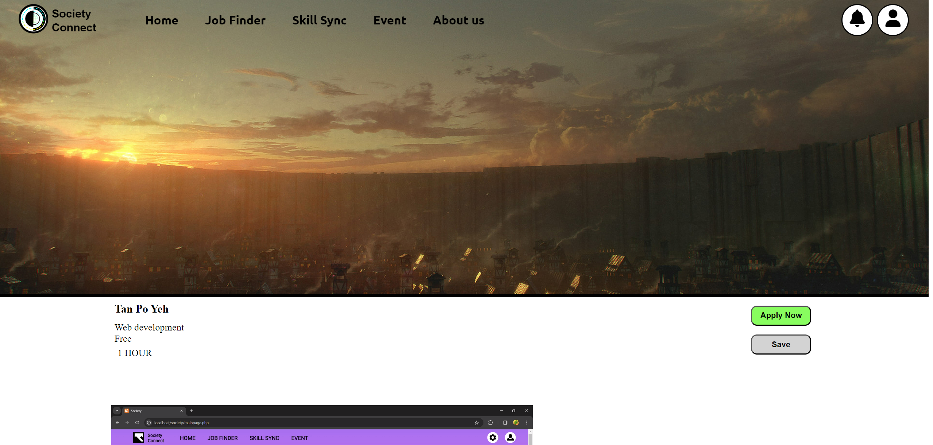

User Guidance Figure

## 4.4 Skill Sync

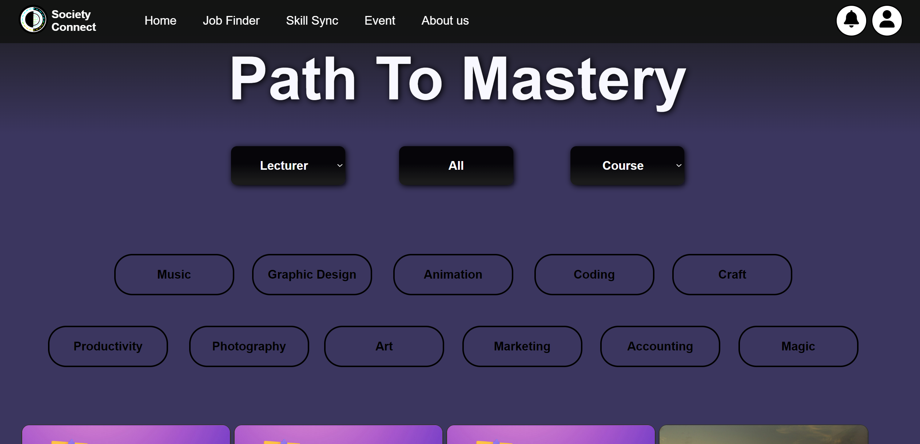

User Guidance Figure

If the user chooses the SKILL SYNC, the system will direct the user to the SKILL SYNC main page as shown above. Here the user has variety of choice. The user can seek for Top Rated Lecture and which course they want to improve or learn a new skill. The user can also organize it by pressing the category button to search he/her relevant field.

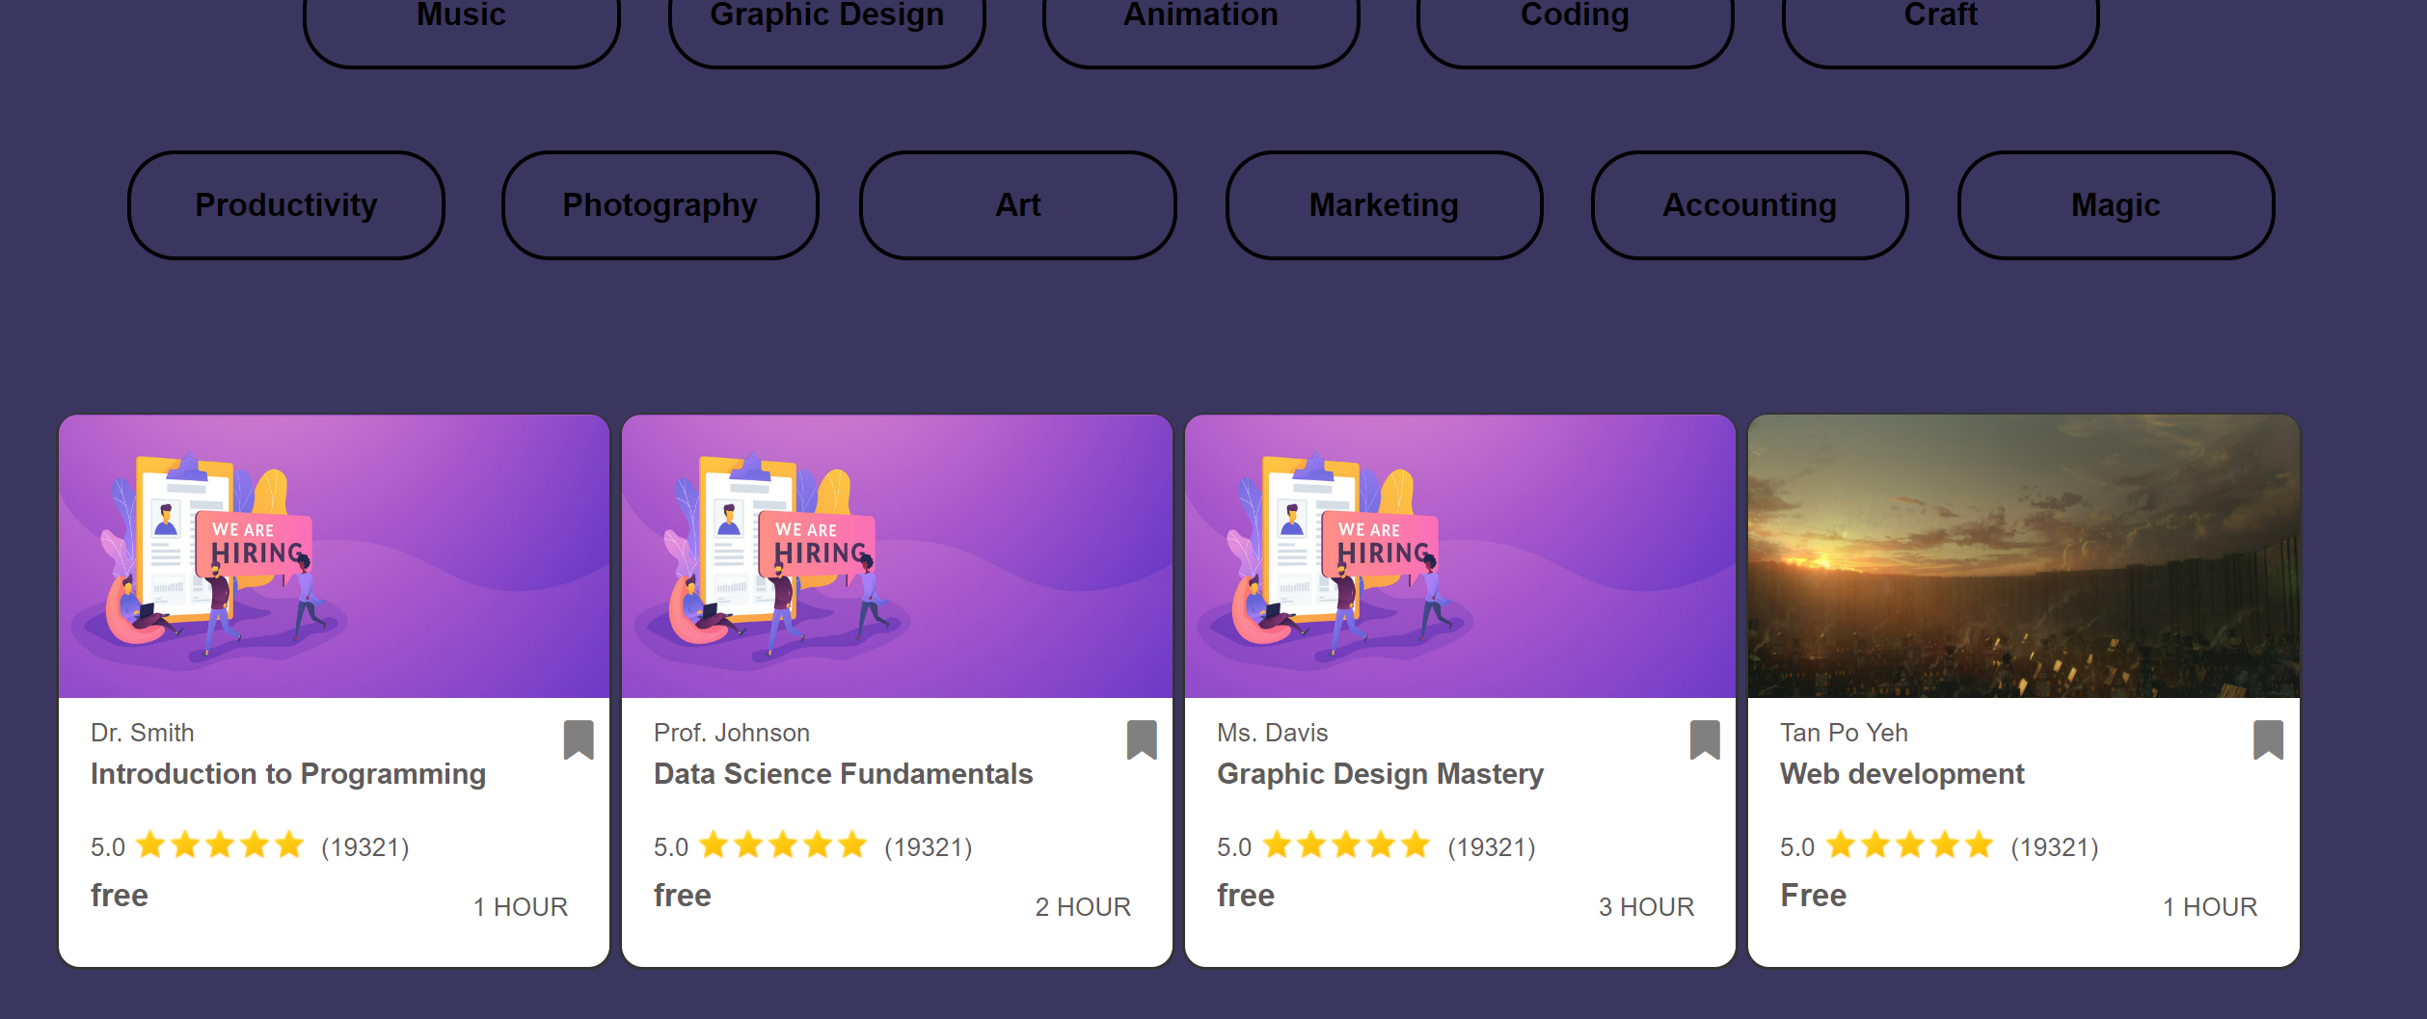

User Guidance Figure

### 4.4.1 Create a Lesson

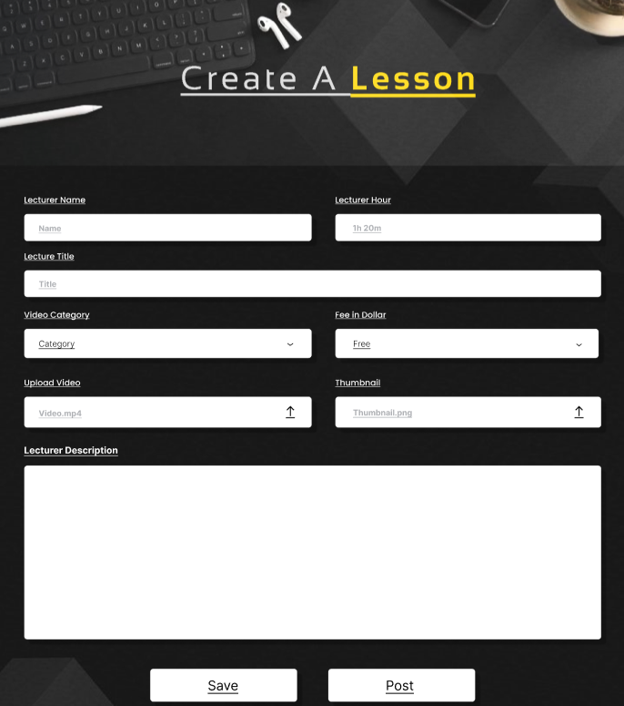

User Guidance Figure

If the user chooses to post/ host an event, he/ she can create an event in our website. As shown above, for the user to create an event in our website the user must fill in the blank with their information. After he/she have created an event, the user can save or post in our website.

### 4.4.2 Review User Posting Course

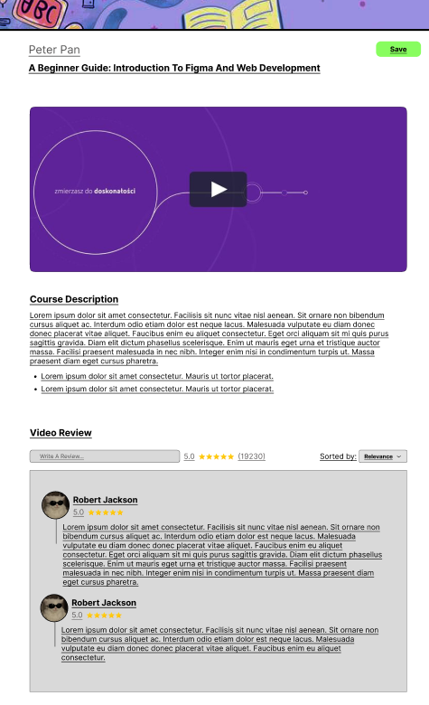

User Guidance Figure

Same as Review User Posting Job page, the user can review on their post lesson as shown above.

## 4.5 Event

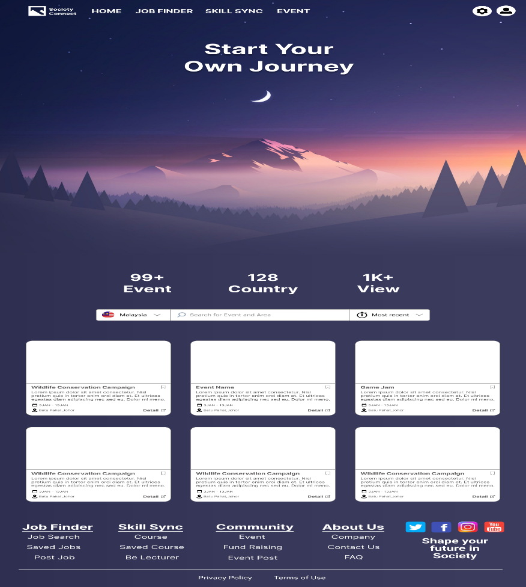

User Guidance Figure

If the user chooses the EVENT, the system will direct the user to the EVENT main page as shown above. Here the user has variety of choice. The user can seek for which event they want to do volunteering event. The user can also organize it by pressing the category button to search he/her relevant field.

### 4.5.1 Create an Event

To create an event post

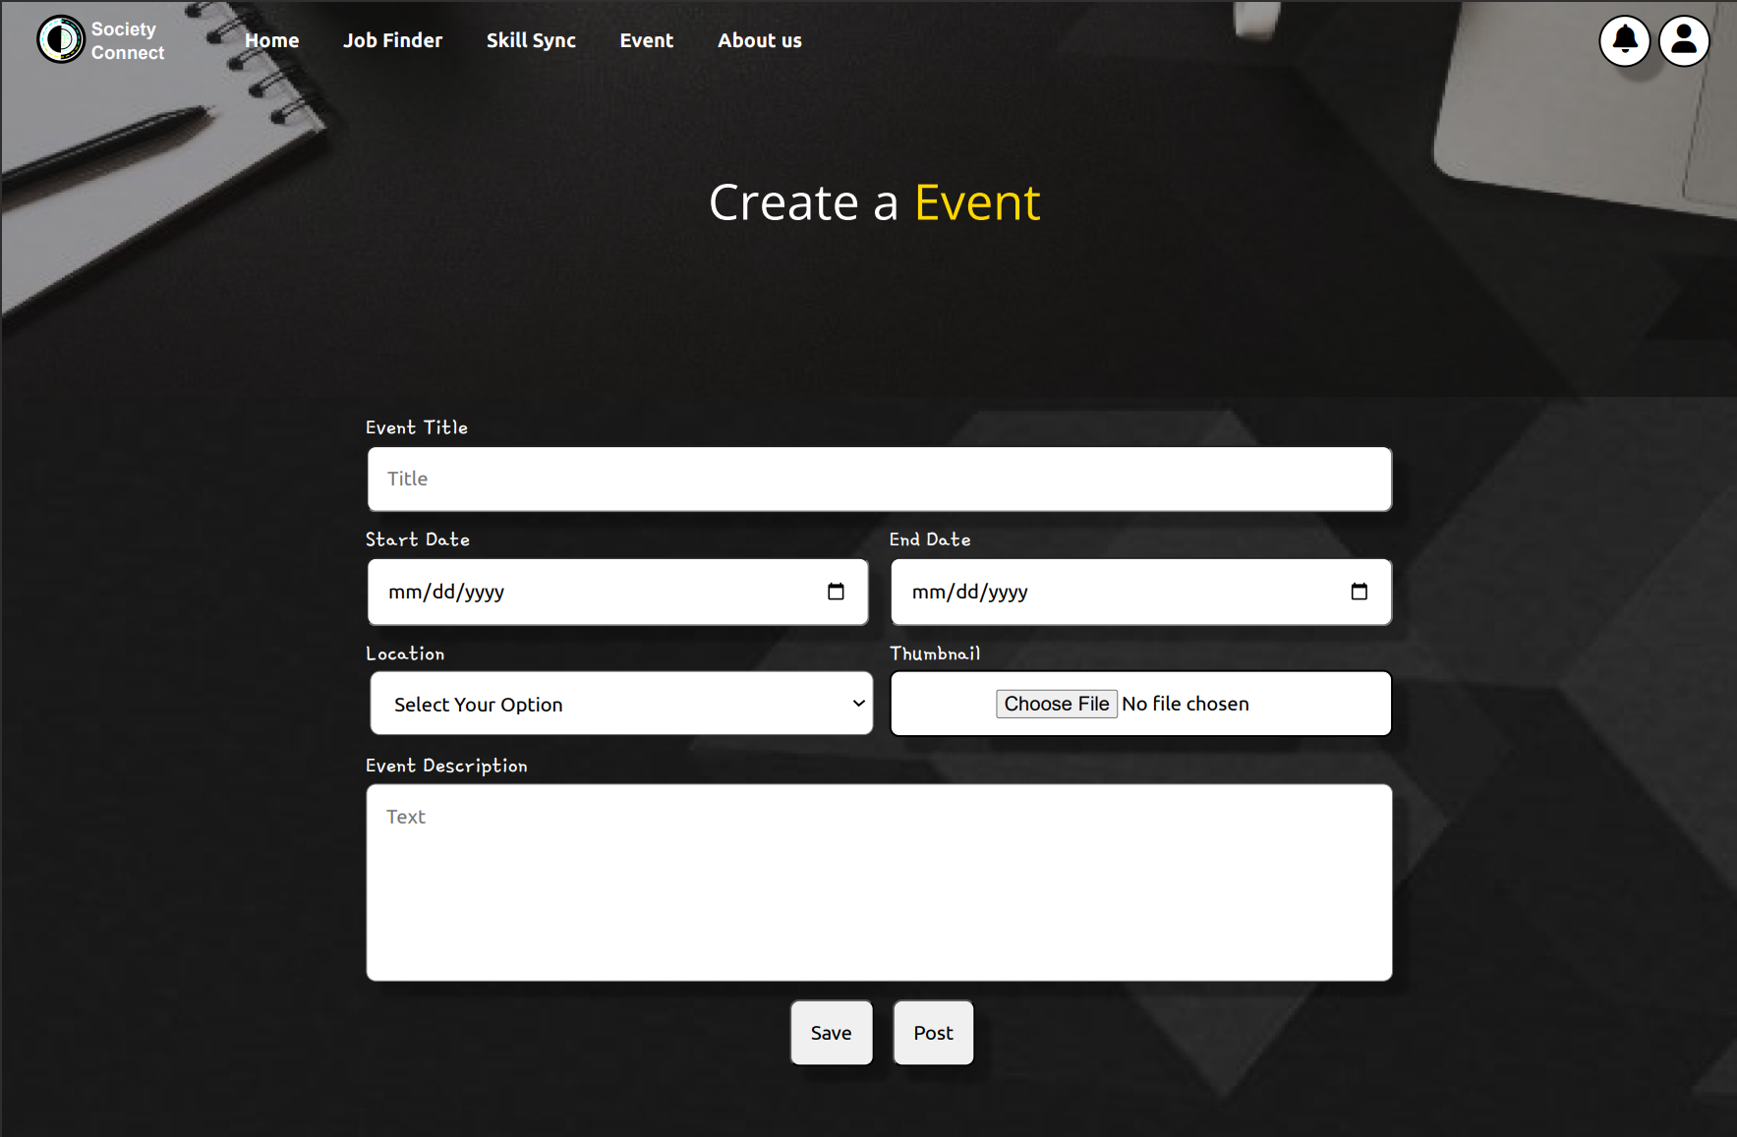

User Guidance Figure

Here the user can create their own event .The user must fill in the blank as shown above .Crucial informtion such as the event name , location, date and event description must be fill .After that , the user can choose to save or post the event .

### 4.5.2 Review Users Posting Event

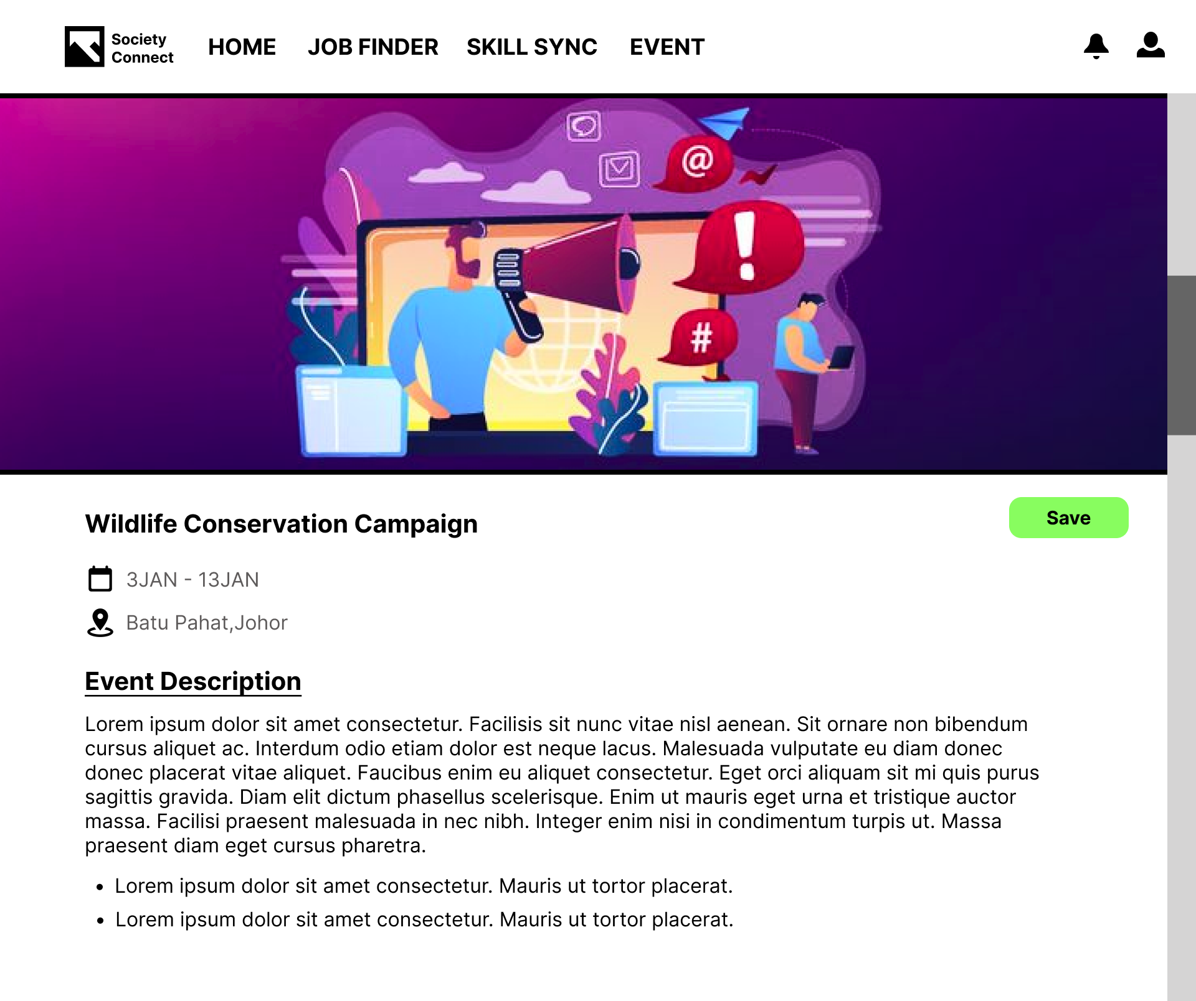

User Guidance Figure

Same as Review User Posting Job page, the user can review on their hosting event as shown above.

## 4.6 User Profile



User Guidance Figure

If user want to check their own profile, user must click on this unique profile icon.



User Guidance Figure

A small animation will pop up and display a various navigation button for the user to click on. Click the “profile” navigation button to triggered the system move on to the profile page.

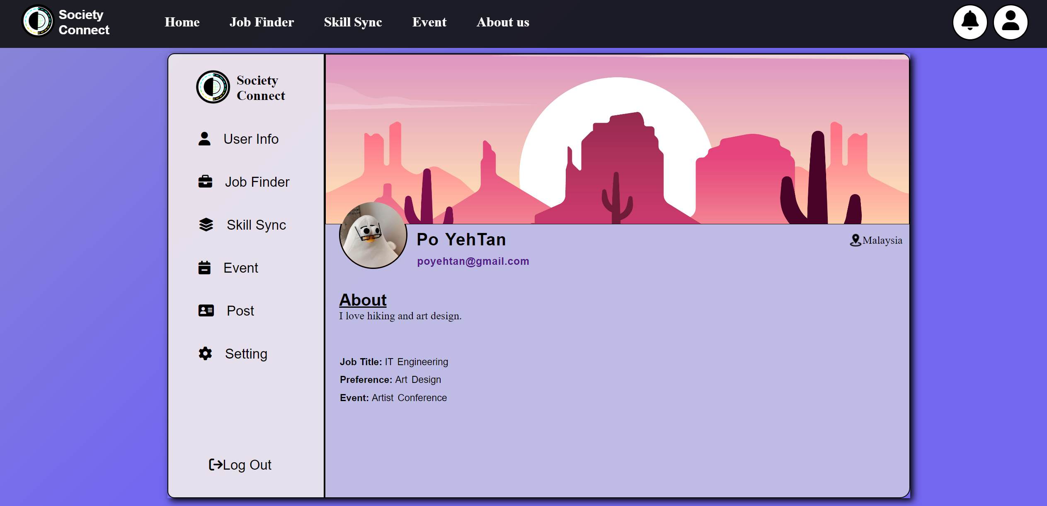

User Guidance Figure

Here the user can see their own Profile page with others infromation such as Job Finder ,Skill Sync ,Event and Post .Lastly, if the user choose to log out from our website the user can click the “Log out” button as shown above .

# 5.0 Conclusion

In conclusion, our website is designed carefully and for navigating the intricacies of the job market and nurturing your professional journey. We have also ensured a user-friendly design, making it easy for individuals to explore opportunities and pursue ongoing development. The interface will seamlessly integrate essential features like Job Finder, Skill Sync, and Events, prioritizing accessibility, and simplicity. The powerful Job Finder simplifies job discovery with advanced search filters and direct links to company pages. Skill Sync empowers users to personalize and enhance their skill development journey. Events recommendations, centralized calendars, and networking features enhance the sense of community, making your experience collaborative and engaging. Focusing on the personalization, accessibility, and security, our website not only known for its dynamic career companion but also evolves based on customers’ valuable feedback. Most importantly, our goal is to show out a holistic and positive experience using the website, guiding user towards a better career opportunities and professional growth.

# 6.0 Workflow Matrix

|  |  |  |
| --- | --- | --- |
| Name | Responsibility | Signature |
| Leong Seng Khuan | 1. Project Plan 2. User Guidance   5.0 Conclusion | SK |
| Chok Jung Shing | 1. Design 2. User Guidance   8.0 References | Chok |
| Tan Po Yeh | 1. Design 2. Implementation   4.0 User Guidance |  |
| Tong Jia Chuen | 1.0 Table of Contents  2.0 Design  4.0 User Guidance | Tong |

# 7.0 References

Coursera. (April, 2012). *CourseRA* . Retrieved from Coursera | Degrees, Certificates, & free online courses: https://www.coursera.org/

*Find jobs in Malaysia | Vacancies & career opportunities - Hiredly*. (2014). Retrieved from Hiredly: https://my.hiredly.com/

Kee, M. C. (1997). *Jobs in Malaysia - Search job vacancies - career | Jobstreet.com.my*. Retrieved from Jobstreet: https://www.jobstreet.com.my/

Kumar, K. (2010). *Start learning today's most in-demand skills for free*. Retrieved from Simplilearn.com: https://www.simplilearn.com/skillup-free-online-courses#exploreCoursesSkillup

# 8.0 Appendix

Proposal:

Society Connect is our group assignment title for our software application. A web application that is dedicated to community service, providing several interesting features. Our platform provides free e-courses that are from experts, teaching them vital skills and personal improvements. For those who are seeking for guidance, our online consultation service is also provided with other organizations that are willing to help via link & appointments in our web application. Users can seek for mental health advice, career counselling and other related interactions. There will be a friendly-user portal that provides Free Job Finder. This feature supports jobless individuals that are currently seeking for a job. With connection to numerous organizations & even portal links to other webs that are currently hiring individuals. A community forum that will encourage discussions among the society, sharing out ideas and opinions. A resource library feature containing articles, guides, news. Including the language support feature, helping individuals that are struggling in understanding other languages by having translation services. A user feedback system feature that can help our web to do improvements. Making our platform user-friendly, foster the connections among the community. All users are required to sign-up and login their credentials to utilize the web application, and it will be easy to navigate and use with ease by the users.

Preliminary Draft:

